**INDEX**

|  |  |  |  |  |
| --- | --- | --- | --- | --- |
| **Sr. No.** | **Topic** | **Date** | **Page No.** | **Sign** |
| 1. | **Write a program for implementing Client Server communication model using TCP** | 16/09/22 |  |  |
| a. | Client server based program using TCP to find if the number entered is prime |  |  |  |
| b. | Client server TCP based chatting application |  |  |  |
| 2. | **Write a program for implementing Client Server communication model using UDP** | 23/09/22 |  |  |
| a. | Client server based program using UDP to find if the number entered is even or odd |  |  |  |
| b. | Client server based program using UDP to find the factorial of the entered number |  |  |  |
| c. | Program to implement simple calculator operations like addition, subtraction, multiplication and division |  |  |  |
| d. | Program that finds the square, square root, cube and cube root of the entered number |  |  |  |
| 3. | **Write a program for implementing Multicast Socket example** | 30/09/22 |  |  |
| 4. | **Write a program to show the object communication using RMI** | 07/10/22 |  |  |
| a. | RMI based application program to display current date and time |  |  |  |
| b. | RMI based application program that converts digits to words, e.g. 123 will be converted to one two three |  |  |  |
| 5. | **Write a program to show the implementation of web services** | 14/10/22 |  |  |
| a. | Implementing Big web Services |  |  |  |
| b. | Implementing web Service that connect to MYSQL Database |  |  |  |
| 6. | **Write a program to implement Xen virtualization and manage with Xen Center** | 21/10/22 |  |  |
| 7. | **Write a program to implement virtualization using VMWare ESXi Server and managing with vCenter** | 11/11/22 |  |  |
| 8. | **Write a program to implement Windows Hyper –v Virtualization** | 18/11/22 |  |  |
| 9. | **Develop application for Microsoft Azure** | 25/11/22 |  |  |

**Practical 1**

**AIM: Write a program for implementing Client Server communication model using TCP**

**A. A client server based program using TCP to find if the number entered is prime.**

**Code:**

**1.tcpServerPrime.java:**

import java.net.*;

import java.io.*;

class tcpServerPrime

{

public static void main(String args[])

{

try

{

ServerSocket ss = new ServerSocket(8001);

System.out.println("UPGCM");

System.out.println("Server Started...............");

Socket s = ss.accept();

DataInputStream in = new

DataInputStream(s.getInputStream());

int x= in.readInt();

DataOutputStream otc = new

DataOutputStream(s.getOutputStream());

int y = x/2;

if(x ==1 || x ==2 || x ==3)

{

otc.writeUTF(x + "is Prime");

System.exit(0);

}

for(int i=2; i<=y; i++)

{

if(x%i != 0)

{

otc.writeUTF(x + " is Prime");

}

else

{

otc.writeUTF(x + " is not Prime");

}

}

}

catch(Exception e)

{

System.out.println(e.toString());

}

}

}

**2.tcpClientPrime.java:**

import java.net.*;

import java.io.*;

class tcpClientPrime

{

public static void main(String args[])

{

try

{

Socket cs = new Socket("LocalHost",8001);

BufferedReader infu = new BufferedReader(new

InputStreamReader(System.in));

System.out.println("UPGCM");

System.out.println("Enter a number : ");

int a = Integer.parseInt(infu.readLine());

DataOutputStream out = new

DataOutputStream(cs.getOutputStream());

out.writeInt(a);

DataInputStream in = new

DataInputStream(cs.getInputStream());

System.out.println(in.readUTF());

cs.close();

}

catch(Exception e)

{

System.out.println(e.toString());

}

}

}

**Output:**

**1.tcpServerPrime.java:**

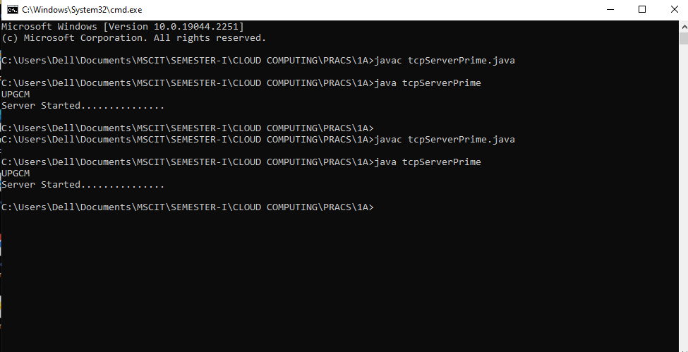

**2.tcpClientPrime.java:**

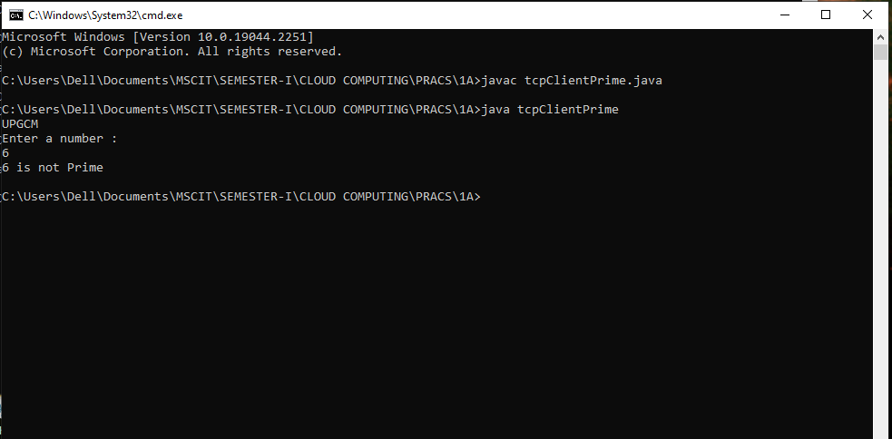

1. **A client server TCP based chatting application.**

**Code:**

**1.ChatServer.java:**

import java.net.*;

import java.io.*;

class ChatServer

{

public static void main(String args[])

{

try

{

ServerSocket ss = new ServerSocket(8000);

System.out.println("UPGCM");

System.out.println("Waiting for client to connect..");

Socket s = ss.accept();

BufferedReader br=new

BufferedReader(new InputStreamReader(System.in));

DataOutputStream out = new DataOutputStream(s.getOutputStream());

DataInputStream in = new DataInputStream(s.getInputStream());

String receive, send;

while((receive = in.readLine()) != null)

{

if(receive.equals("STOP"))

break;

System.out.println("Client Says : "+receive);

System.out.print("Server Says : ");

send = br.readLine();

out.writeBytes(send+"\n");

}

br.close();

in.close();

out.close();

s.close();

}

catch(Exception e)

{

e.printStackTrace();

}

}

}

**2.ChatClient.java:**

import java.net.*;

import java.io.*;

class ChatClient

{

public static void main(String args[])

{

try

{

System.out.println("UPGCM");

Socket s = new Socket("Localhost",8000);

BufferedReader br = new BufferedReader(newInputStreamReader(System.in));

DataOutputStream out = new DataOutputStream(s.getOutputStream());

DataInputStream in = new DataInputStream(s.getInputStream());

String msg;

System.out.println("To stop chatting with server type STOP");

System.out.print("Client Says: ");

while((msg = br.readLine()) != null)

{

out.writeBytes(msg+"\n");

if(msg.equals("STOP"))

break;

System.out.println("Server Says : "+in.readLine());

System.out.print("Client Says : ");

}

br.close();

in.close();

out.close();

s.close();

}

catch(Exception e)

{

e.printStackTrace();

}

}

}

**Output:**

**1.ChatServer.java:**

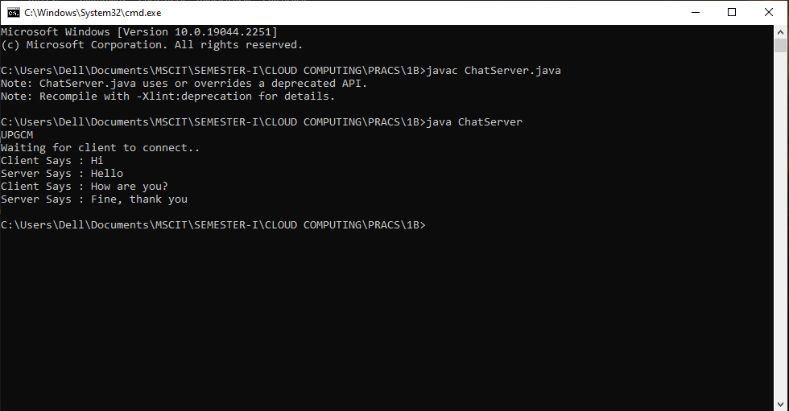

**2.ChatClient.java:**

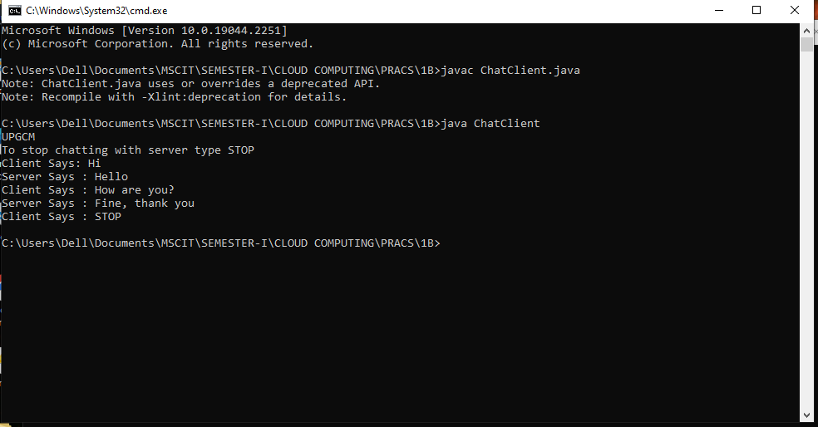

**Practical 2**

**AIM: Write a program for implementing Client Server communication model using UDP**

**A. A client server based program using UDP to find if the number entered is even or odd.**

**Code:**

**1.udpServerEO.java:**

/*Program which finds entered number is even or odd */

import java.io.*;

import java.net.*;

public class udpServerEO {

public static void main(String args[]) {

try {

System.out.println("UPGCM”);

DatagramSocket ds = new DatagramSocket(2000);

byte b[] = new byte[1024];

DatagramPacket dp = new DatagramPacket(b,b.length);

ds.receive(dp);

String str = new String(dp.getData(),0,dp.getLength());

System.out.println(str);

int a= Integer.parseInt(str);

String s= new String();

if (a%2 == 0) s = "Number is even";

else s = "Number is odd";

byte b1[] = new byte[1024];

b1 = s.getBytes();

DatagramPacket dp1 = new

DatagramPacket(b1,b1.length,InetAddress.getLocalHost(),1000);

ds.send(dp1);

}

catch(Exception e)

{

e.printStackTrace();

}

}

}

**2.udpClientEO.java:**

/*Program which finds entered number is even or odd*/

import java.io.*;

import java.net.*;

public class udpClientEO {

public static void main(String args[]) {

try {

System.out.println("UPGCM");

DatagramSocket ds = new DatagramSocket(1000);

BufferedReader br = new BufferedReader(new

InputStreamReader(System.in));

System.out.println("Enter a number : ");

String num = br.readLine();

byte b[] = new byte[1024];

b=num.getBytes();

DatagramPacket dp = new

DatagramPacket(b,b.length,InetAddress.getLocalHost(),2000);

ds.send(dp);

byte b1[] = new byte[1024];

DatagramPacket dp1 = new DatagramPacket(b1,b1.length);

ds.receive(dp1);

String str = new String(dp1.getData(),0,dp1.getLength());

System.out.println(str);

}

catch(Exception e)

{

e.printStackTrace();

}

}

}

**Output:**

**1.udpServerEO.java:**

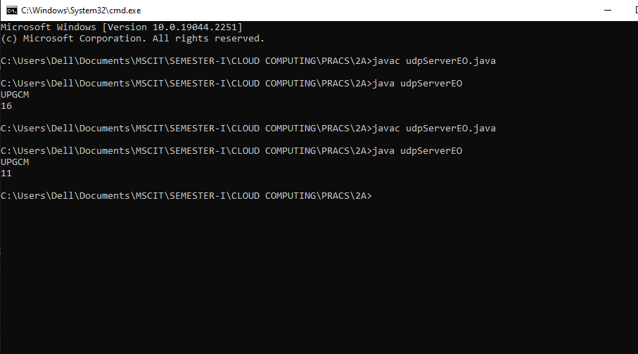

**2.udpClientEO.java:**

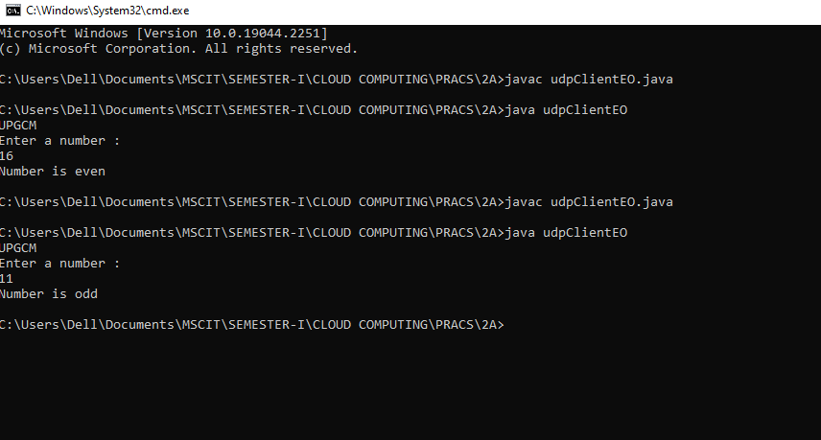

**B. A client server based program using UDP to find the factorial of the entered number.**

**Code:**

**1.udpServerFact.java:**

/*Program which calculate factorial of a number*/

import java.io.*;

import java.net.*;

public class udpServerFact

{

public static void main(String args[])

{

try

{

System.out.println("UPGCM");

DatagramSocket ds = new DatagramSocket(2000);

byte b[] = new byte[1024];

DatagramPacket dp = new DatagramPacket(b,b.length);

ds.receive(dp);

String str = new

String(dp.getData(),0,dp.getLength());

System.out.println(str);

int a= Integer.parseInt(str);

int f = 1, i;

String s= new String();

for(i=1;i<=a;i++)

{

f=f*i;

}

s=Integer.toString(f);

String str1 = "The Factorial of " + str + " is : " + f;

byte b1[] = new byte[1024];

b1 = str1.getBytes();

DatagramPacket dp1 = new

DatagramPacket(b1,b1.length,InetAddress.getLocalHost(),1000);

ds.send(dp1);

}

catch(Exception e)

{

e.printStackTrace();

}

}

}

**2.udpClientFact.java:**

/*Program which calculate factorial of a number*/

import java.io.*;

import java.net.*;

public class udpClientFact

{

public static void main(String args[])

{

try

{

System.out.println("UPGCM");

DatagramSocket ds = new DatagramSocket(1000);

BufferedReader br = new BufferedReader(new InputStreamReader(System.in));

System.out.println("Enter a number : ");

String num = br.readLine();

byte b[] = new byte[1024];

b=num.getBytes();

DatagramPacket dp = new

DatagramPacket(b,b.length,InetAddress.getLocalHost(),2000);

ds.send(dp);

byte b1[] = new byte[1024];

DatagramPacket dp1 = new DatagramPacket(b1,b1.length);

ds.receive(dp1);

String str = new

String(dp1.getData(),0,dp1.getLength());

System.out.println(str);

}

catch(Exception e)

{

e.printStackTrace();

}

}

}

**Output:**

**1.udpServerFact.java**

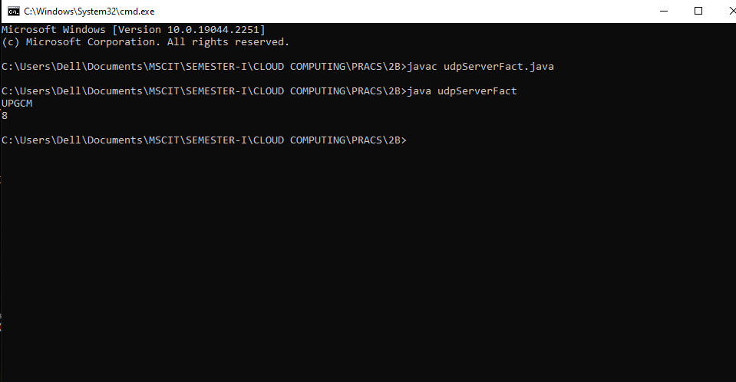

**2.udpClientFact.java:**

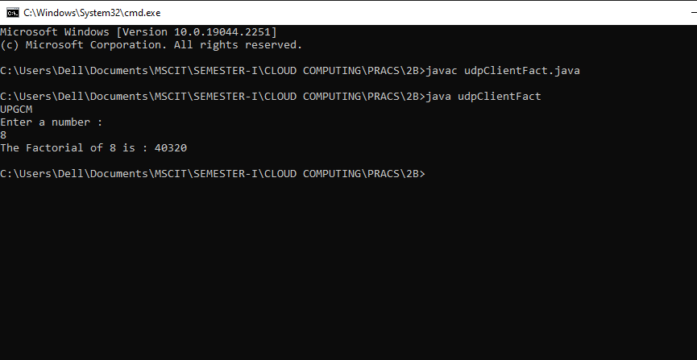

1. **A program to implement simple calculator operations like addition, subtraction, multiplication and division.**

**Code:**

**1.RPCServer.java:**

import java.util.*;

import java.net.*;

class RPCServer

{

DatagramSocket ds;

DatagramPacket dp;

String str,methodName,result;

int val1,val2;

RPCServer()

{

try

{

System.out.println("UPGCM");

ds=new DatagramSocket(1200);

byte b[]=new byte[4096];

while(true)

{

dp=new DatagramPacket(b,b.length);

ds.receive(dp);

str=new String(dp.getData(),0,dp.getLength());

if(str.equalsIgnoreCase("q"))

{

System.exit(1);

}

else

{

StringTokenizer st = new StringTokenizer(str," ");

int i=0;

while(st.hasMoreTokens())

{

String token=st.nextToken();

methodName=token;

val1 = Integer.parseInt(st.nextToken());

val2 = Integer.parseInt(st.nextToken());

}

}

System.out.println(str);

InetAddress ia = InetAddress.getLocalHost();

if(methodName.equalsIgnoreCase("add"))

{

result= "" + add(val1,val2);

}

else if(methodName.equalsIgnoreCase("sub"))

{

result= "" + sub(val1,val2);

}

else if(methodName.equalsIgnoreCase("mul"))

{

result= "" + mul(val1,val2);

}

else if(methodName.equalsIgnoreCase("div"))

{

result= "" + div(val1,val2);

}

byte b1[]=result.getBytes();

DatagramSocket ds1 = new DatagramSocket();

DatagramPacket dp1 = new

DatagramPacket(b1,b1.length,InetAddress.getLocalHost(), 1300);

System.out.println("result : "+result+"\n");

ds1.send(dp1);

}

}

catch (Exception e)

{

e.printStackTrace();

}

}

public int add(int val1, int val2)

{

return val1+val2;

}

public int sub(int val3, int val4)

{

return val3-val4;

}

public int mul(int val3, int val4)

{

return val3*val4;

}

public int div(int val3, int val4)

{

return val3/val4;

}

public static void main(String[] args)

{

new RPCServer();

}

}

**2.RPCClient.java:**

import java.io.*;

import java.net.*;

class RPCClient

{

RPCClient()

{

try

{

System.out.println("UPGCM");

InetAddress ia = InetAddress.getLocalHost();

DatagramSocket ds = new DatagramSocket();

DatagramSocket ds1 = new DatagramSocket(1300);

System.out.println("\nRPC Client\n");

System.out.println("Enter method name and parameter like add 3 4\n");

while (true)

{

BufferedReader br = new

BufferedReader(new InputStreamReader(System.in));

String str = br.readLine();

byte b[] = str.getBytes();

DatagramPacket dp = new

DatagramPacket(b,b.length,ia,1200);

ds.send(dp);

dp = new DatagramPacket(b,b.length);

ds1.receive(dp);

String s = new String(dp.getData(),0,dp.getLength());

System.out.println("\nResult = " + s + "\n");

}

}

catch (Exception e)

{

e.printStackTrace();

}

}

public static void main(String[] args)

{

new RPCClient();

}

}

**Output:**

**1.RPCServer.java:**

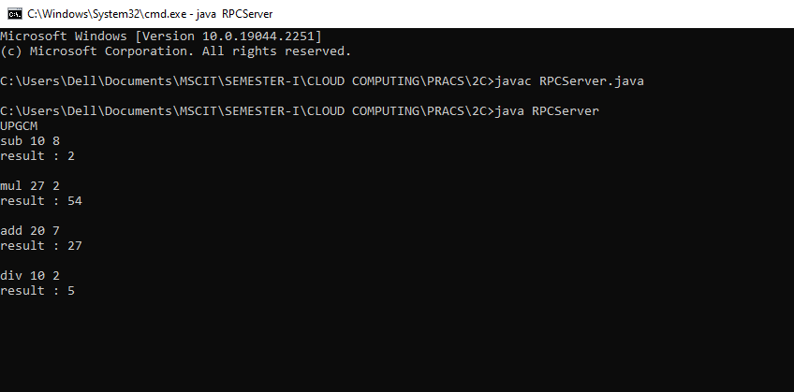

**2.RPCClient.java:**

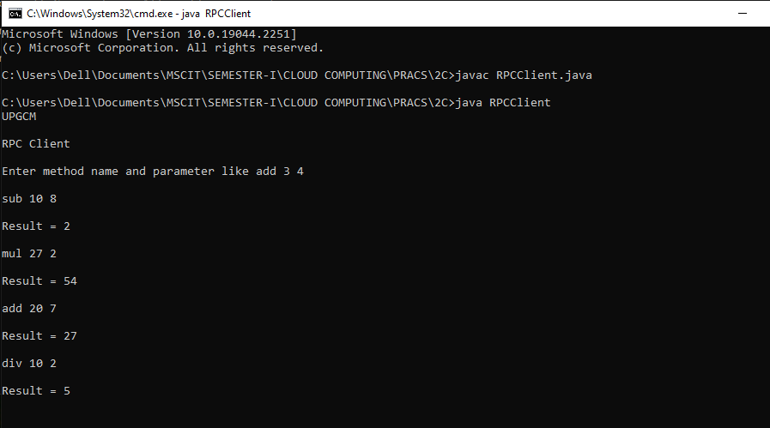

1. **A program that finds the square, square root, cube and cube root of the entered number.**

**Code:**

**1.RPCNumServer.java:**

import java.util.*;

import java.net.*;

import java.io.*;

class RPCNumServer

{

DatagramSocket ds;

DatagramPacket dp;

String str,methodName,result;

int val;

RPCNumServer()

{

try

{

System.out.println("UPGCM");

ds=new DatagramSocket(1200);

byte b[]=new byte[4096];

while(true)

{

dp=new DatagramPacket(b,b.length);

ds.receive(dp);

str=new

String(dp.getData(),0,dp.getLength());

if(str.equalsIgnoreCase("q"))

{

System.exit(1);

}

else

{

StringTokenizer st = new StringTokenizer(str," ");

int i=0;

while(st.hasMoreTokens())

{

String token=st.nextToken();

methodName=token;

val = Integer.parseInt(st.nextToken());

}

}

System.out.println(str);

InetAddress ia = InetAddress.getLocalHost();

if(methodName.equalsIgnoreCase("square"))

{

result= "" + square(val);

}

else if(methodName.equalsIgnoreCase("squareroot"))

{

result= "" + squareroot(val);

}

else if(methodName.equalsIgnoreCase("cube"))

{

result= "" + cube(val);

}

else if(methodName.equalsIgnoreCase("cuberoot"))

{

result= "" + cuberoot(val);

}

byte b1[]=result.getBytes();

DatagramSocket ds1 = new DatagramSocket();

DatagramPacket dp1 = new

DatagramPacket(b1,b1.length,InetAddress.getLocalHost(), 1300);

System.out.println("result : "+result+"\n");

ds1.send(dp1);

}

}

catch (Exception e)

{

e.printStackTrace();

}

}

public double square(int a) throws Exception

{

double ans;

ans = a*a;

return ans;

}

public double squareroot(int a) throws Exception

{

double ans;

ans = Math.sqrt(a);

return ans;

}

public double cube(int a) throws Exception

{

double ans;

ans = a*a*a;

return ans;

}

public double cuberoot(int a) throws Exception

{

double ans;

ans = Math.cbrt(a);

return ans;

}

public static void main(String[] args)

{

new RPCNumServer();

}

}

**2.RPCNumClient.java:**

import java.io.*;

import java.net.*;

class RPCNumClient

{

RPCNumClient()

{

try

{

System.out.println("UPGCM");

InetAddress ia = InetAddress.getLocalHost();

DatagramSocket ds = new DatagramSocket();

DatagramSocket ds1 = new DatagramSocket(1300);

System.out.println("\nRPC Client\n");

System.out.println("1. Square of the number - square\n2. Square root of the number - squareroot\n3.Cube of the number - cube\n4. Cube root of the number -cuberoot");

System.out.println("Enter method name and the number\n");

while (true)

{

BufferedReader br = new

BufferedReader(new InputStreamReader(System.in));

String str = br.readLine();

byte b[] = str.getBytes();

DatagramPacket dp = new

DatagramPacket(b,b.length,ia,1200);

ds.send(dp);

dp = new DatagramPacket(b,b.length);

ds1.receive(dp);

String s = new String(dp.getData(),0,dp.getLength());

System.out.println("\nResult = " + s + "\n");

}

}

catch (Exception e)

{

e.printStackTrace();

}

}

public static void main(String[] args)

{

new RPCNumClient();

}

}

**Output:**

**1.RPCNumServer.java:**

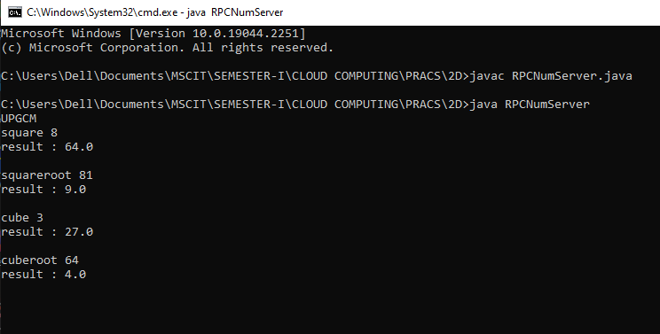

**2.RPCNumClient.java:**

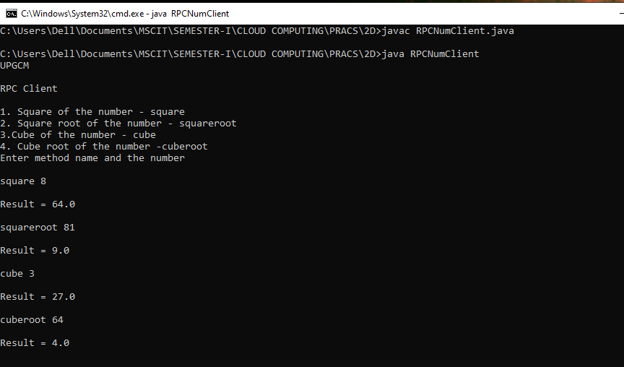

**Practical 3**

**AIM:** **A multicast Socket example.**

**3. Write a program for implementing Multicast Socket example**

**Code:**

1. **BroadcastServer.java:**

import java.net.*;

import java.io.*;

import java.util.*;

public class BroadcastServer

{

public static final int PORT = 1234;

public static void main(String args[])throws

Exception {

MulticastSocket socket;

DatagramPacket packet;

InetAddress address;

System.out.println("UPGCM");

// set the multicast address to your local subnet

address = InetAddress.getByName("239.1.2.3");

socket = new MulticastSocket();

// join a Multicast group and send the group messages

socket.joinGroup(address);

byte[] data = null;

for(;;)

{

Thread.sleep(10000);

System.out.println("Sending ");

String str = ("This is Neha Calling....");

data = str.getBytes();

packet = new DatagramPacket(data, str.length(),address,PORT);

// Sends the packet

socket.send(packet);

} // end for

} // end main

} // end class BroadcastServer

1. **BroadcastClient.java:**

import java.net.*;

import java.io.*;

public class BroadcastClient

{

public static final int PORT = 1234;

public static void main(String args[])throws

Exception {

MulticastSocket socket;

DatagramPacket packet;

InetAddress address;

System.out.println("UPGCM");

// set the mulitcast address to your local subnet

address = InetAddress.getByName("239.1.2.3");

socket = new MulticastSocket(PORT);

//join a Multicast group and wait for a message

socket.joinGroup(address);

byte[]

data = new byte[100];

packet = new DatagramPacket(data,data.length);

for(;;)

{

// receive the packets

socket.receive(packet);

String str = new String(packet.getData());

System.out.println("Message received from " +packet.getAddress() + "Message is : "+str);

} // for

} // main

} // end BroadcastClient

**Output:**

**1.BroadcastServer.java:**

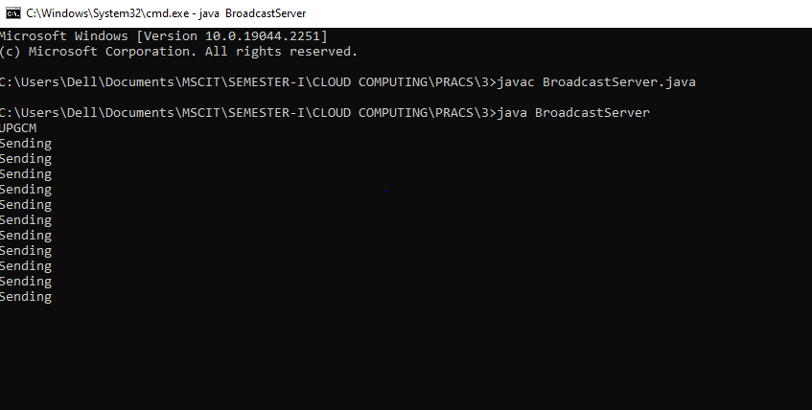

**2.BroadcastClient.java:**

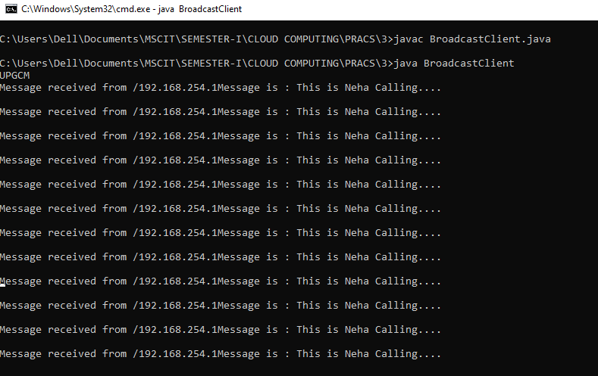

**Practical 4**

**AIM:** **Write a program to show the object communication using RMI.**

**A. A RMI based application program to display current date and time.**

**Code:**

**1.InterDate.java:**

import java.rmi.*;

public interface InterDate extends Remote

{

public String display() throws Exception;

}

**2.ServerDate.java:**

import java.rmi.*;

import java.rmi.server.*;

import java.util.*;

public class ServerDate extends UnicastRemoteObject implements

InterDate {

public ServerDate() throws Exception

{

System.out.println("UPGCM");

}

public String display() throws Exception

{

String str = "";

Date d = new Date();

str = d.toString();

return str;

}

public static void main(String args[]) throws

Exception {

ServerDate s1 = new ServerDate();

Naming.bind("DS",s1);

System.out.println("Object registered.....");

}

}

**3.ClientDate.java:**

import java.rmi.*;

import java.io.*;

public class ClientDate

{

public static void main(String args[]) throws

Exception {

String s1;

InterDate h1 = (InterDate)Naming.lookup("DS");

s1 = h1.display();

System.out.println(s1);

System.out.println("UPGCM");

}

}

**Output:**

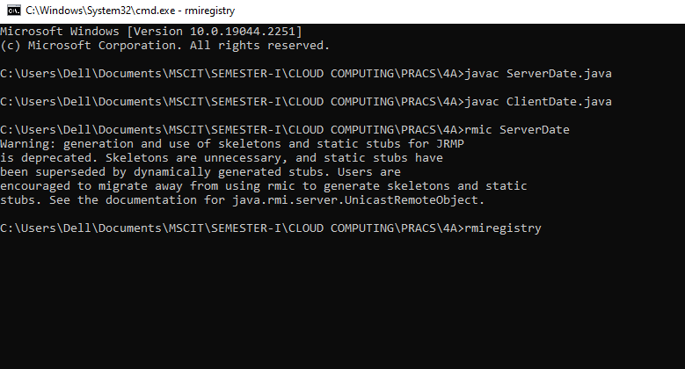

**1.ServerDate.java:**

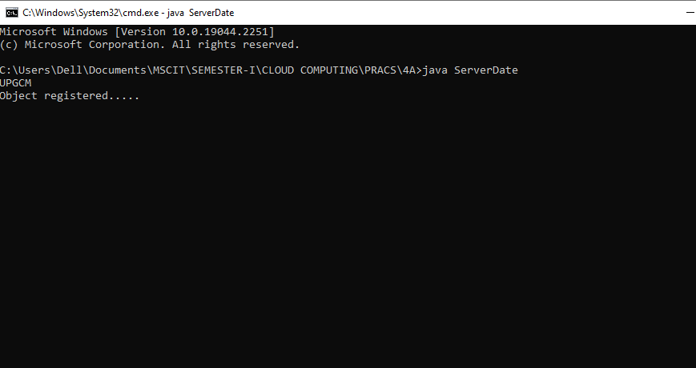

**2.ClientDate.java:**

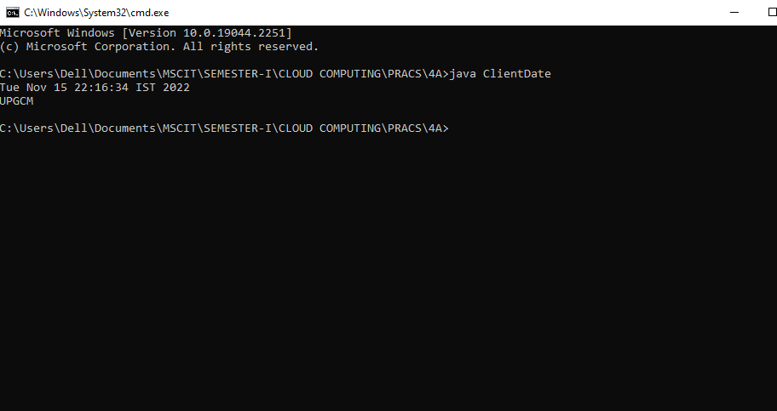

**B. A RMI based application program that converts digits to words, e.g. 123 will be converted to one two three.**

**Code:**

**1.InterConvert.java:**

import java.rmi.*;

public interface InterConvert extends Remote

{

public String convertDigit(String no) throws Exception;

}

**2.ServerConvert.java:**

import java.rmi.*;

import java.rmi.server.*;

public class ServerConvert extends UnicastRemoteObject implements

InterConvert {

public ServerConvert() throws Exception

{

}

public String convertDigit(String no) throws Exception

{

String str = "";

for(int i = 0; i < no.length(); i++)

{

int p = no.charAt(i);

if( p == 48)

{

str += "zero ";

}

if( p == 49)

{

str += "one ";

}

if( p == 50)

{

str += "two ";

}

if( p == 51)

{

str += "three ";

}

if( p == 52)

{

str += "four ";

}

if( p == 53)

{

str += "five ";

}

if( p == 54)

{

str += "six ";

}

if( p == 55)

{

str += "seven ";

}

if( p == 56)

{

str += "eight ";

}

if( p == 57)

{

str += "nine ";

}

}

return str;

}

public static void main(String args[]) throws

Exception {

ServerConvert s1 = new ServerConvert();

Naming.bind("Wrd",s1);

System.out.println("Object registered....");

System.out.println("UPGCM");

}

}

**3.ClientConvert.java:**

import java.rmi.*;

import java.io.*;

public class ClientConvert

{

public static void main(String args[]) throws

Exception {

InterConvert h1 = (InterConvert)Naming.lookup("Wrd");

BufferedReader br = new BufferedReader(new InputStreamReader(System.in));

System.out.println("Enter a number : \t");

String no = br.readLine();

String ans = h1.convertDigit(no);

System.out.println("The word representation of the entered digit is : " +ans);

System.out.println("UPGCM");

}

}

**Output:**

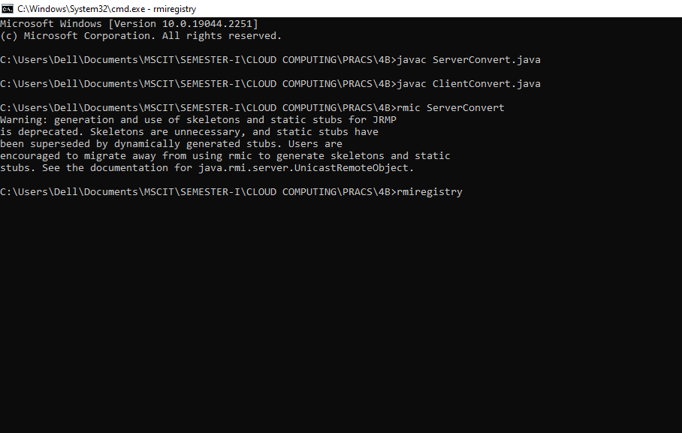

**1.ServerConvert.java:**

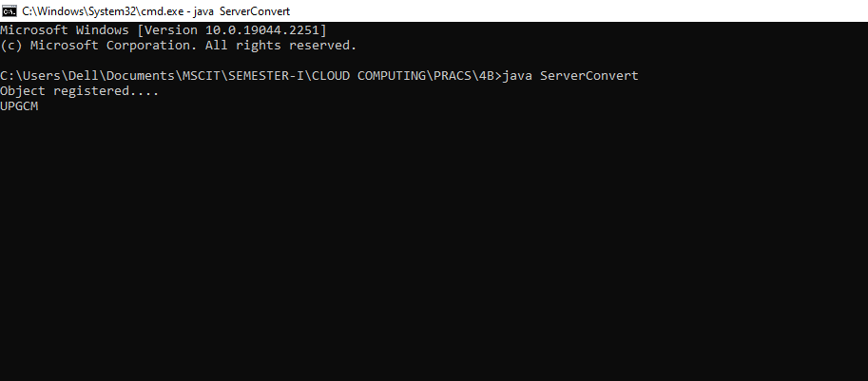

**2.ClientConvert.java:**

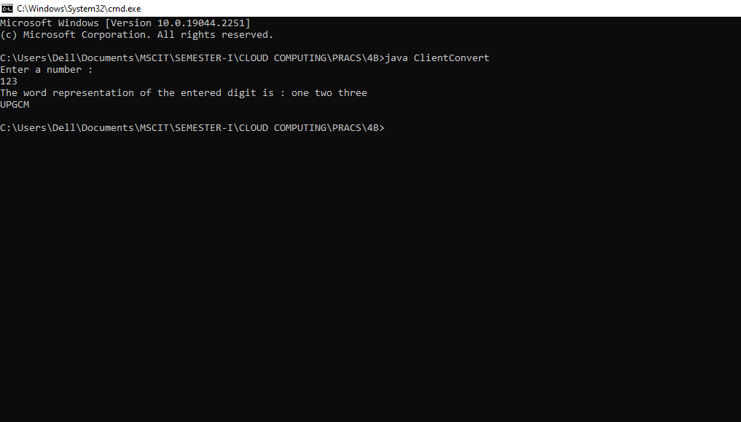

**Practical 5**

**Aim:** **Show the implementation of web services.**

1. **Implementing “Big” Web Service**

**1) Creating a Web Service**

A. Choosing a Container:

1. Choose File > New Project. Select Web Application from the Java Web

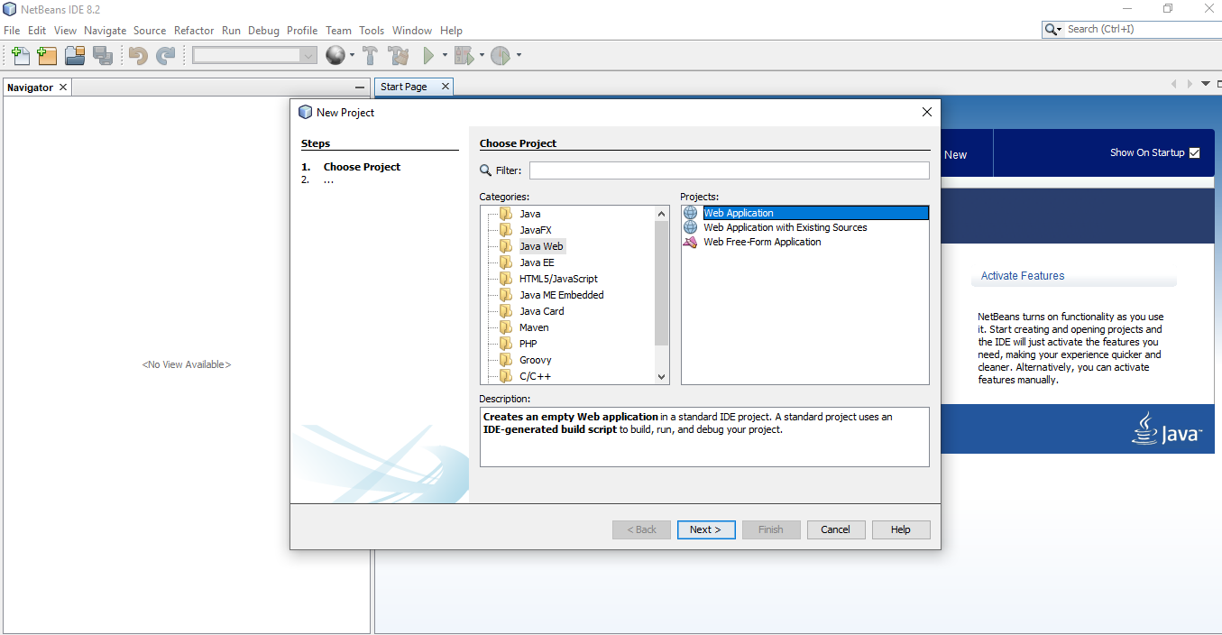

1. Name the project CalculatorWSApplication. Select a location for the project. Click Next.

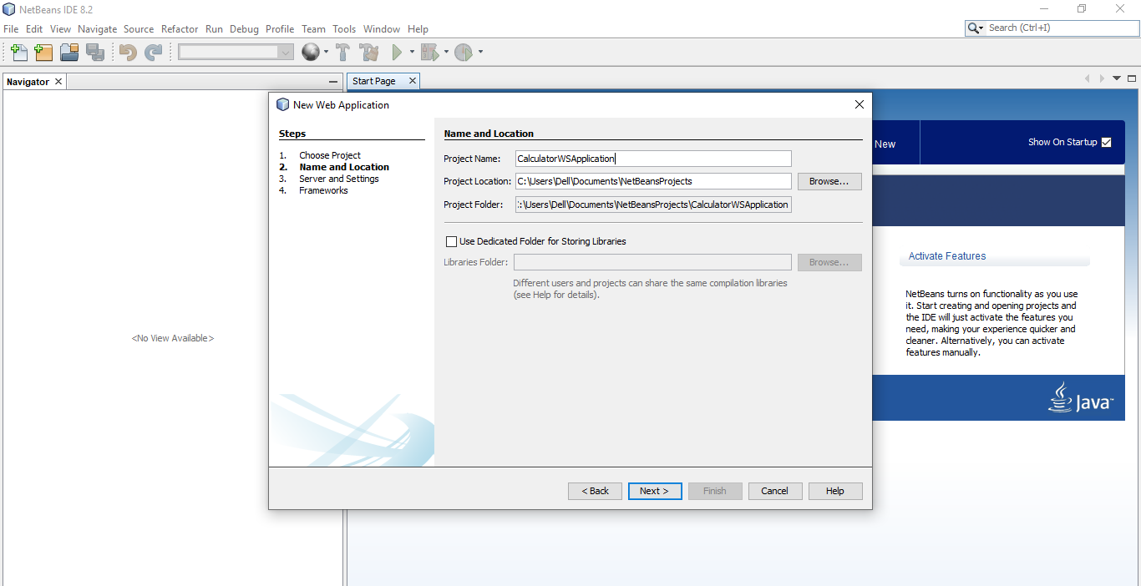

1. Select your server and Java EE version and click Finish.
2. **Creating a Web Service from a Java Class**
3. Right-click the CalculatorWSApplication node and choose New > Web Service.

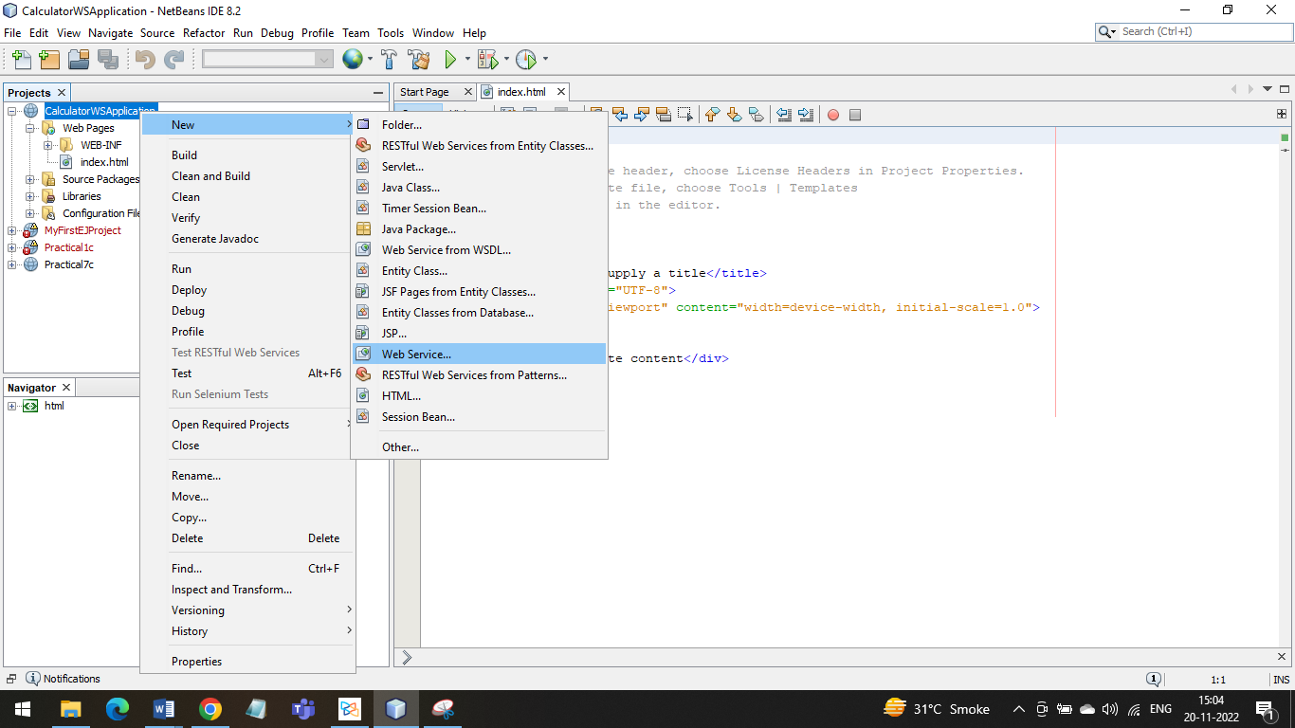

2.Name the web service CalculatorWS and type org.me.calculator in Package. Leave Create Web Service from Scratch selected. If you are creating a Java EE 6 project on GlassFish or WebLogic, select Implement Web Service as a Stateless Session Bean

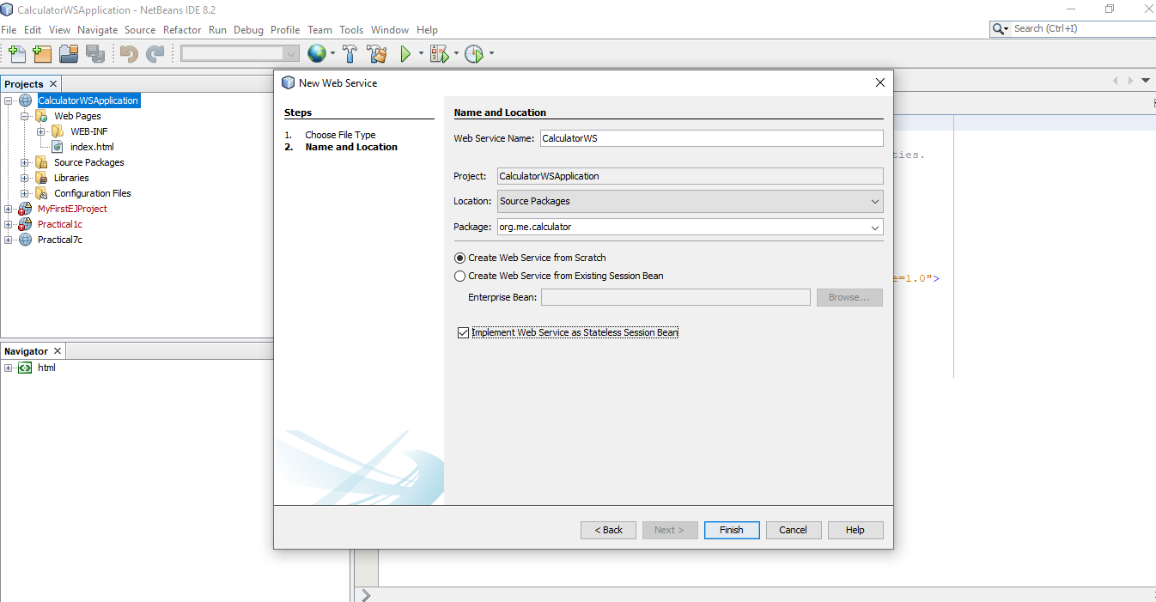

3.Click Finish. The Projects window displays the structure of the new web service and the source code is shown in the editor area

**2) Adding an Operation to the Web Service**

A. To add an operation to the web service:

1. Change to the Design view in the editor.

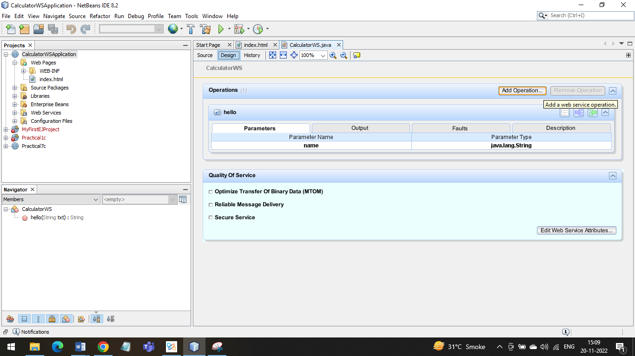

2.Click Add Operation in either the visual designer or the context menu. The Add Operation dialog opens.

3. In the upper part of the Add Operation dialog box, type add in Name and type int in the Return Type drop-down list.

4.In the lower part of the Add Operation dialog box, click Add and create a parameter of type int named i.

5.Click Add again and create a parameter of type int called j. You now see the following:

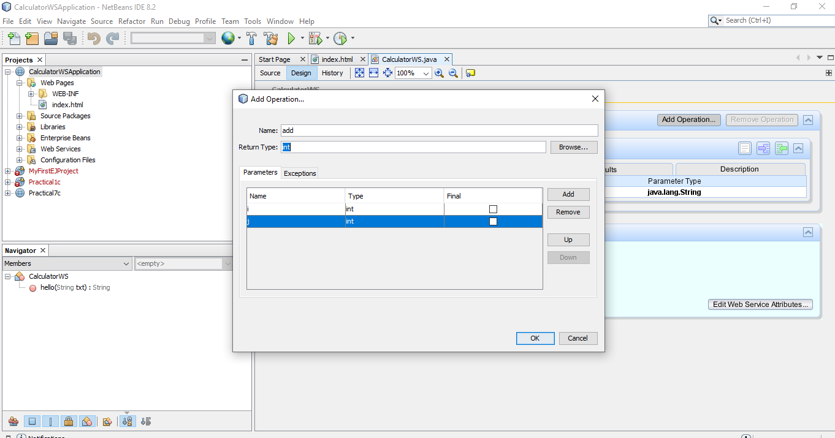

6. Click OK at the bottom of the Add Operation dialog box. You return to the editor.

7.The visual designer now displays the following:

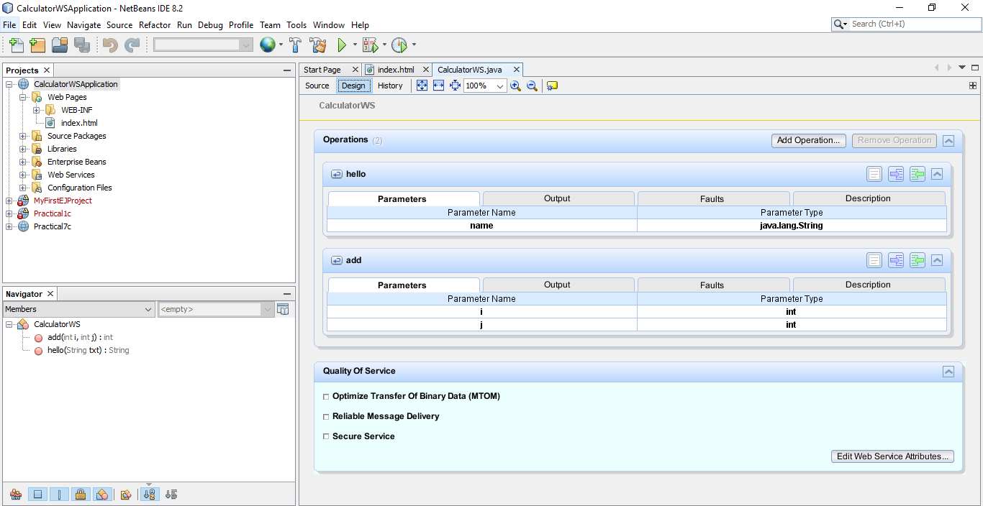

8. Click Source. And code the following.

@WebMethod(operationName = "add") public int add(@WebParam(name = "i") int i, @WebParam(name = "j") int j)

{

int k = i + j; return k;

}

**3) Deploying and Testing the Web Service**

A.To test successful deployment to a GlassFish or WebLogic server:

1. Right-click the project and choose Deploy. The IDE starts the application server, builds the application, and deploys the application to the server

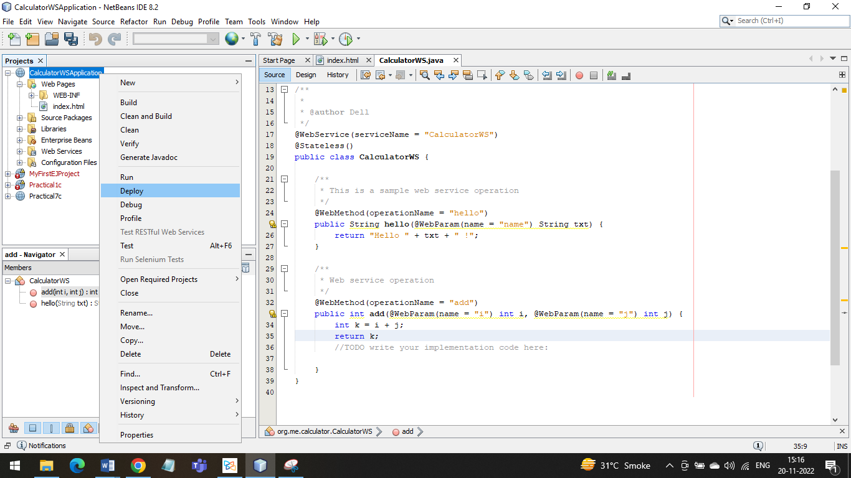

2.In the IDE's Projects tab, expand the Web Services node of the CalculatorWSApplication project. Right-click the CalculatorWS node, and choose Test Web Service

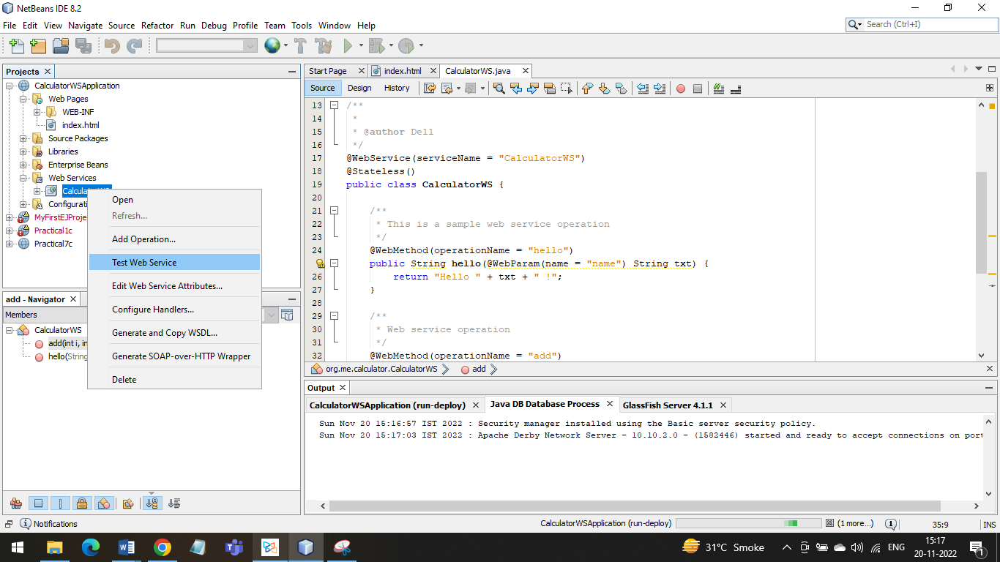

3. The IDE opens the tester page in your browser, if you deployed a web application to the GlassFish server.

4.If you deployed to the GlassFish server, type two numbers in the tester page, as shown below:

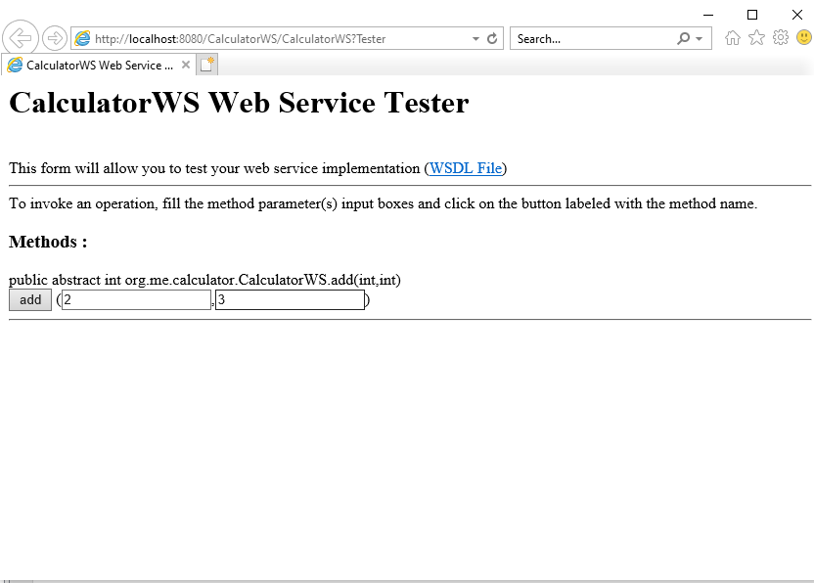

5.The sum of the two numbers is displayed

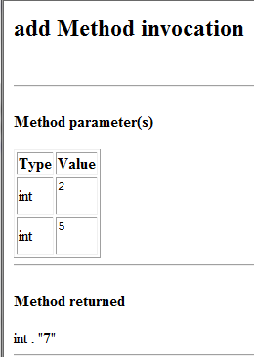

**4) Consuming the Web Service**

1. Client: Java Class in Java SE Application

2. Choose File > New Project. Select Java Application from the Java category. Name the project CalculatorWS_Client_Application. Leave Create Main Class selected and accept all other default settings. Click Finish.

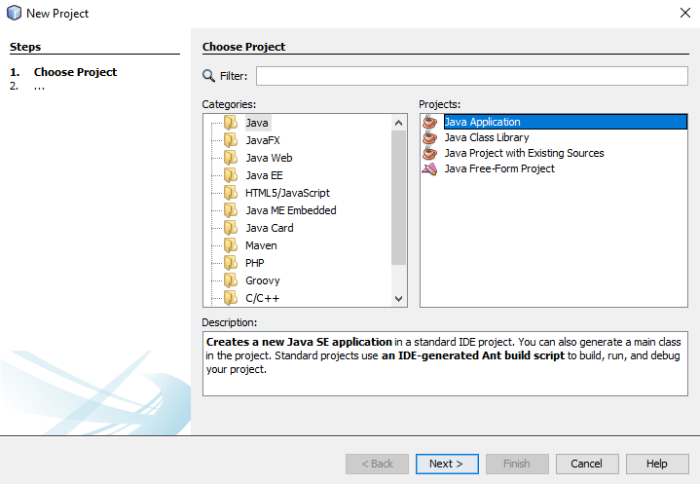

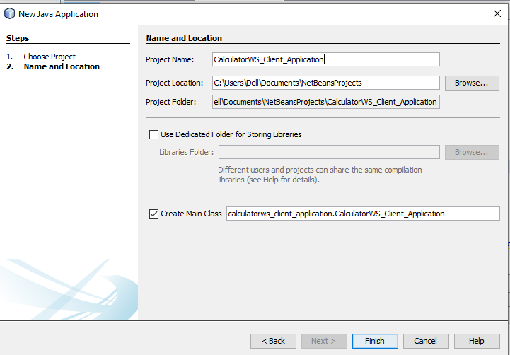

3.Right-click the CalculatorWS_Client_Application node and choose New > Web Service Client. The New Web Service Client wizard opens.

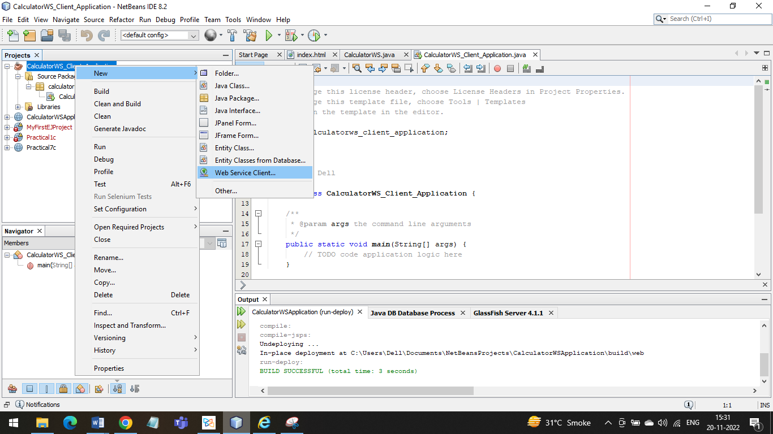

4.Select Project as the WSDL source. Click Browse. Browse to the CalculatorWS web service in the CalculatorWSApplication project. When you have selected the web service, click OK.

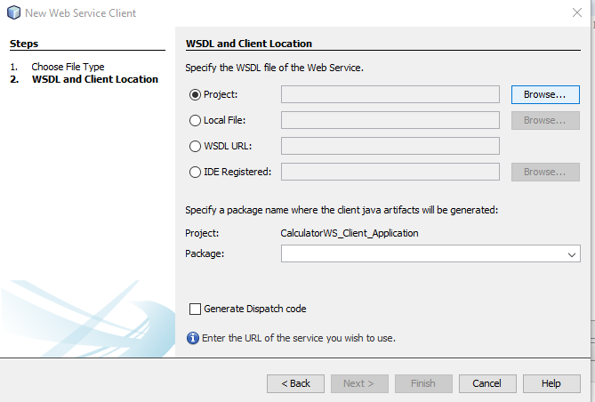

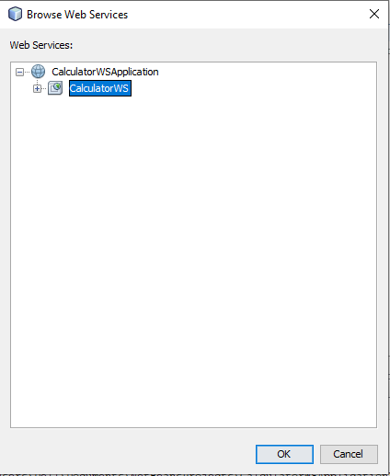

5.Do not select a package name. Leave this field empty.

6. Leave the other settings at default and click Finish. The Projects window displays the new web service client, with a node for the add method that you created:

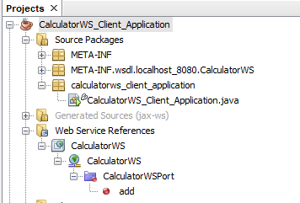

7..Double-click your main class so that it opens in the Source Editor. Drag the add node below the main() method.

You now see the following:

public static void main(String[] args) {

// TODO code application logic here }

private static int add(int i, int j) {

org.me.calculator.CalculatorWS_Service

service= new

org.me.calculator.CalculatorWS_Service();

org.me.calculator.CalculatorWS

port = service.getCalculatorWSPort(); return port.add(i, j);

}

8.. In the main() method body, replace the TODO comment with code that initializes values for i and j, calls add(), and prints the result.

public static void main(String[] args) {

int i = 3;

int j = 4;

int result = add(i, j);

System.out.println("Result = " + result);

}

9. Surround the main() method code with a try/catch block that prints an exception.

10. Right-click the project node and choose Run.

The Output window now shows the sum: compile: run:

Result = 7 BUILD SUCCESSFUL (total time: 1 second**)**

**B. Implementing Web Service that connects to MySQL** **database.**

**1. Creating MySQL DB Table**

create database bookshop;

use bookshop;

1. Create a table named Books that will store valid books information
2. Create table books(isbn varchar(20) primary key, bookname varchar(100), bookprice varchar(10));
3. Insert valid records in the Books table

insert into books values("111-222-333","Learn My SQL","250");

insert into books values("111-222-444","Java EE 6 for Beginners","850");

insert into books values("111-222-555","Programming with Android","500");

insert into books values("111-222-666","Oracle Database for you","400");

insert into books values("111-222-777","Asp.Net for advanced programmers","1250");

**2. Creating a web service**

1. Choosing a container
2. Creating a web application
3. To create a Web application, select File - New Project.

New Project dialog box appears.

1. Select Java Web available under the Categories section and Web Application available under the Projects section. Click Next
2. New Web Application dialog box appears. Enter BookWS as the project name in the Project Name textbox and select the option Use Dedicated Folder for Storing Libraries.
3. Click Next. Server and Settings section of the New Web Application dialog box appears. Choose the default i.e. GlassFish v3 Domain as the Web server, the Java EE 6 Web as the Java EE version and the Context Path.
4. Click –Finish

The Web application named BookWS is created**.**

1. Creating a web service

Right-click the BookWS project and select New -> Web Service as shown in diagram

New Web Service dialog box appears. Enter the name BookWS in the Web Service Name textbox, webservice in the Package textbox, select the option Create Web Service from scratch and also select the option implement web service as a stateless session bean as shown in the diagram.

Click Finish. The web service in the form of java class is ready.

1. **Designing the web service**

Now add an operation which will accept the ISBN number from the client to the web service.

1. Adding an operation to the web service
2. Change the source view of the BookWS.java to design view by clicking Design available just below the name of the BookWS.java tab.

1. The window changes as shown in the diagram.

Click Add Operation available in the design view of the web service.

1. Add Operation dialog appears. Enter the name getBookDetails in the Name textbox and java.lang.String in the Return Type textbox as shown in the diagram.
2. In Add Operation dialog box, click Add and create a parameter of the type String named isbn as shown in the diagram.
3. Click Ok. The design view displays the operation added as shown in the diagram.
4. Click Source. The code spec expands due to the operation added to the web service as shown in the diagram.
5. Modify the code spec of the web service BookWS.java.

package webservice;

import java.sql.*;

import javax.jws.WebMethod;

import javax.jws.WebParam;

import javax.jws.WebService;

import javax.ejb.Stateless;

@WebService() @Stateless() public class BookWS

{ /**

* Web service operation */

@WebMethod(operationName = "getBookDetails") public String getBookDetails(@WebParam(name = "isbn") String isbn)

{

//TODO write your implementation code here:

Connection dbcon= null;

Statement stmt = null; ResultSet rs = null;

String query = null; try {

Class.forName("com.mysql.jdbc.Driver").newInstance();

dbcon =

DriverManager.getConnection("jdbc:mysql://localhost/bookshop","root","123");

stmt = dbcon.createStatement();

query = "select * from books where isbn = '" +isbn+ "'"; rs = stmt.executeQuery(query);

rs.next();

String bookDetails = "<h1>The name of the book is <b>"+rs.getString("bookname") + "</b> and its cost is <b>" +rs.getString("bookprice") + "</b></h1>.";

return bookDetails;

}

catch(Exception e) {

System.out.println("Sorry failed to connect to the database.." + e.getMessage());

}

return null;

}

}

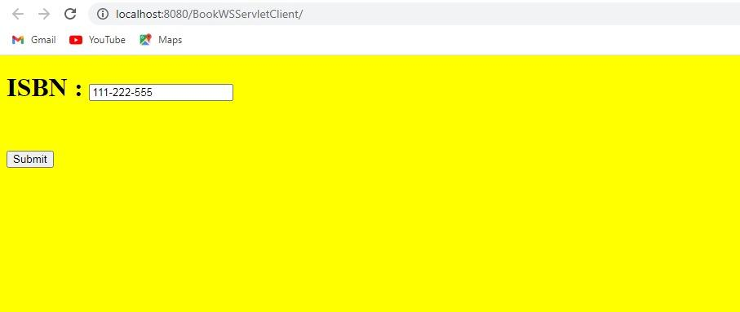

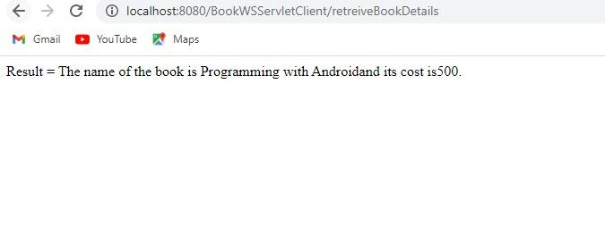

**4. Adding the MySQL connector**

1. We need to add a reference of MySQL connector to our web service. It is via this connector that our web service will be able to communicate with the database.
2. Right click on the libraries and select Add JAR/Folder as shown in the diagram.
3. Choose the location where mysql-coonector-java-5.1.10-bin is located, select it and click on open as shown.

**5. Deploying and testing the web service**

1. To test the BookWS application, right click the BookWS project and select Deploy as shown in the diagram
2. The IDE starts the server, builds the application and deploys the application to the server.
3. Follow the progress of these operations in the BookWS (run-deploy) and GlassFish v3 Domain tabs in the Output view.
4. Now expand the web services directory of the BookWS project, right-click the BookWS Web service and select Test web service as shown in the diagram.
5. The IDE opens the tester page in the web browser, if the web application is deployed using GlassFish server as shown in the figure.
6. Enter the ISBN number as shown in the diagram.
7. Click getBookDetails. The book name and its cost are displayed as shown in the diagram.

**6. Consuming the web service**

1. Creating a web application
2. To create a web application, select File -> New Project.

New project dialog box appears, select java web available under the categories section and web application available under the projects section. Click Finish.

1. New web application dialog box appears. Enter BookWSServletClient as the project name in the Project Name textbox and select the option Use Dedicated Folder for Storing Libraries.
2. Click Next. Server and settings section of the new web application, dialog box appears.
3. Choose the default i.e. GlassFish v3 Domain as the web server, the Java EE 6 web as the Java EE version and the context path.

Click Finish.

1. The web application named BookWSServletClient is created.

ii. Adding the web service to the client application

1)Right-click the BookWSServletClient project and select New -> Web Service Client as shown in the diagram.

2)New Web Service Client dialog box appears. In the Project section, click Browse and browse through the web service which needs to be consumed. Click ok. The name of the web service appears in the New Web Service Client as shown in the diagram.

3)The Web Service Reference directory is added to the BookWSServletClient application as shown in the diagram. Itdisplays the structure of the newly created client including the getBookDetails() method created earlier

iii.Creating a servlet

1)Right click source package directory, select New -> Servlet.

2)New Servlet dialog box appears. Enter retreiveBookDetails in the Class Name textbox and enter servlet in the package textbox.

3)Click Next. Configure Servlet Deployment section of the New Servlet dialog box appears. Keep the defaults.

4)Click Finish. This creates the servlet named retreiveBookDetails.java in the servlet package.

In the retreieveBookDetails.java source code, remove the following comments available in the body of the processRequest() method.

/*TODO output your page here*/ Replace the following code spec: out.println("<h1>Servlet retreiveBookDetails at " + request.getContextPath () + "</h1>");

The web service is instantiated by the @WebServiceRef annotation.

Now change the following code spec: java.lang.String isbn = “”; to

java.lang.String isbn = request.getParameter(“isbn”);

iv. Creating an HTML form

Since NetBeans IDE by default [as a part of Web Application creation] makes available index.jsp file. Modify it to hold the following code spec.

<%@page contentType="text/html" pageEncoding="UTF-8"%> <!DOCTYPE HTML PUBLIC "-//W3C//DTD HTML 4.01 Transitional//EN"

"http://www.w3.org/TR/html4/loose.dtd">

<html>

<head>

<meta http-equiv="Content-Type" content="text/html; charset=UTF-8"> <title>SOAP Cleint - Get Book Details</title>

</head> <

body bgcolor="pink">

<form name="frmgetBookDetails" method="post" action="retreiveBookDetails">

<h1> ISBN : <input type="text" name="isbn"/><br><br>

</h1> <input type="submit" value="Submit"/>

</form>

</body>

</html>

v.Building the Web Application

Build the web application.

1. Right click BookWSServletClient project and select Build.

Once the Build menu item is clicked the details about the compilation and building of the BookWSServletClient Webapplication appears in the output – BookWSServletClient (dist) window.

vi. Running the Application

Once the compilation and building of the web application is done run the application.

1)Right click the BookWSServerCleint project and select run.

Once the run processing completes in NetBeans IDE a web browser is automatically launched and the BookWSServletCleint application is executed as shown in the diagram.

2) Enter the ISBN as shown in the diagram

3)Click Submit. The book name and its cost are displayed as shown in the diagram.

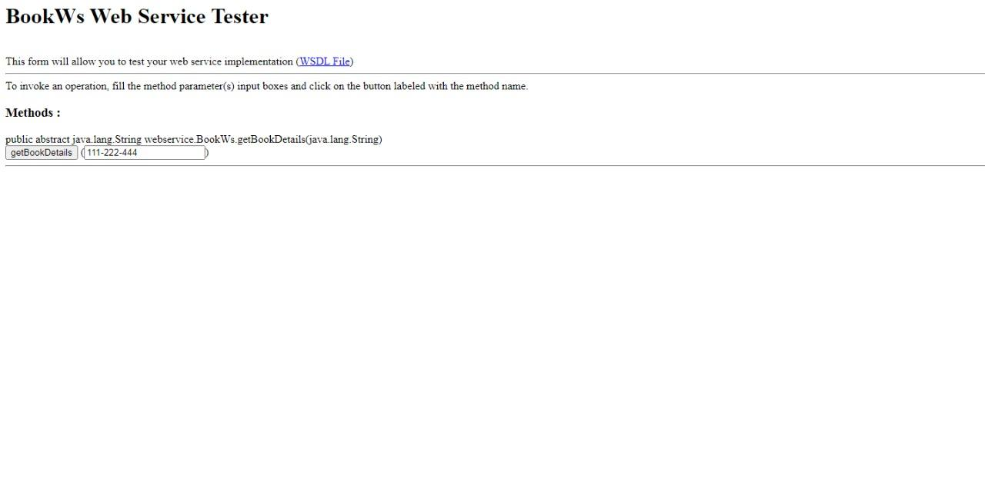

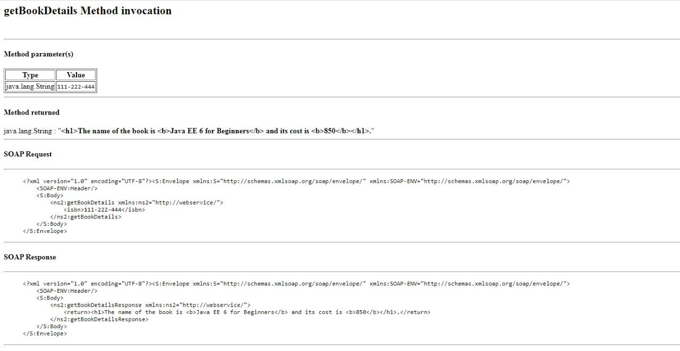

**Practical 6**

**Aim: Implement Xen virtualization and manage with Xen Center**

Step 1: Open **VMWare Workstation** and create a new Virtual Machine

-> Click on Next

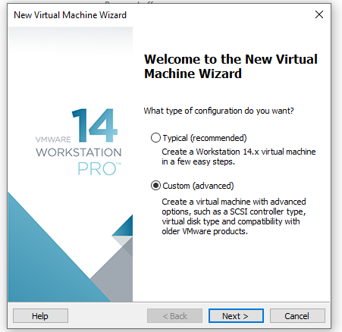

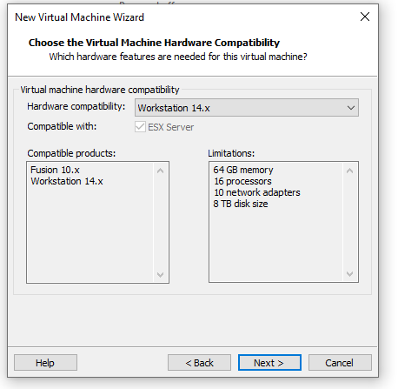

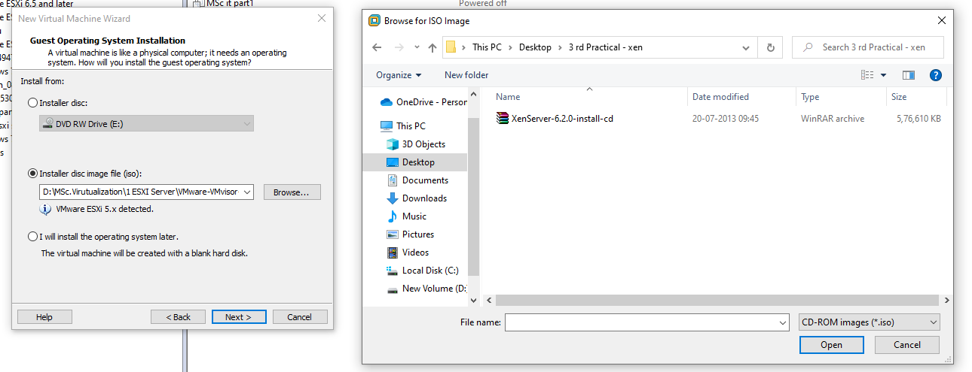

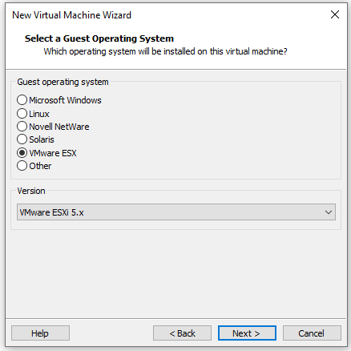

-> Select **Custom (advanced)** and click **Next**

-> Set Hardware compatibility to **Workstation 12.x** and click **Next**

->Then select ‘Installer disc image file iso’ and browse location for Xen server.

->Select the guest operating system as **VMware ESX** ,Version **VMware ESXi 5**

-> Set a name to the virtual machine and click Next

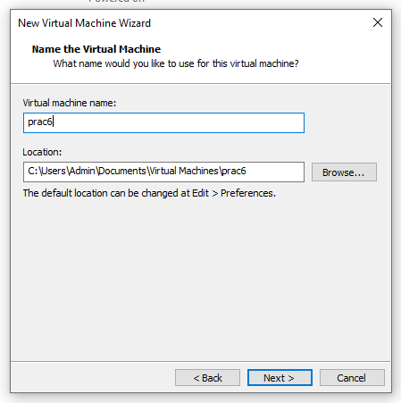

->Set the following

-> Set the memory to 2GB , click Next.

-> Click on **Use host only networking**

-> Select the I/O controller type as **LSI Logic SAS**

-> Select the disk type as **SCS**I which is recommended.

->Then select **Create a new virtual disk** and next.

->Select **Split virtual disk into multiple files**

-> click Finish

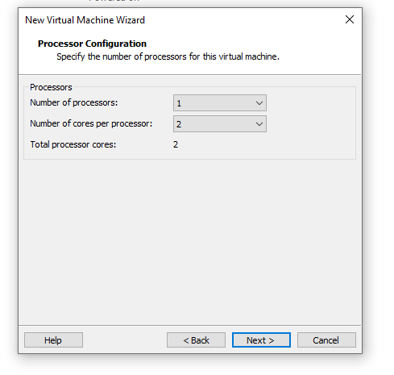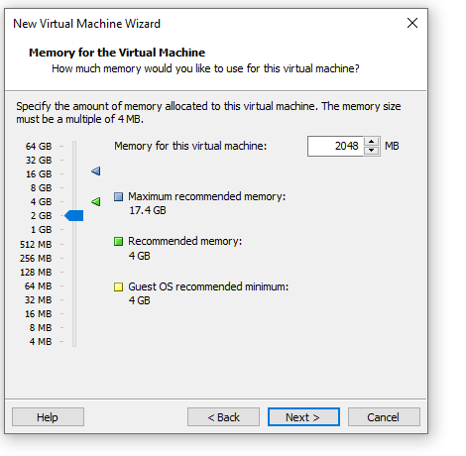

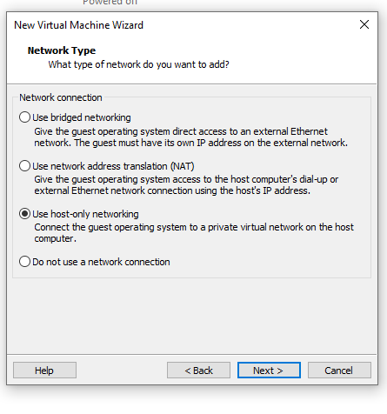

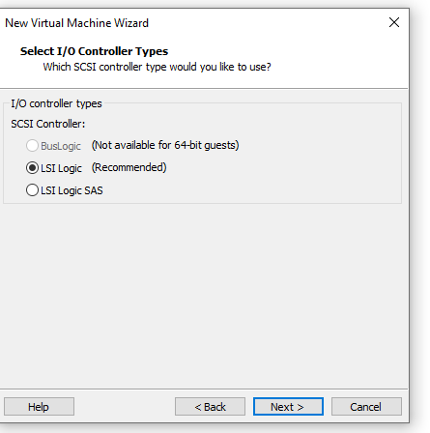

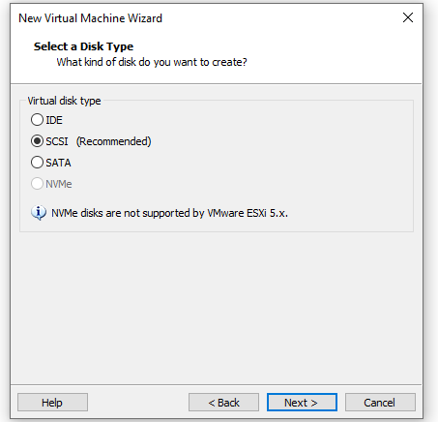

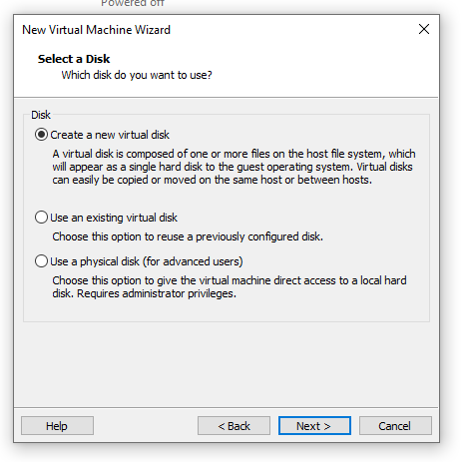

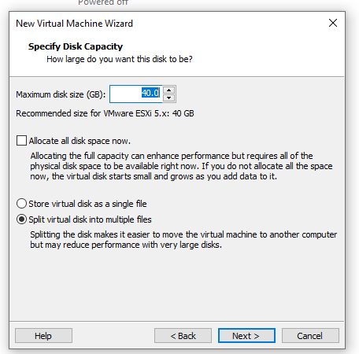

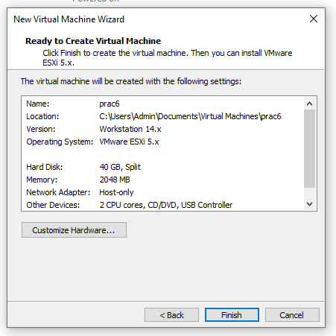

Step 2: Installation

-> Power on the machine and let the Xen server begin

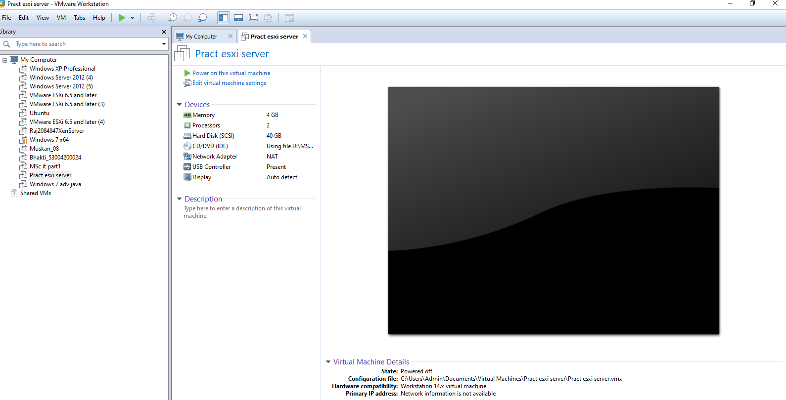

-> A Xen Server Setup dialogue box appears , click on **OK**

-> **Accept** EULA License agreement

-> Then select both : **sda -40 GB**

**Enable thin provisioning** and click OK

->Select the type of source for installation as Local media

->select Yes to install any supplemental packs

-> Verify the installation source and click OK once done

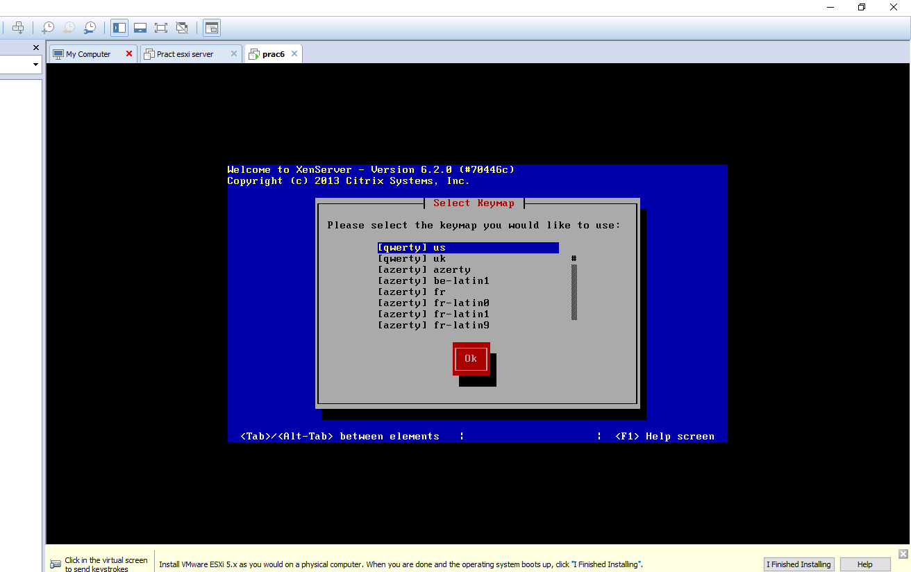

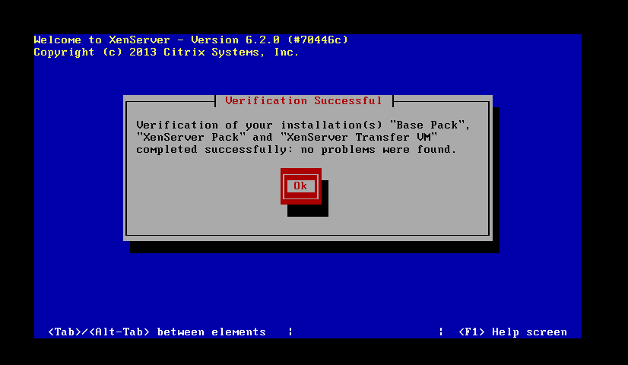

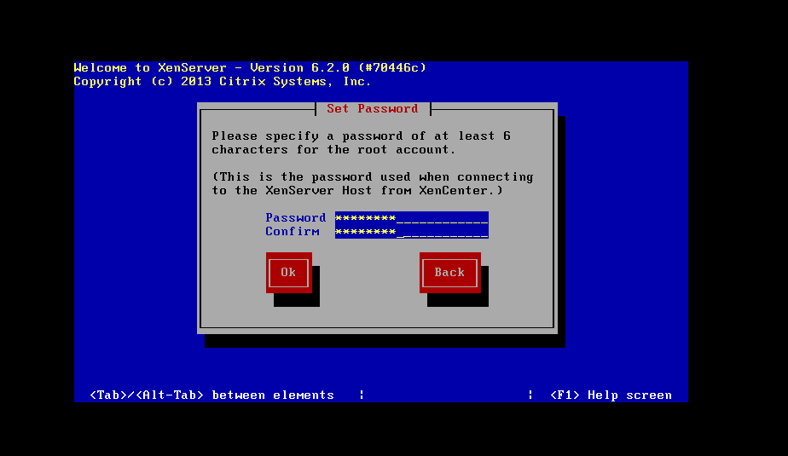

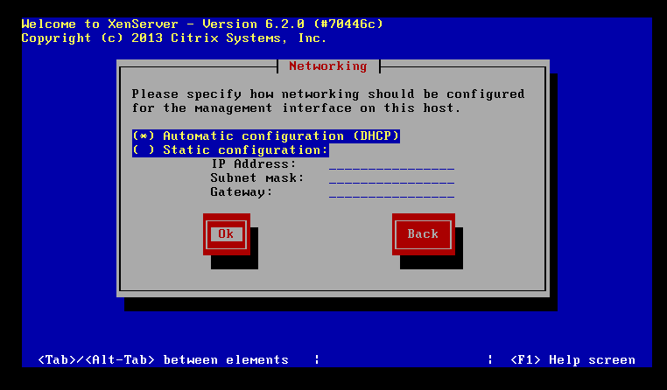

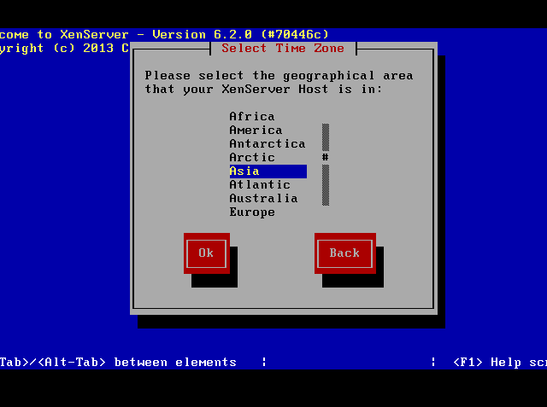

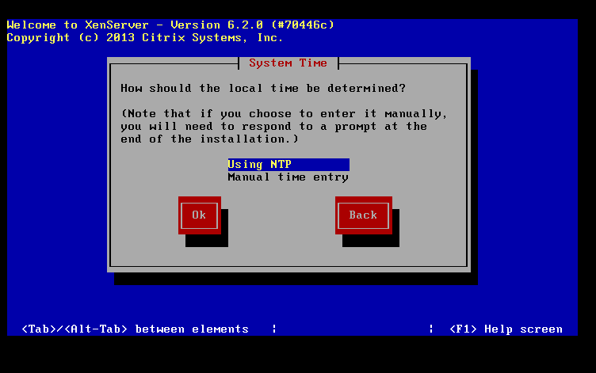

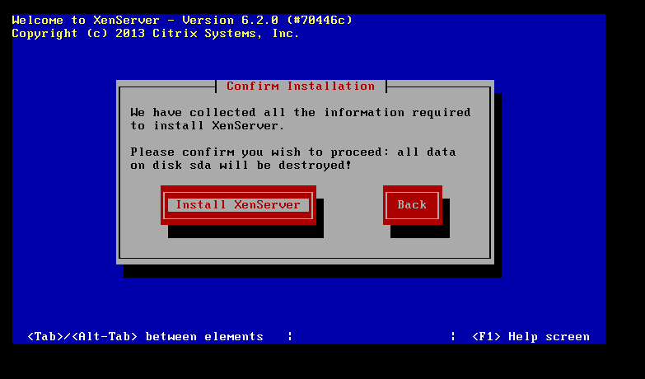

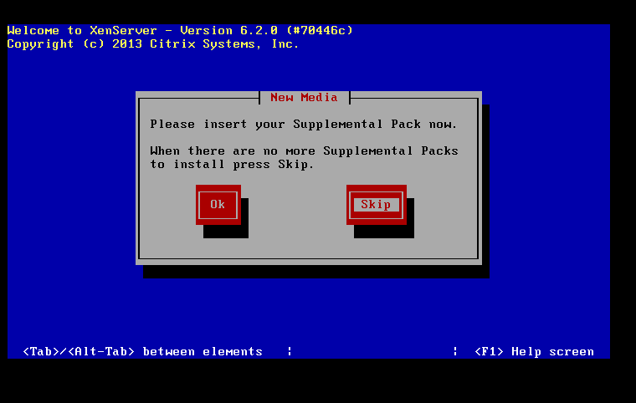

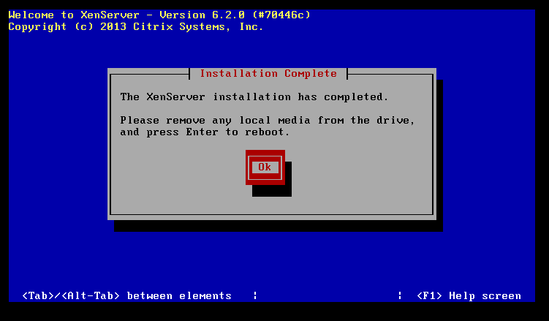

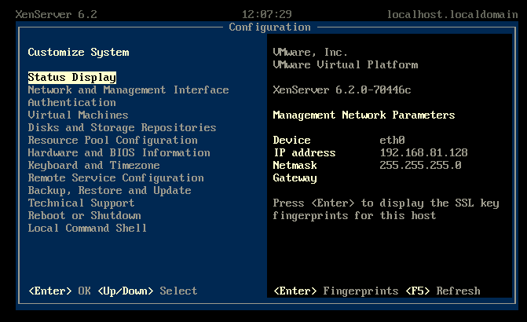

->Set a password for the server and remember .

-> Next , select Automatic configuration (DHCP) and click ok

-> Under Hostname configuration select Automatically set via DHCP , and under DNC Configuration select Automatically set via DHCP and click ok

-> Select your geographical area , here Asia - Calcutta

-> Set the local time Using NTP.

-> Under NTP configuration select NTP is configured by my DHCP server.

-> confirm and select Install XenServer .

->Once the installation is completed , click OK to insert the supplemental pack

-> Once completed click on Ok to reboot

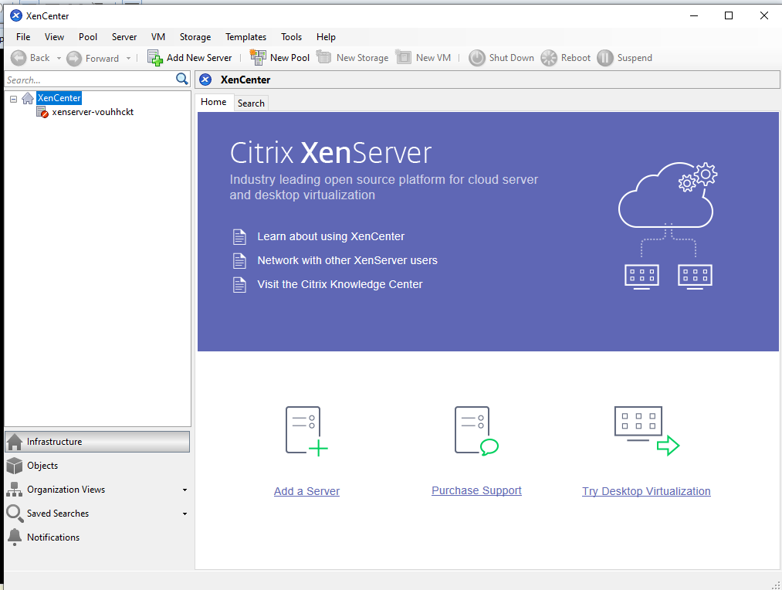

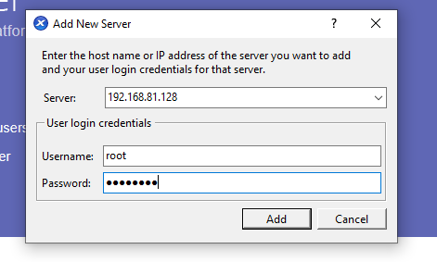

-> to change the IP address select Configure management interface and click enter

-> then click on configure with DHCP Enabled and enter

->The Network is configured successfully.

Step 3:

-> Open Citrix XenCenter and enter the IP address along with the username and password to connect .

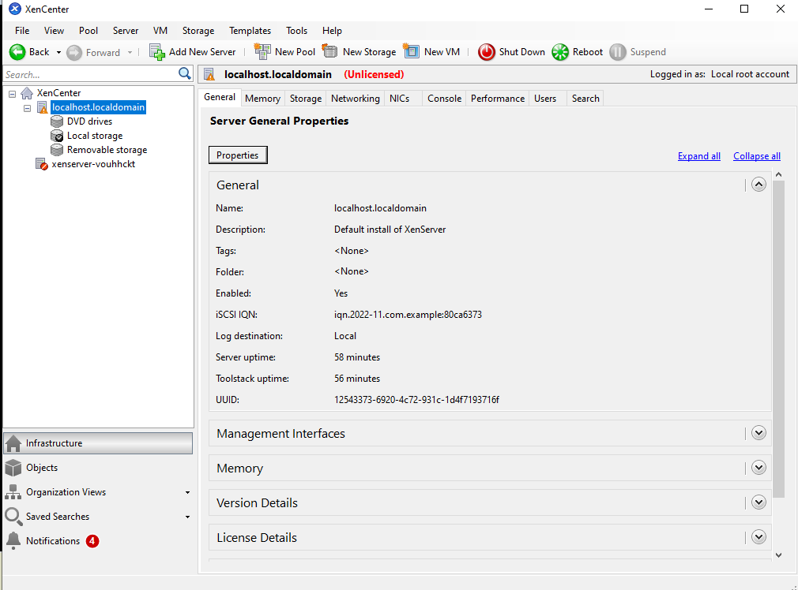

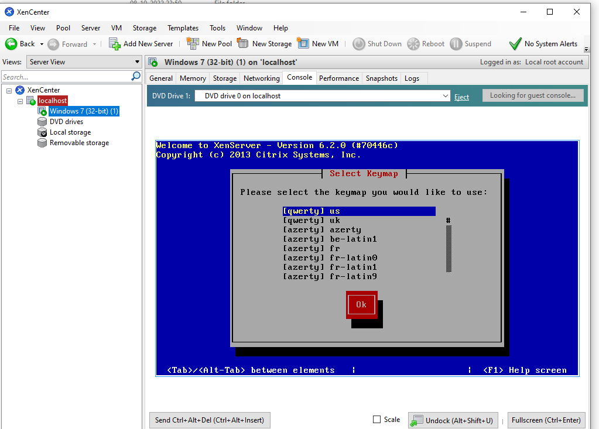

**Practical 7**

**Aim: Implement virtualization using VMWare ESXi Server and managing with vCenter**

Step 1: Open **VMWare Workstation** and create a new Virtual Machine

-> Click on **Typical (recommended)** and Next.

-> Select the option to **install the operating system later** and click next

-> Select the guest operating system as **VMware ESX** , Version **ESXi 4**

-> Give a name to the Virtual Machine

->Click on **split virtual disk into multiple files** and next

->Set memory to 2GB and select the CD from your device **VMvisor**

-> Click Finish.

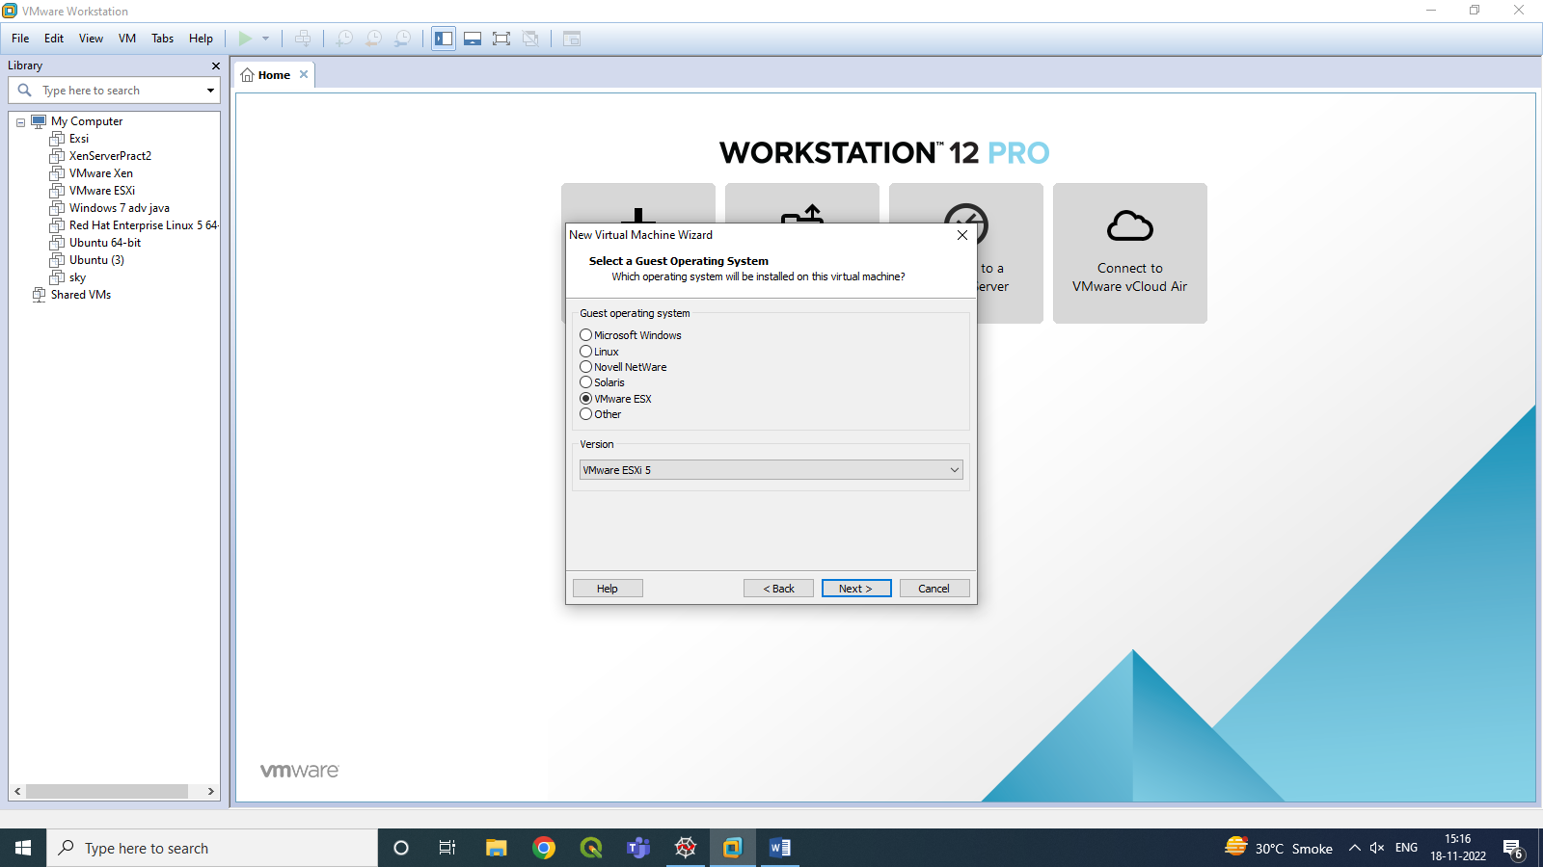

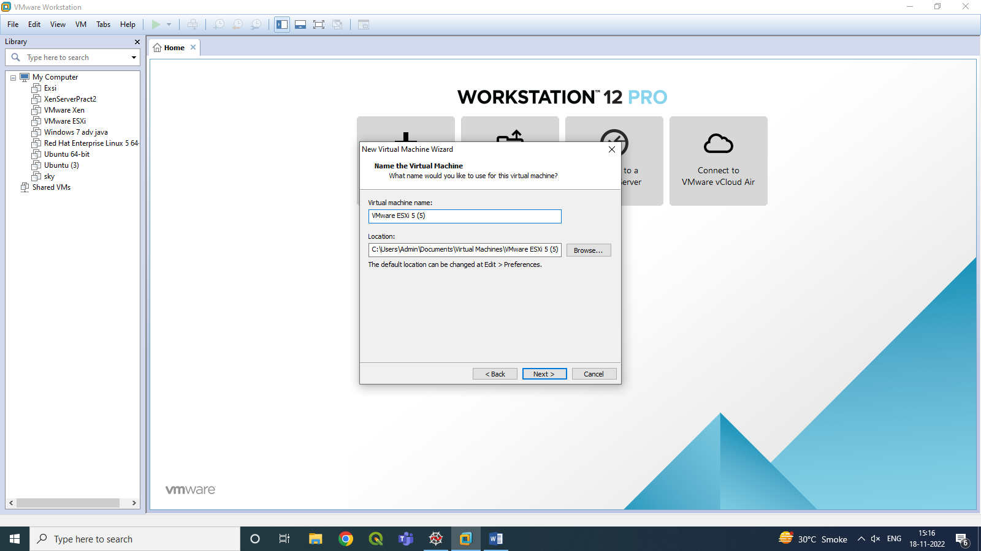

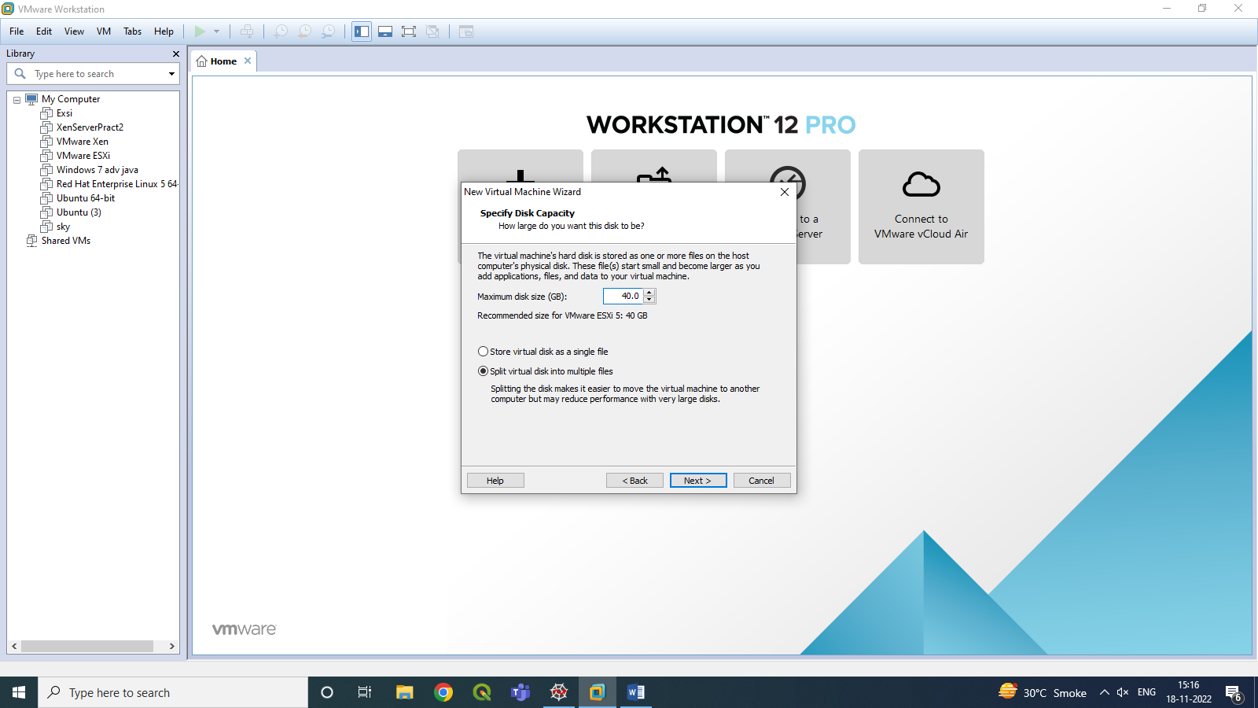

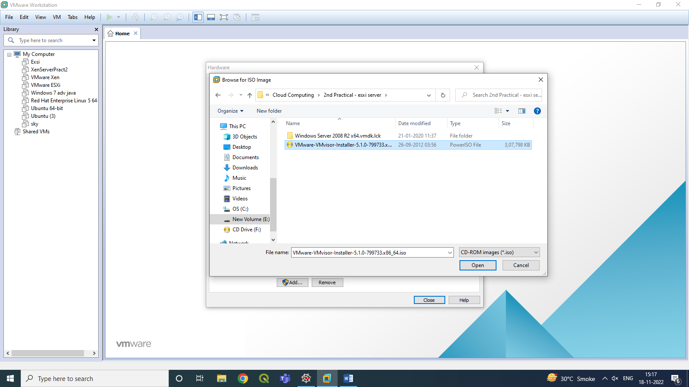

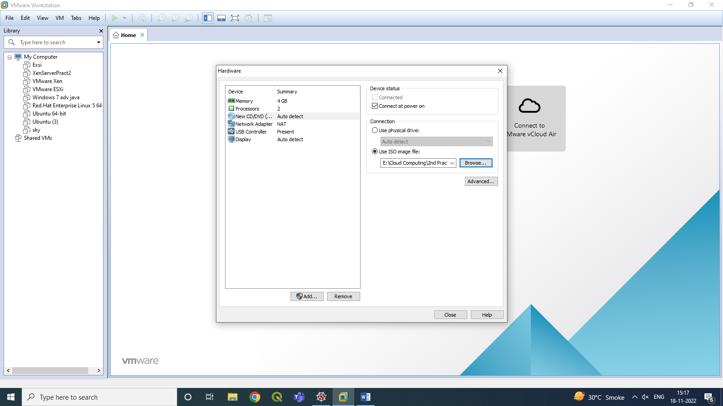

Step 2: Installation of ESXi

-> Power on the machine

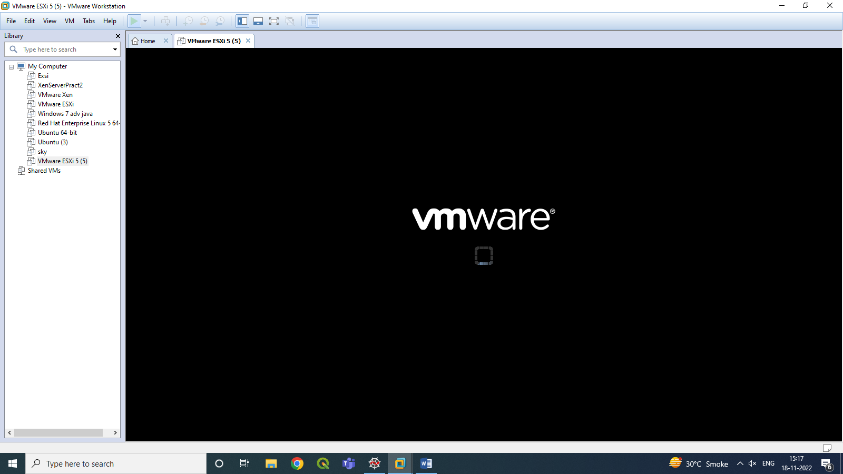

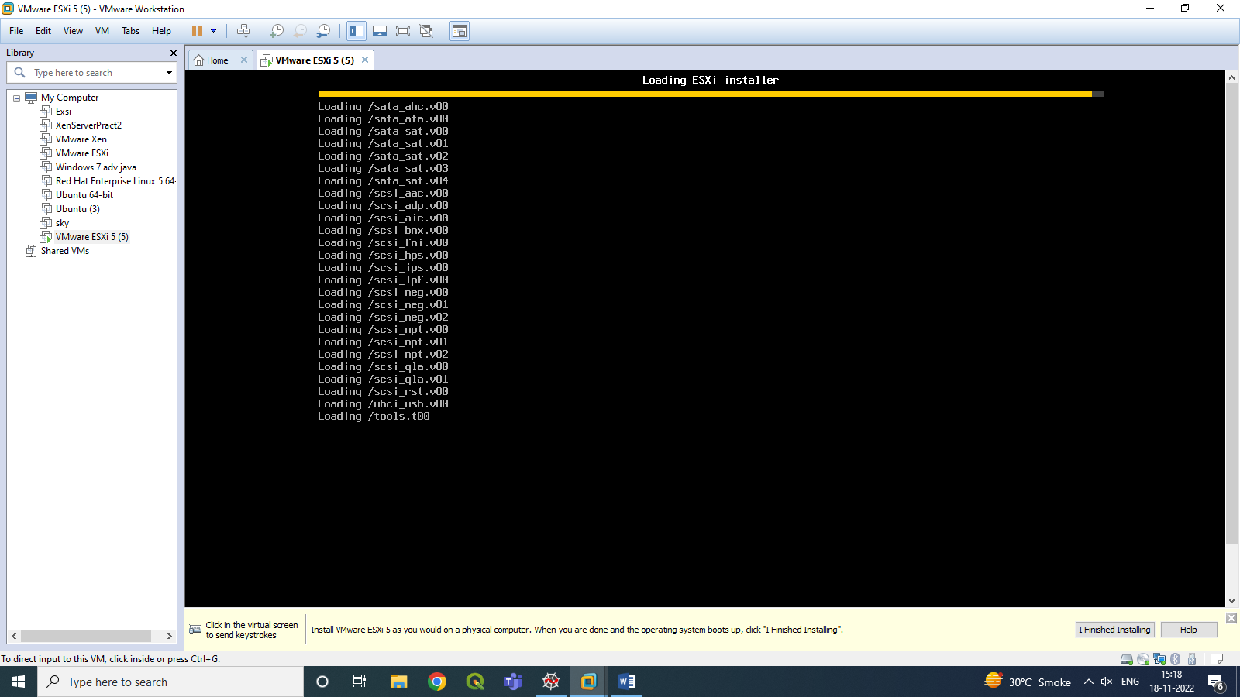

-> Click Enter and accept the license.

->Select the following

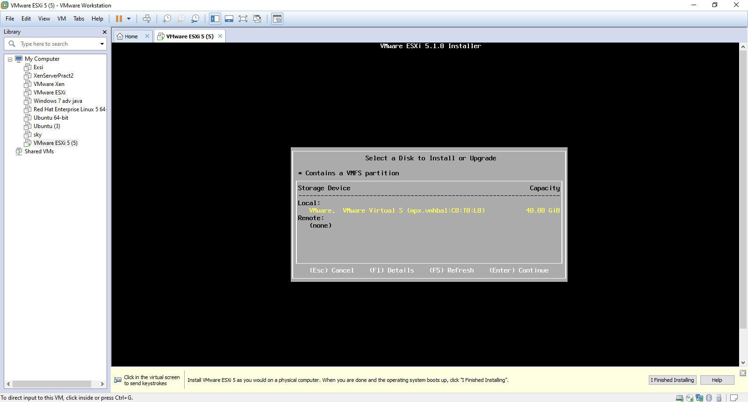

-> Set a password and click enter.

-> Then click **F11** to install ESXi 5.

-> Once the installation is completed , click **Enter** to Reboot.

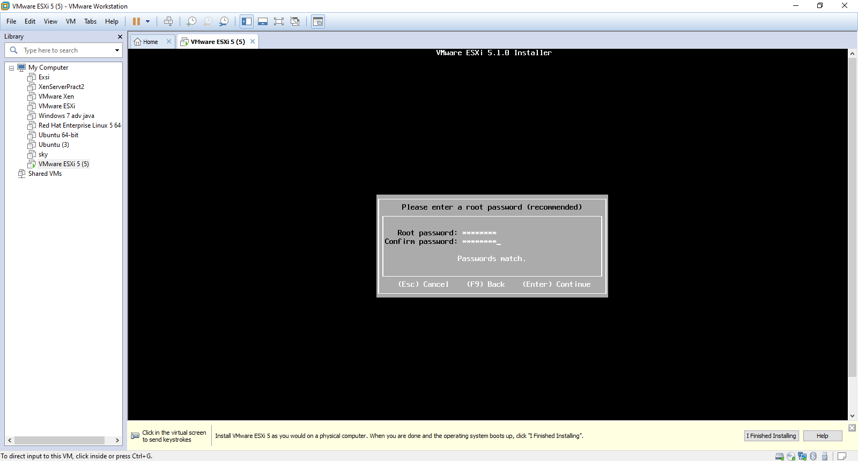

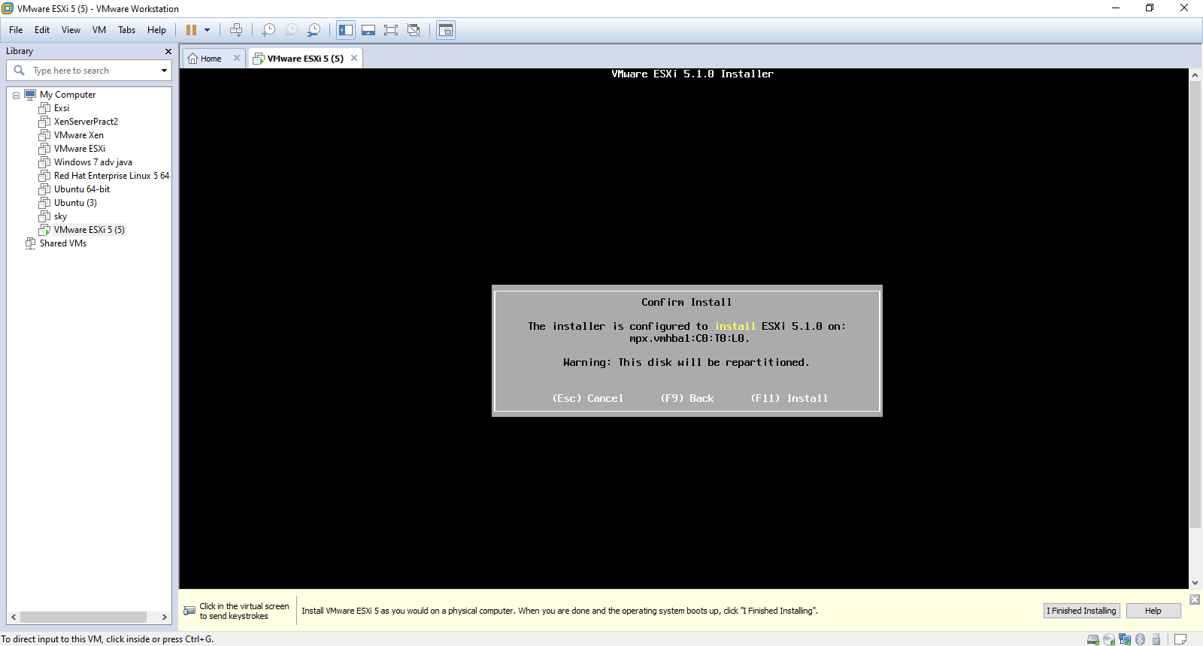

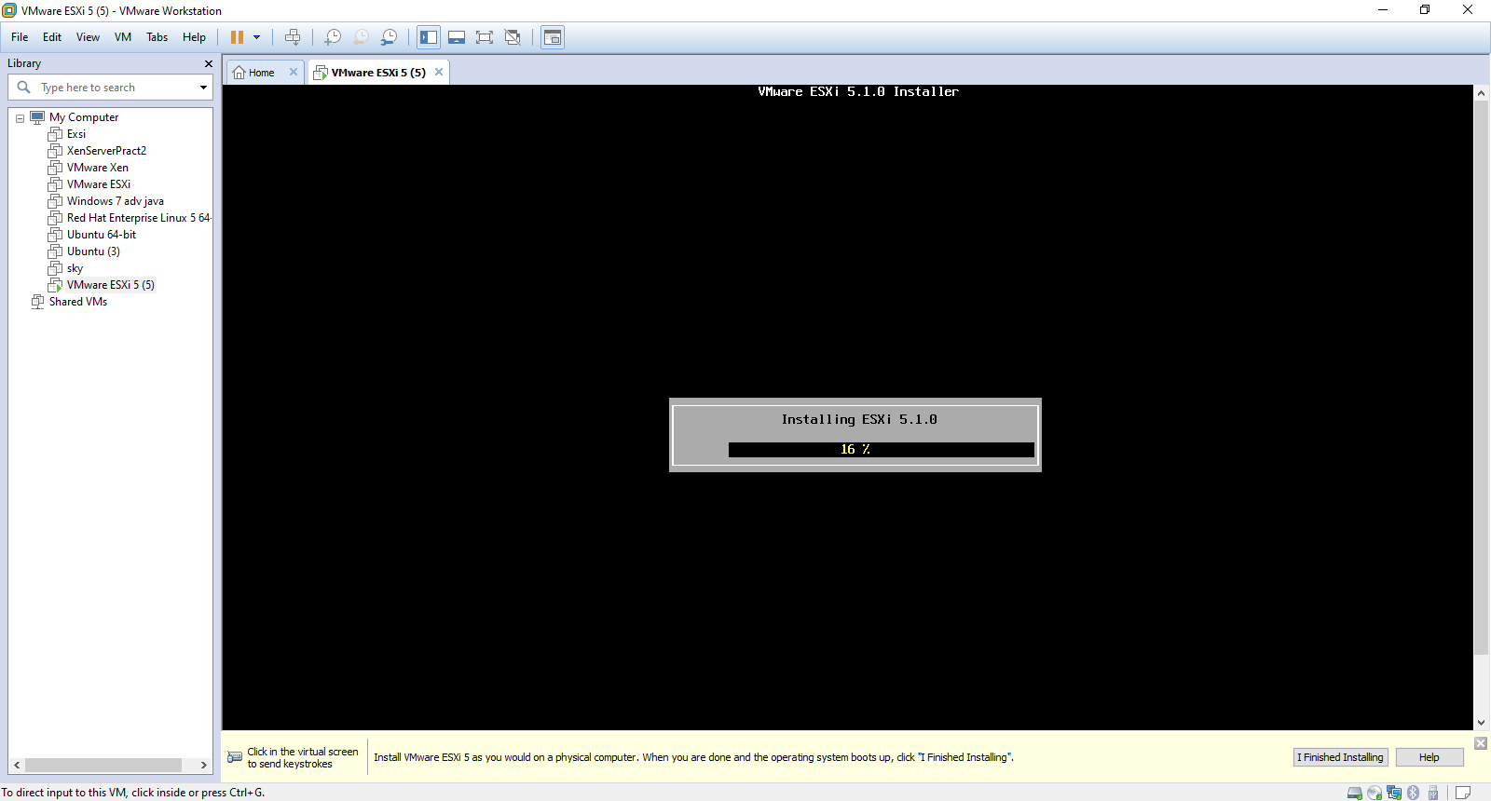

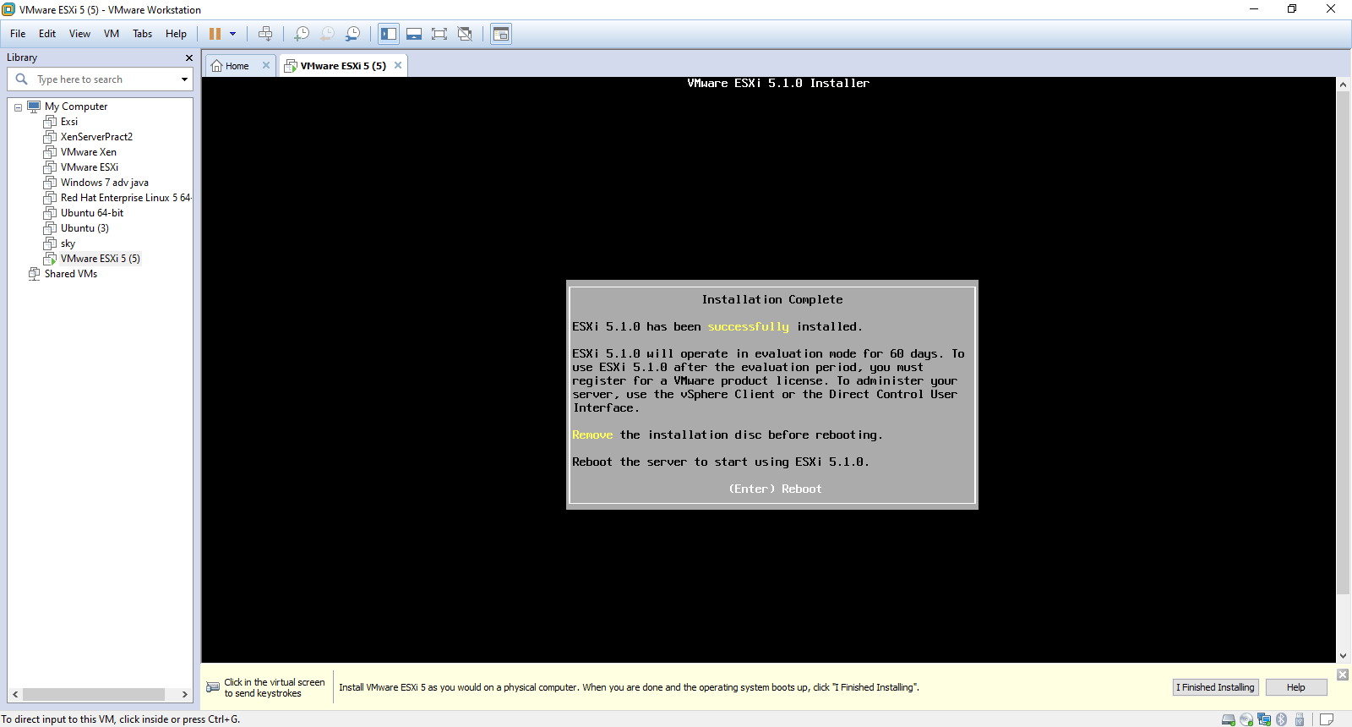

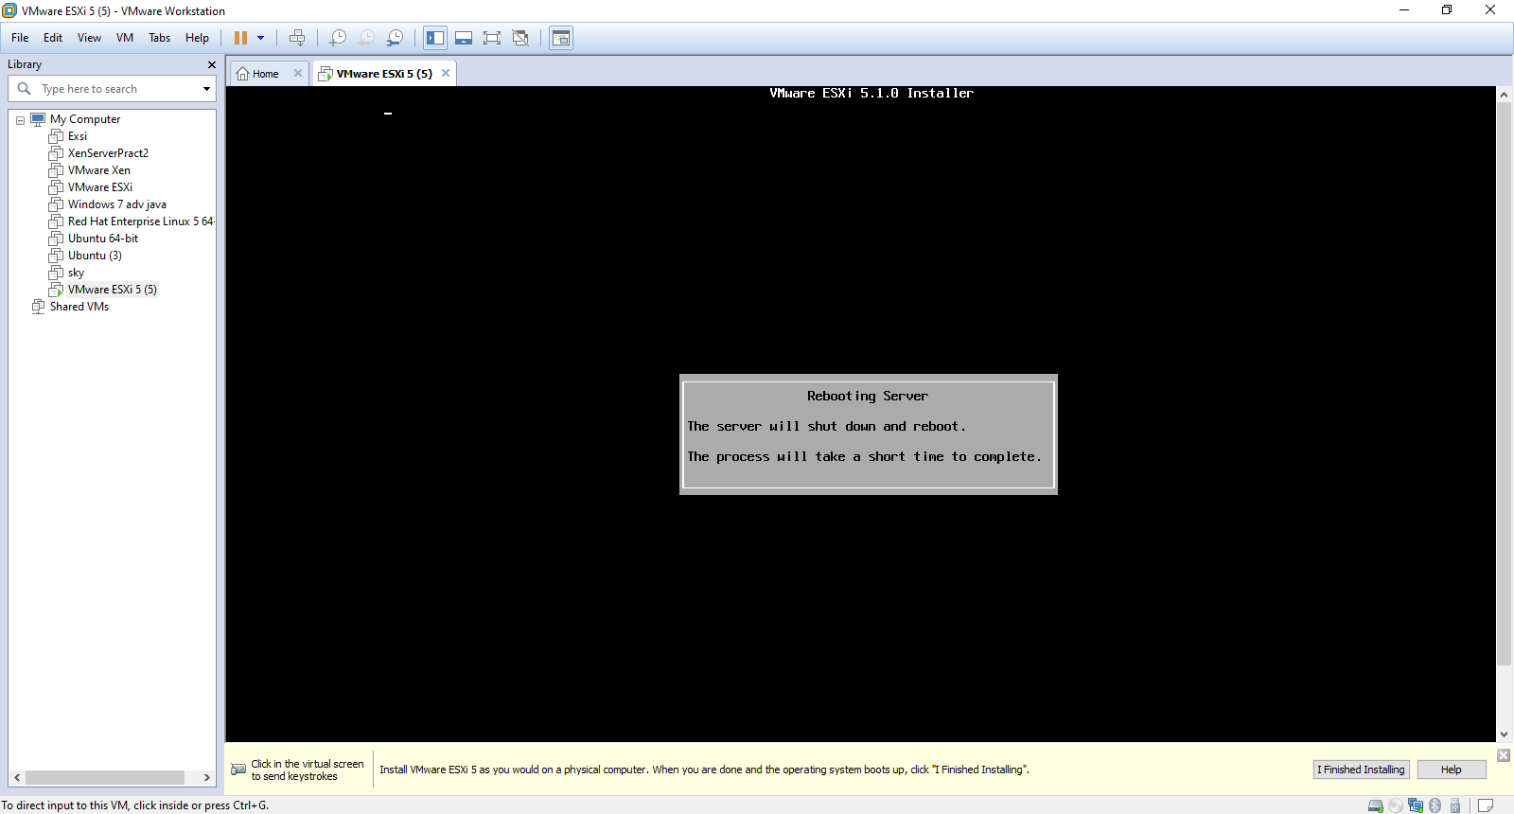

Step 3: Configuring

-> Click **F2** and enter the password .

-> Click **F2** and under system customization go to **Configure Management Network.**

->IP Configure and Enter

-> Select **Set static IP address and network configuration** and enter the following

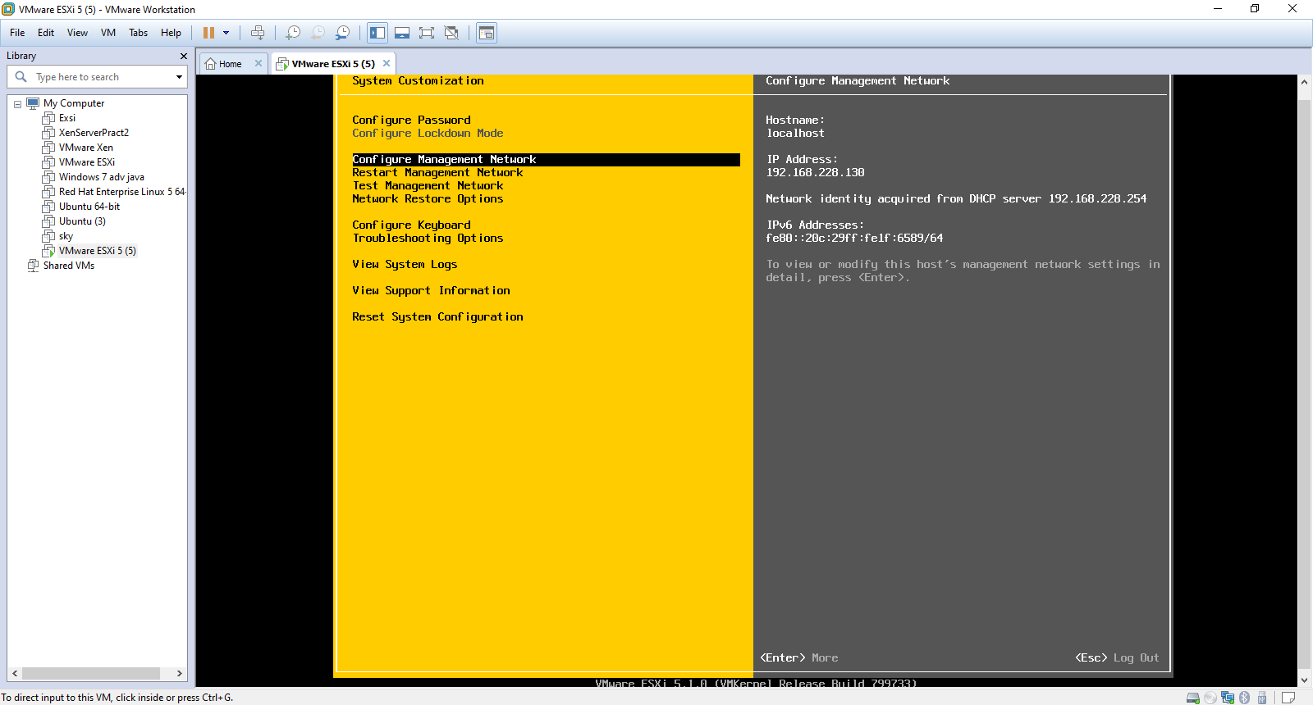

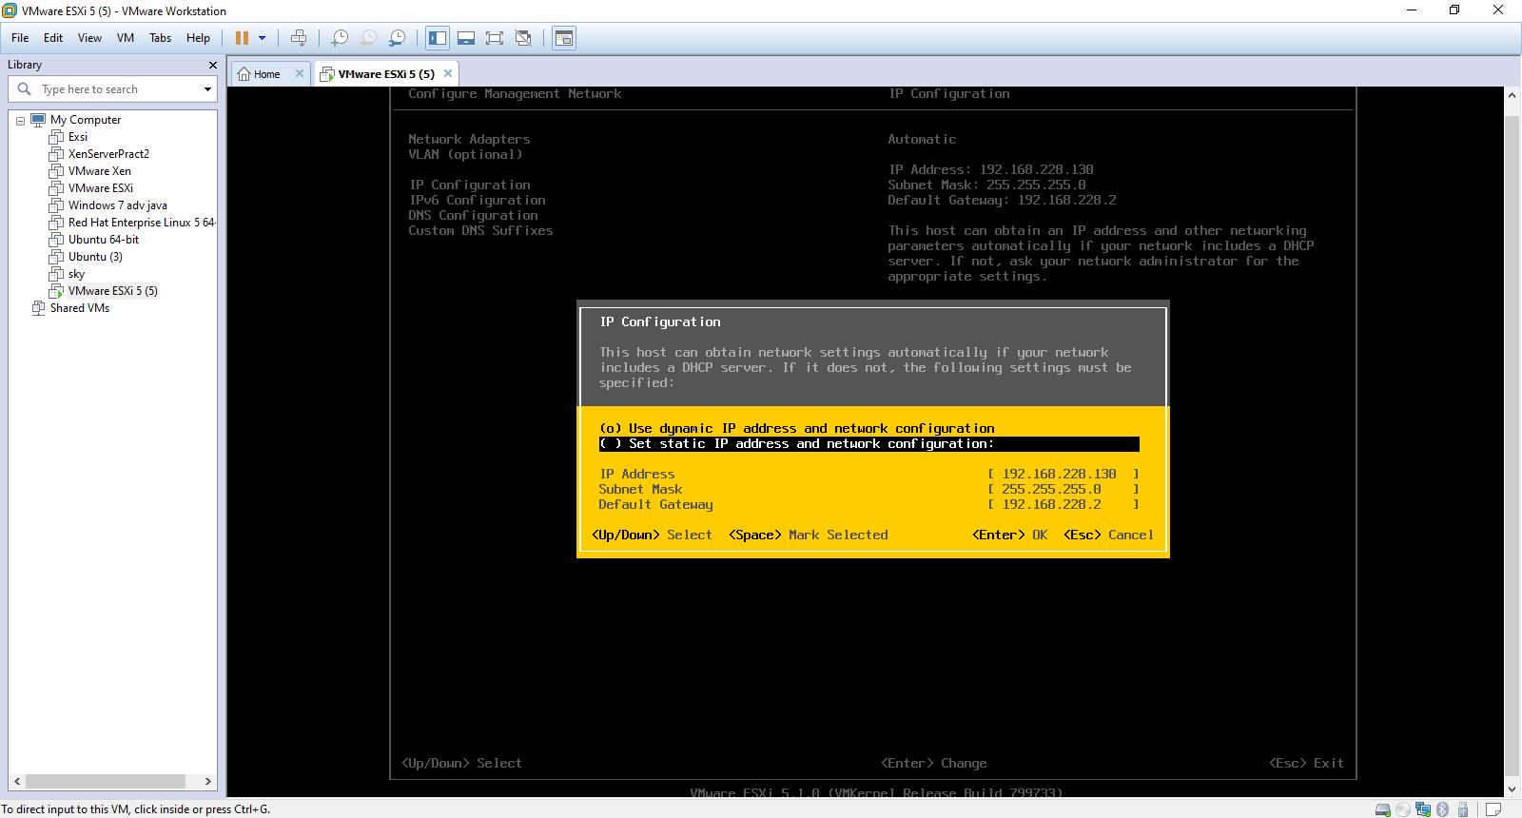

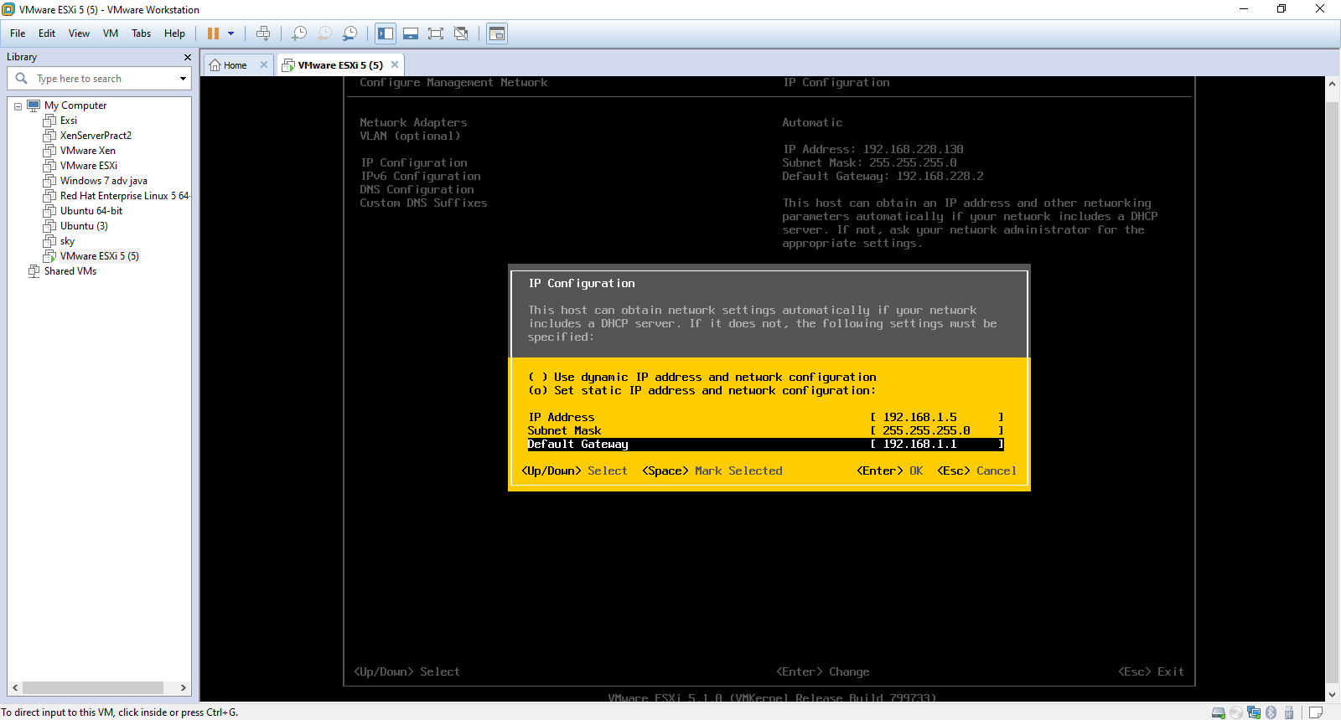

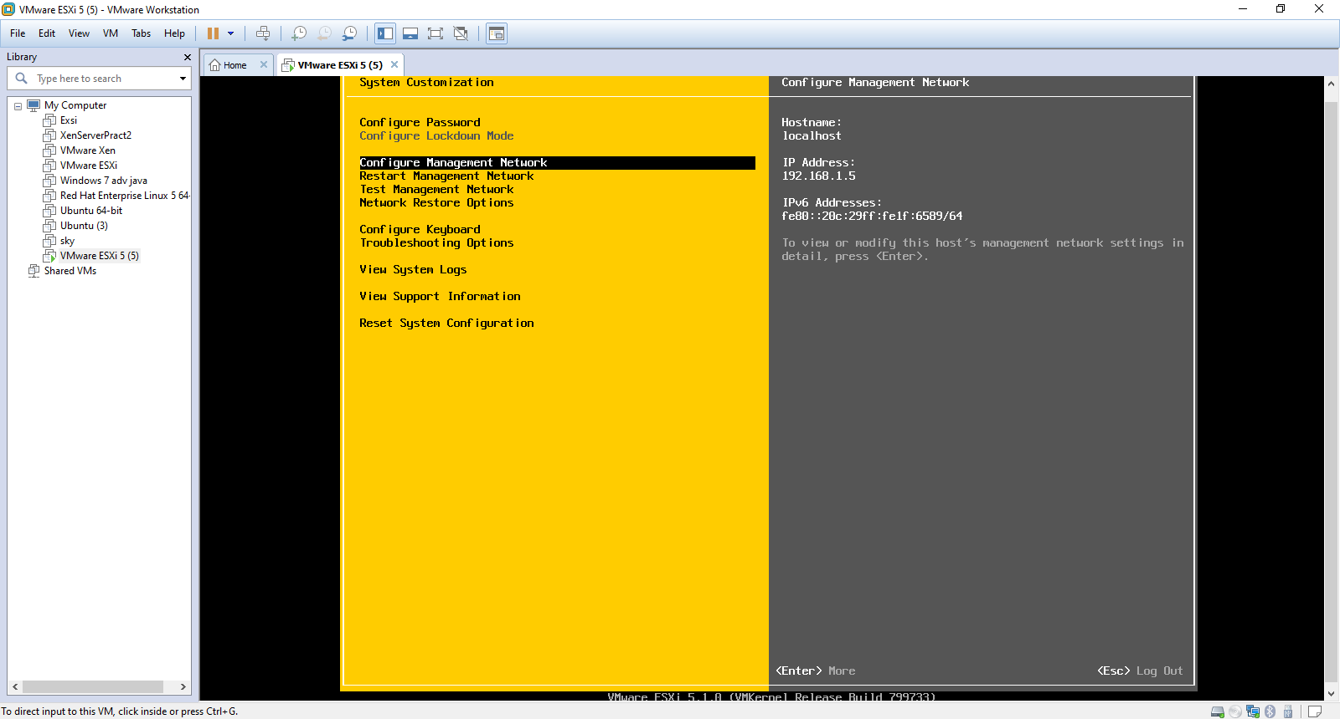

-> Select Exit and Restart.

Step 4: Client Installation

-> Open the VMware_client.exe file saved on your machine

-> Click next to install and Finish

-> go to control panel and change the IP address to:

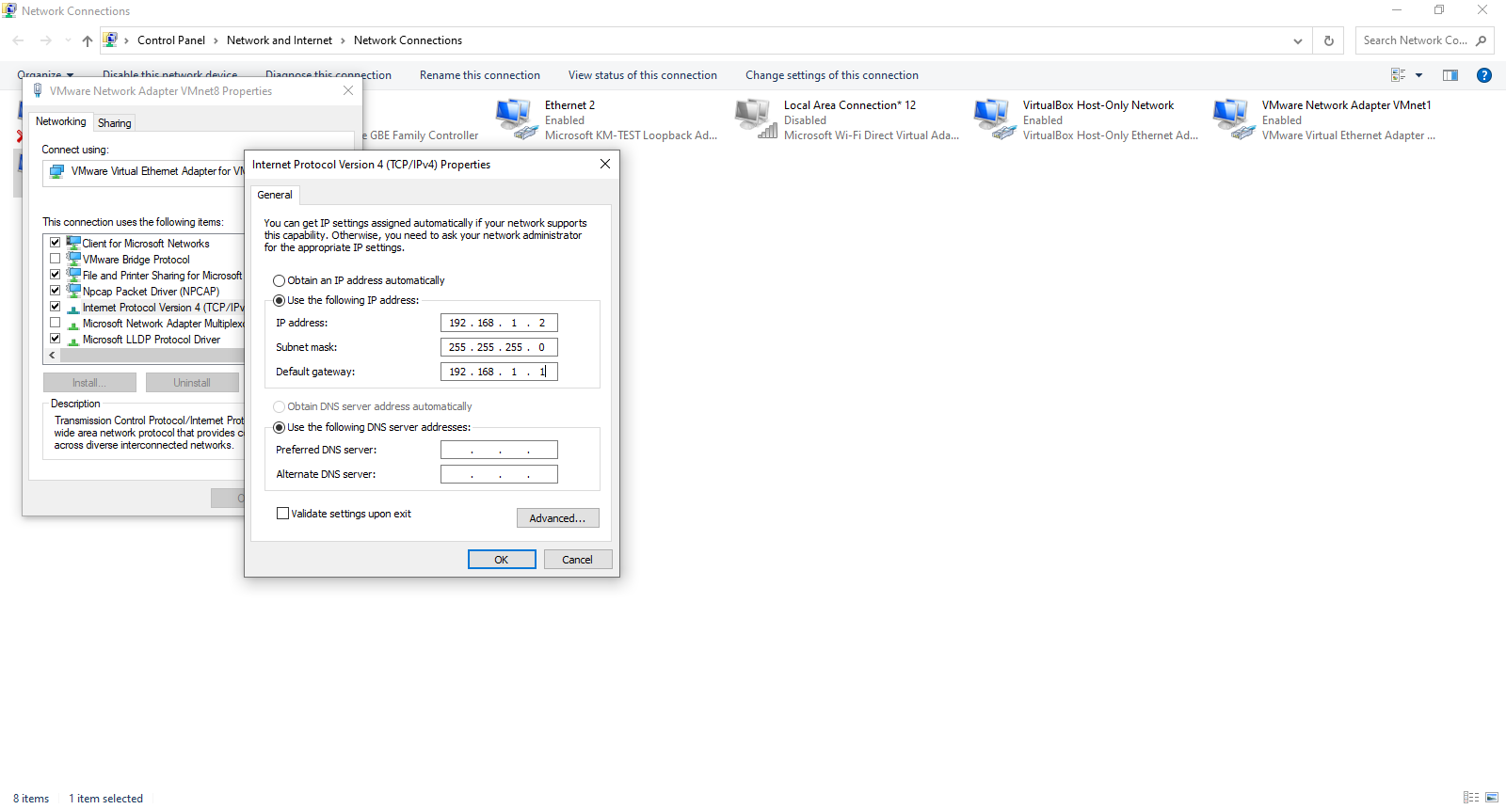

-> Open VMware sphere Client and Enter you virtual machine IP address and password.

Step 5: Creating a machine

-> click on create a new Virtual machine.

->click Next .

-> Under guest operating system select other (32-bit)

-> next check the box with Edit the virtual machine settings before completion and click Continue.

->Set Memory to 1GB , Enter the CD saved on the local media

-> Finish

-> Power on and go to summary

-> Click open Console.

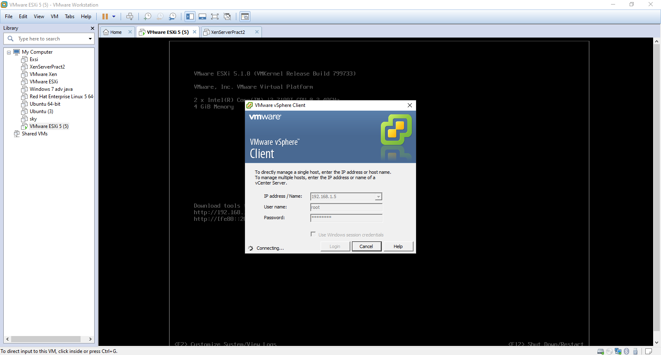

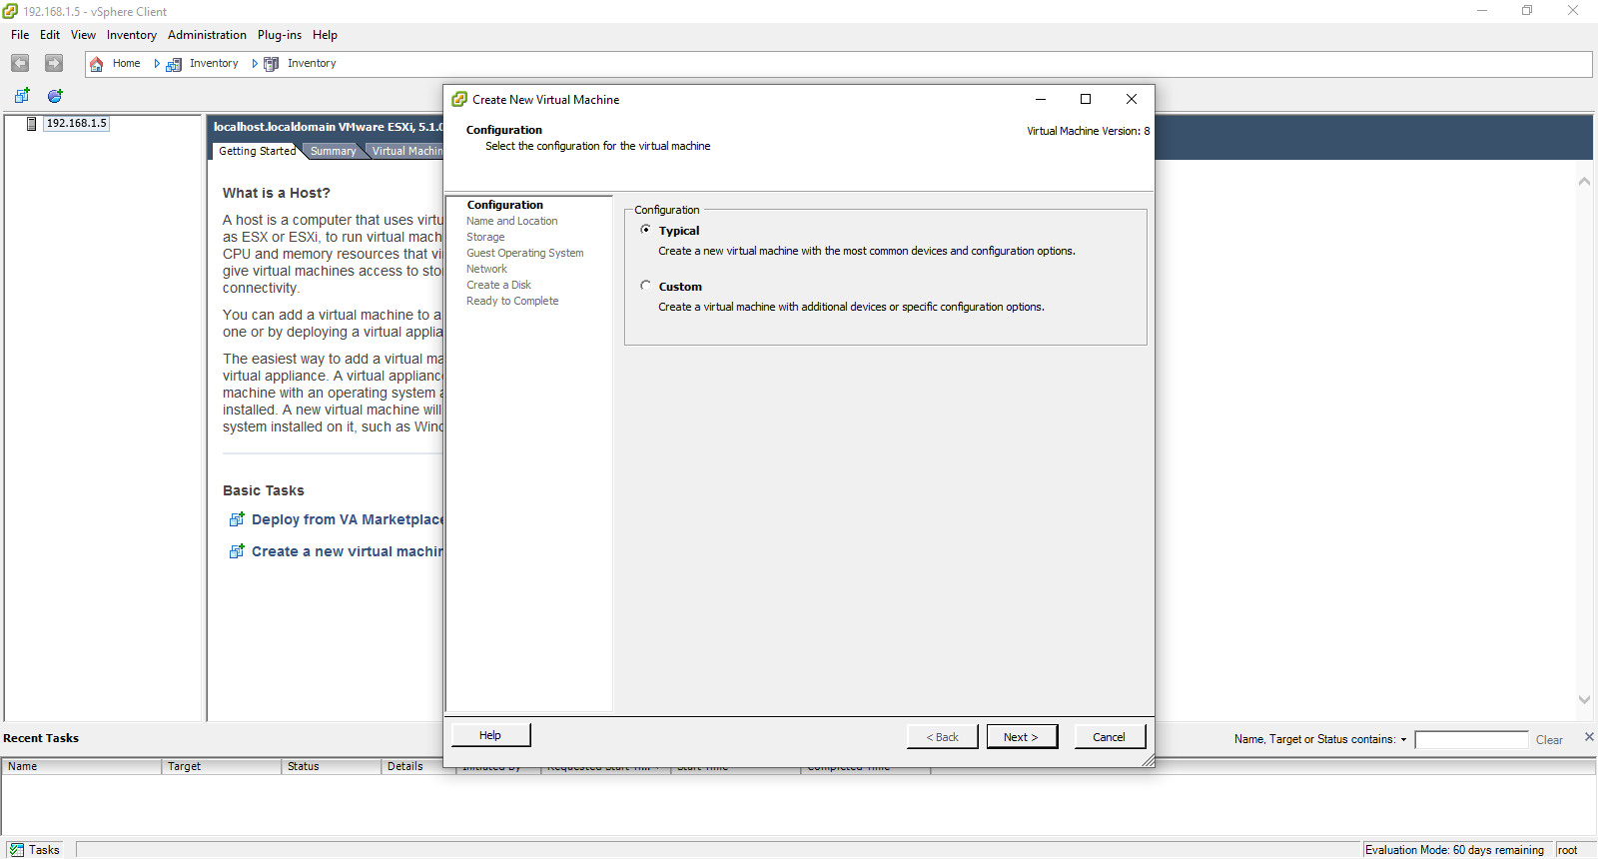

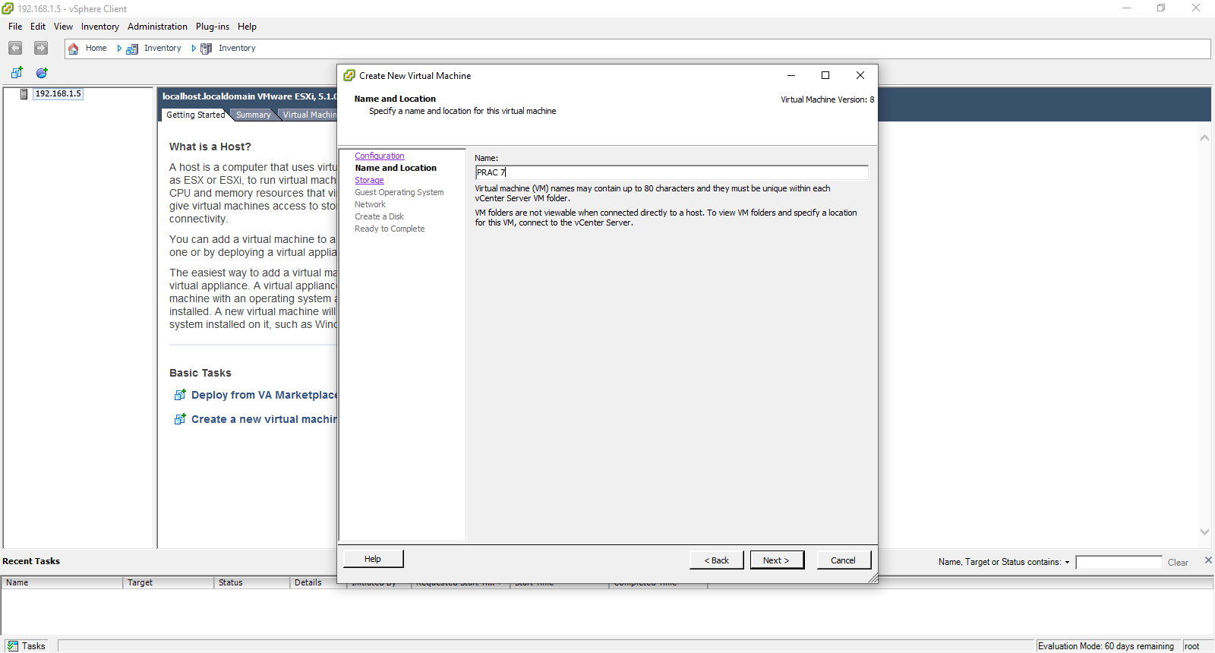

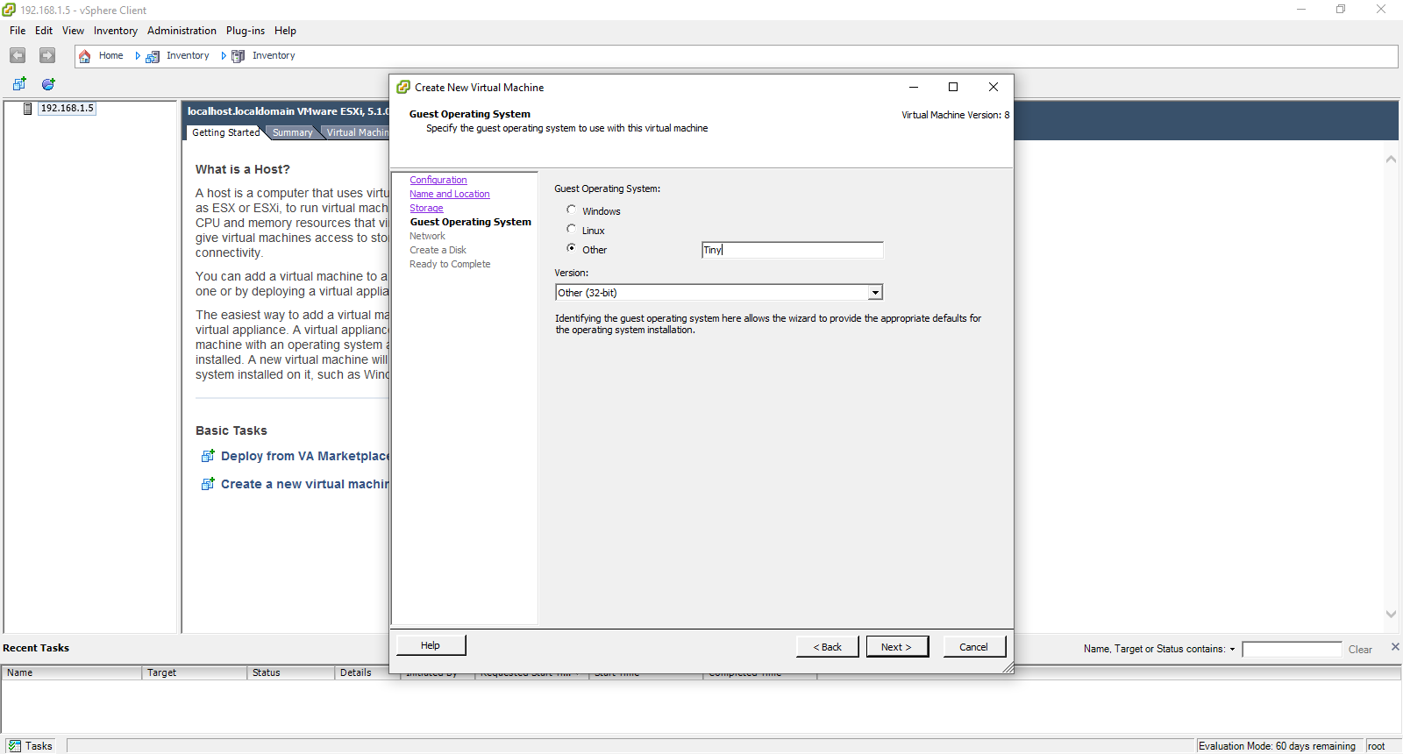

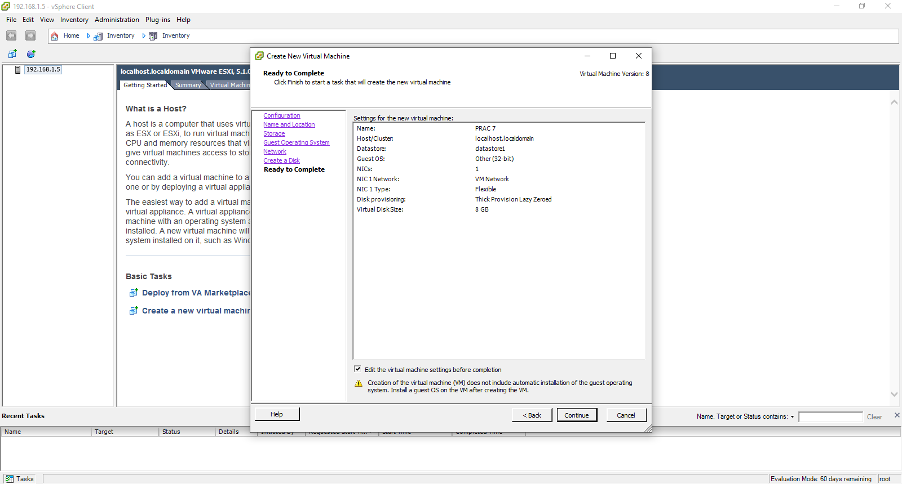

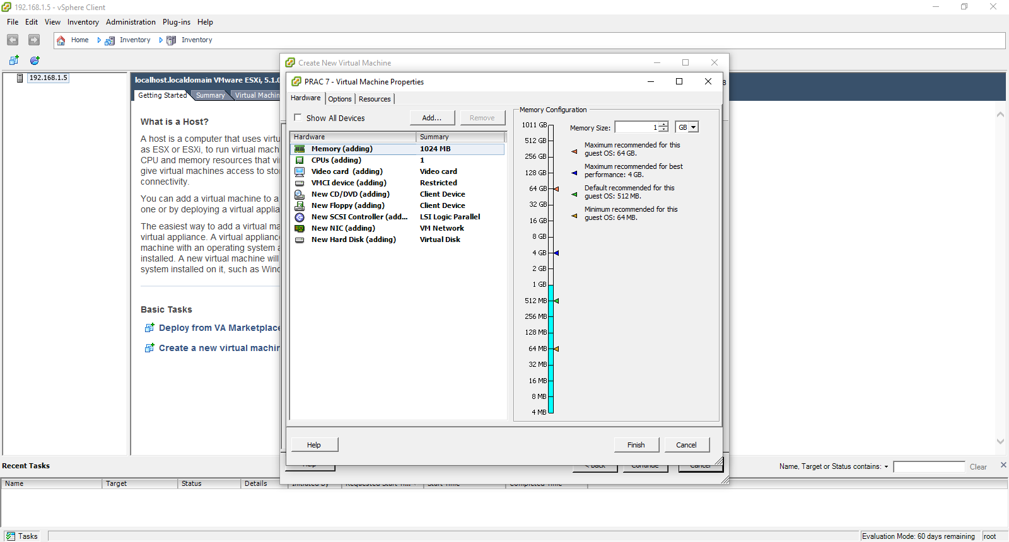

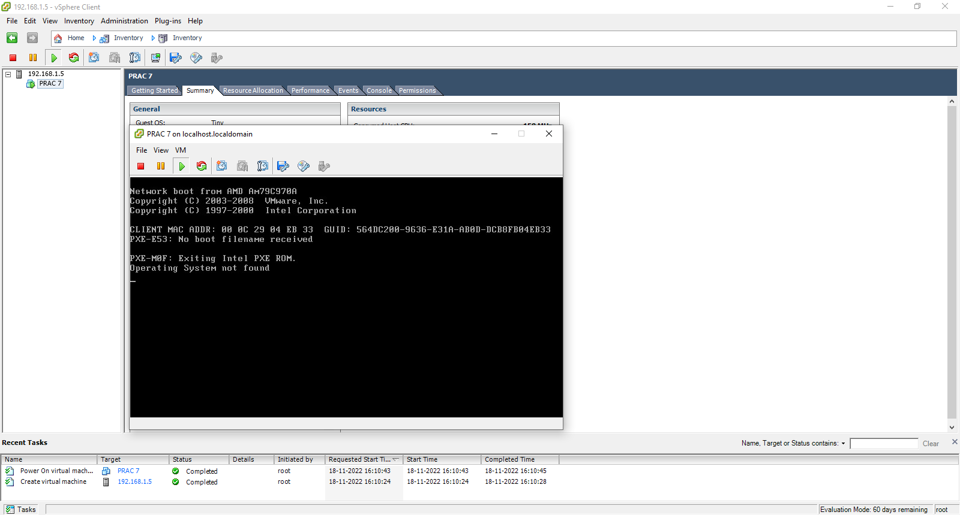

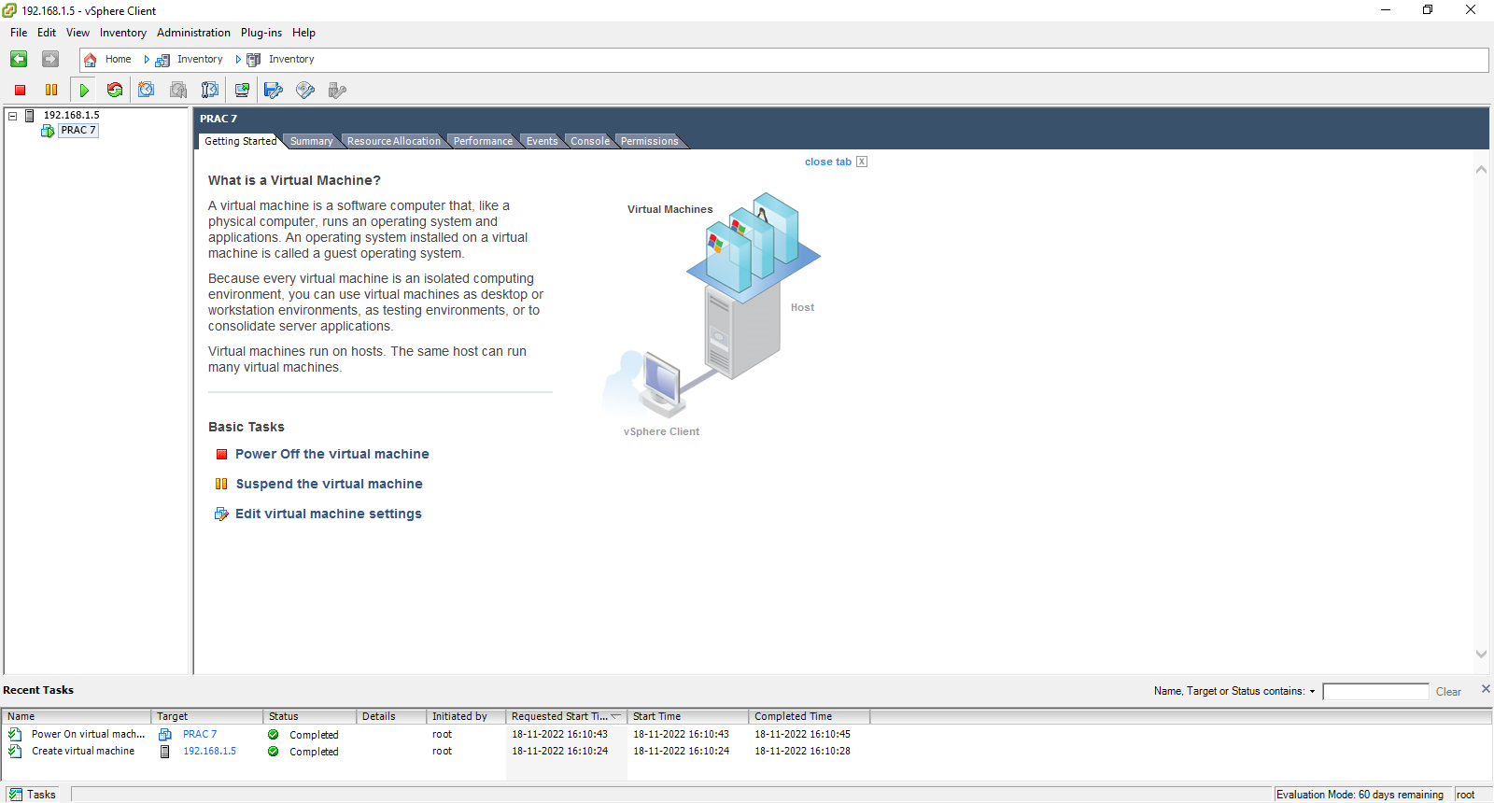

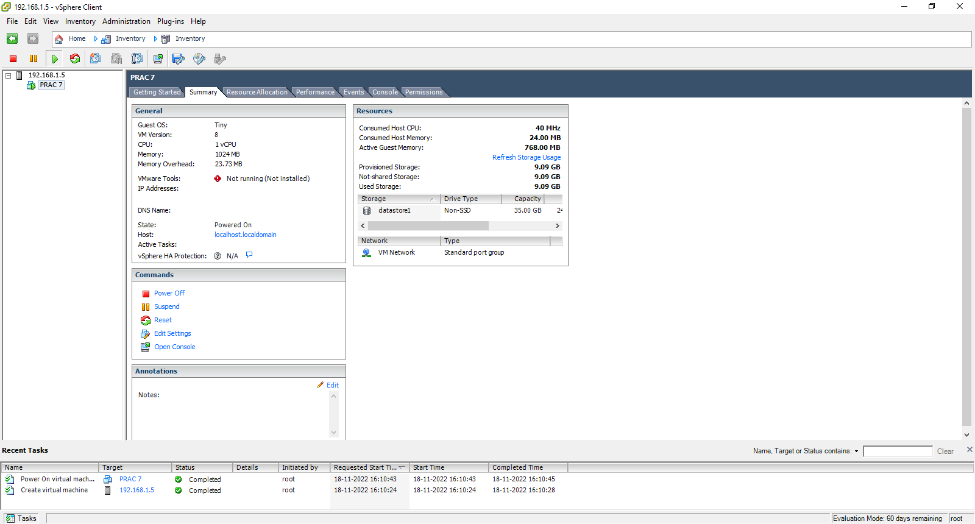

**Practical 8**

**Aim: Implement Windows Hyper V virtualization**

1.Select File->Open New Virtual Machine

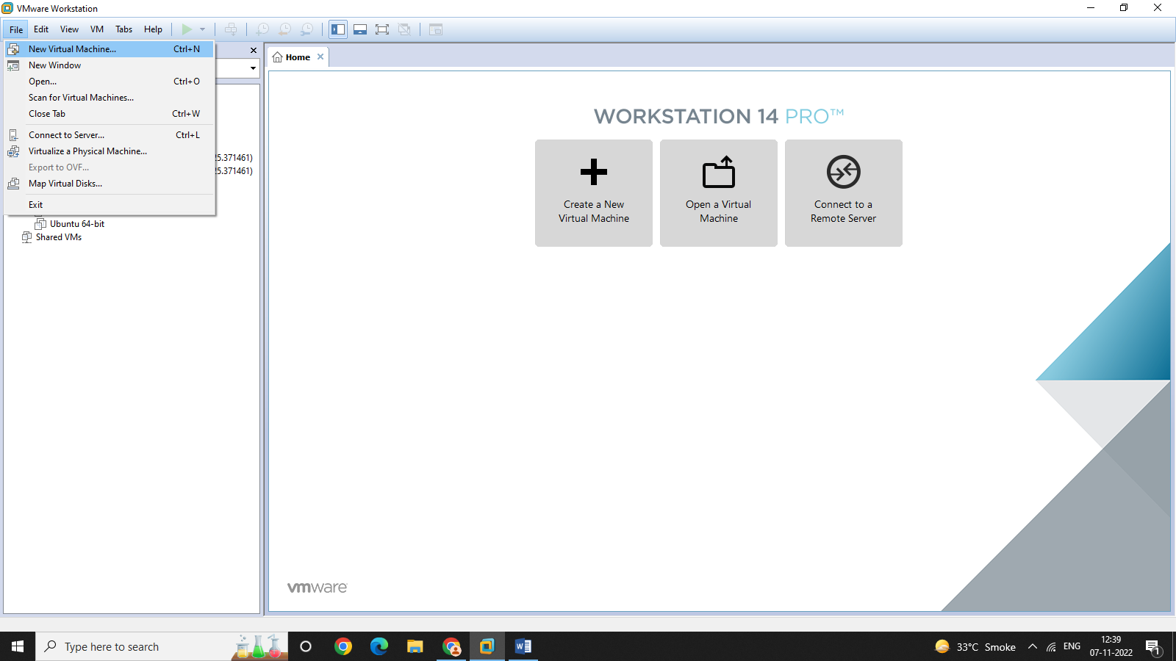

2.Select I will install operating system later option and click next.

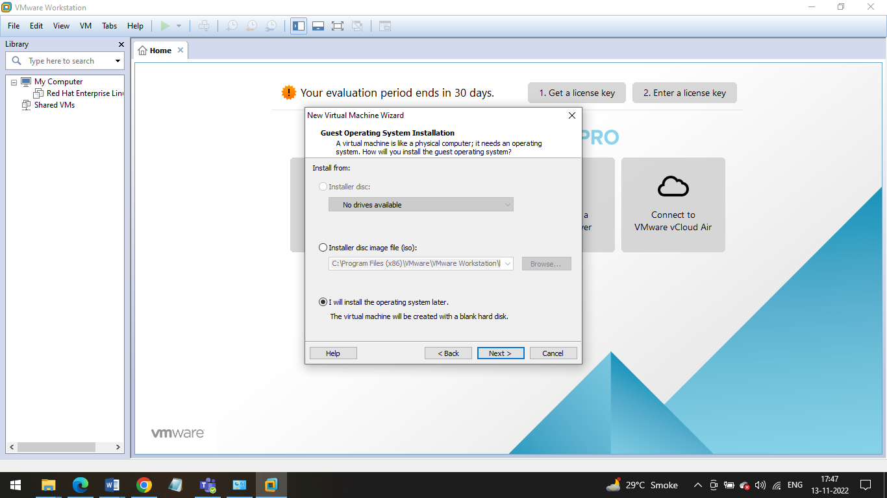

3.Select Microsoft Windows as guest operating system and Hyper-V(unsupported) as version and click next.

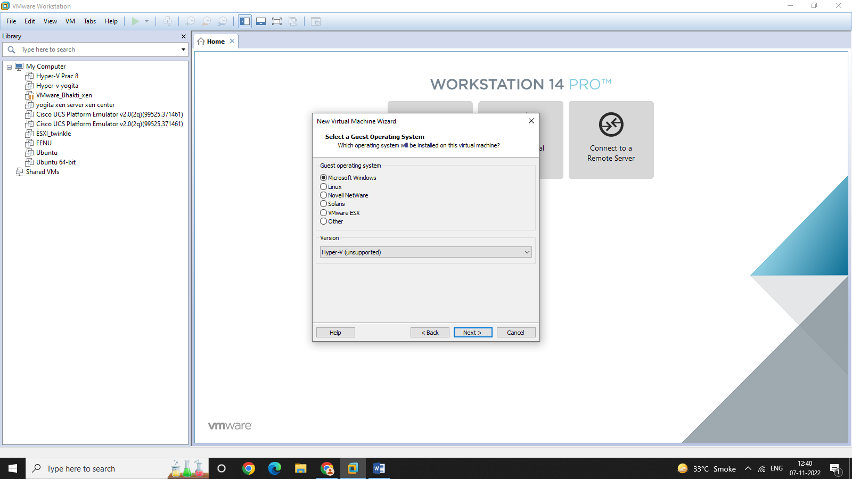

4.Name the virtual machine and click on next. Specific Disk Capacity is shown then click next.

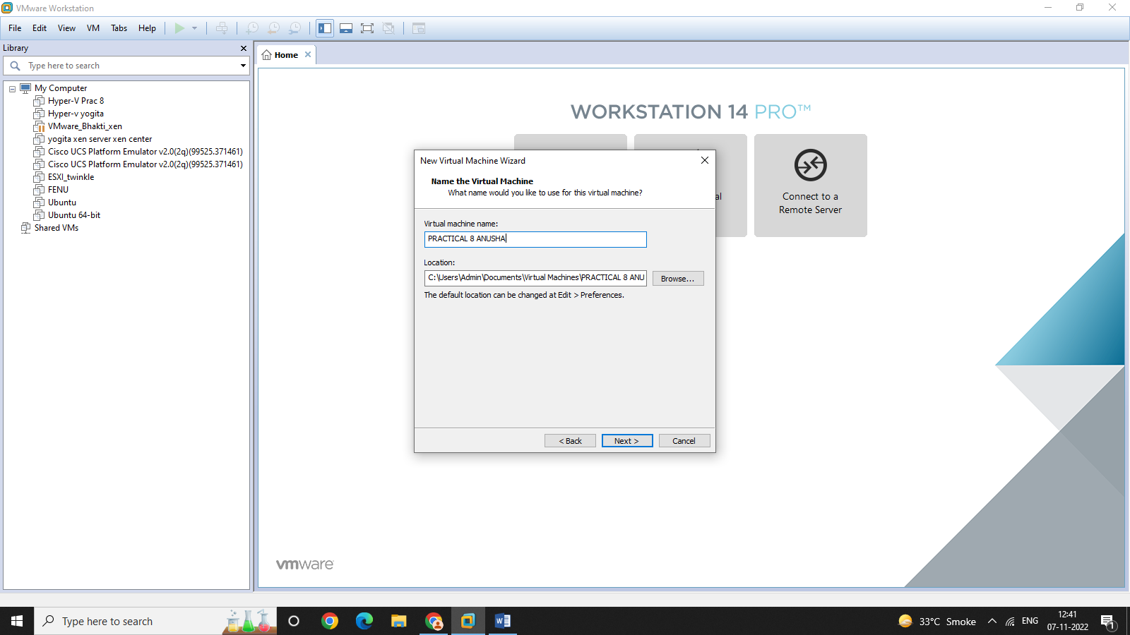

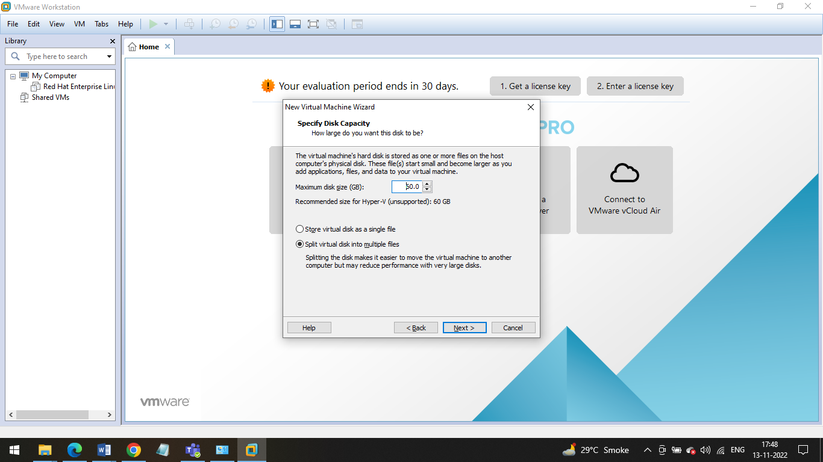

5.Click on Customize Hardware

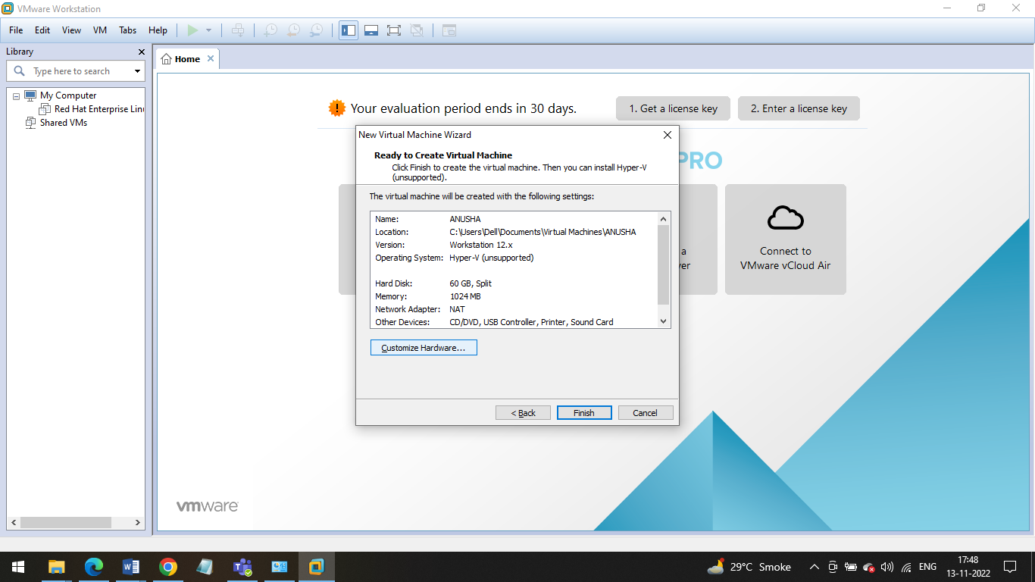

6.Set the memory to 2GB and add an ISO image file.

Click on close and then Finish.

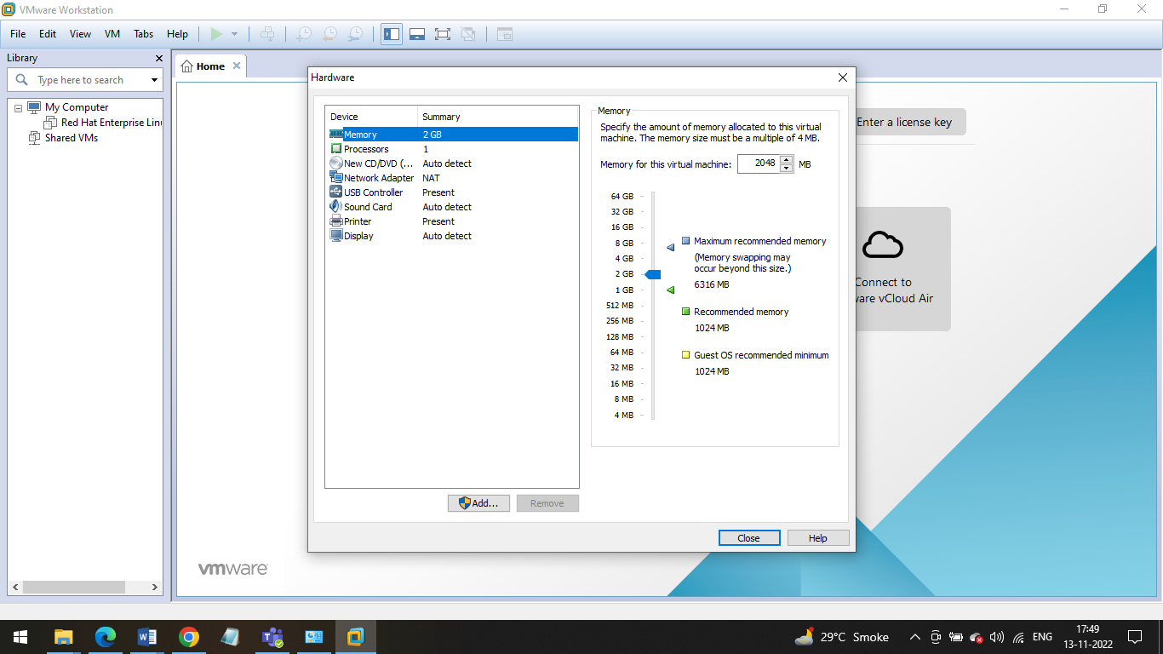

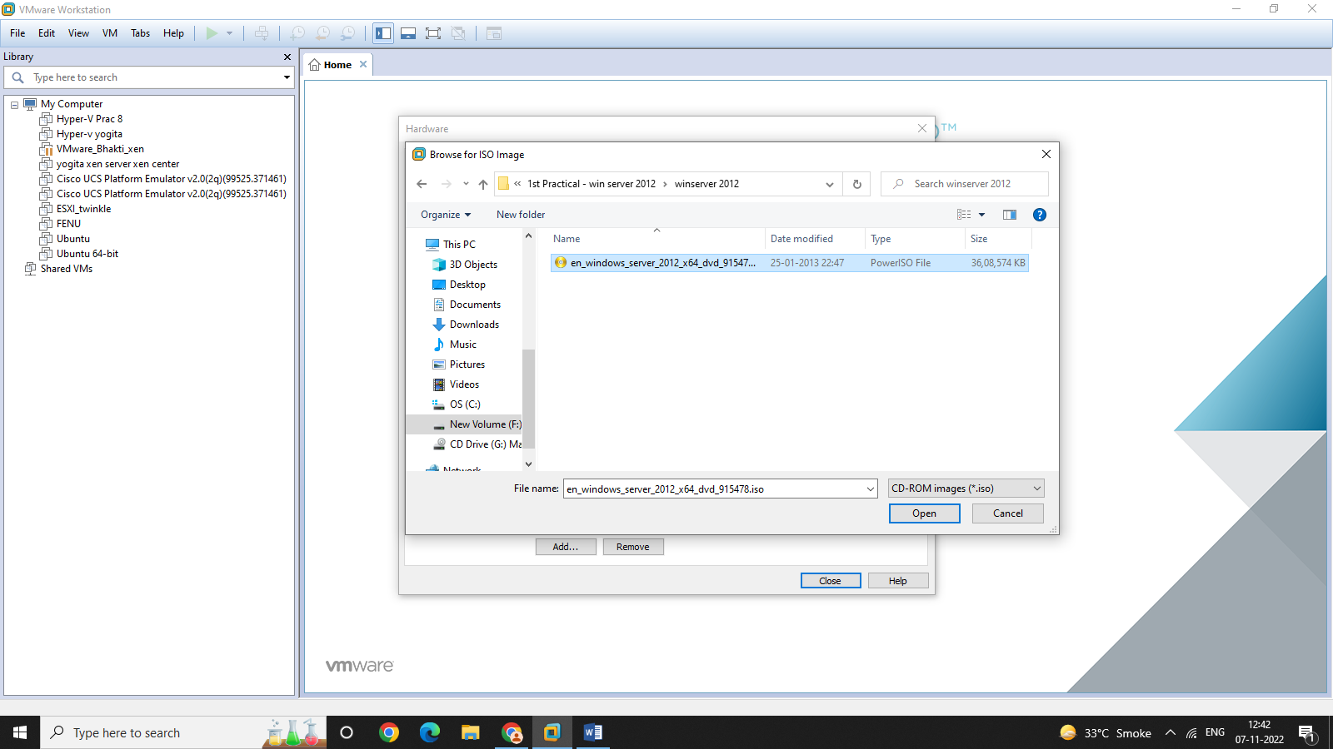

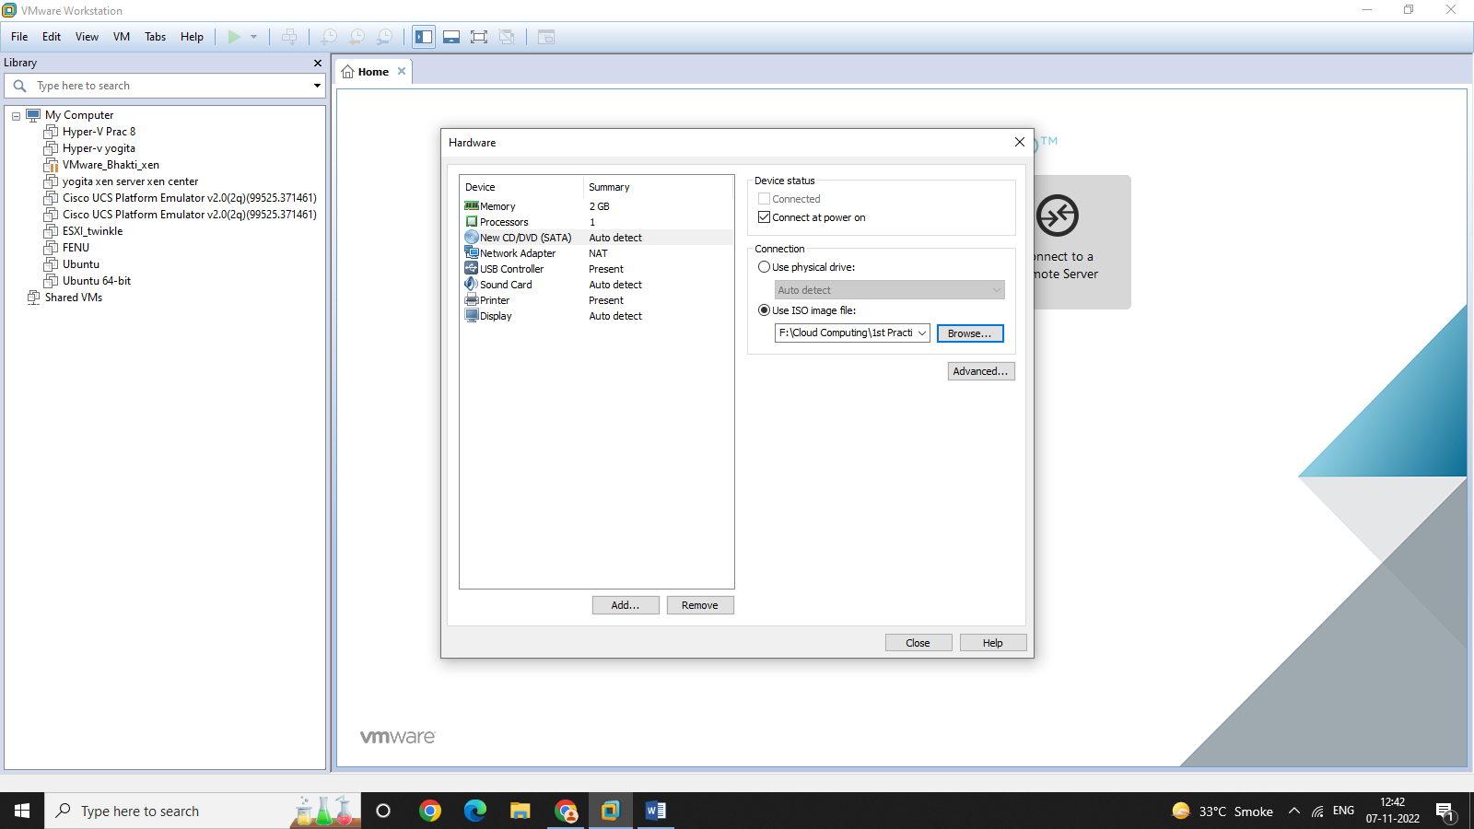

7.Power on the virtual machine and click next.

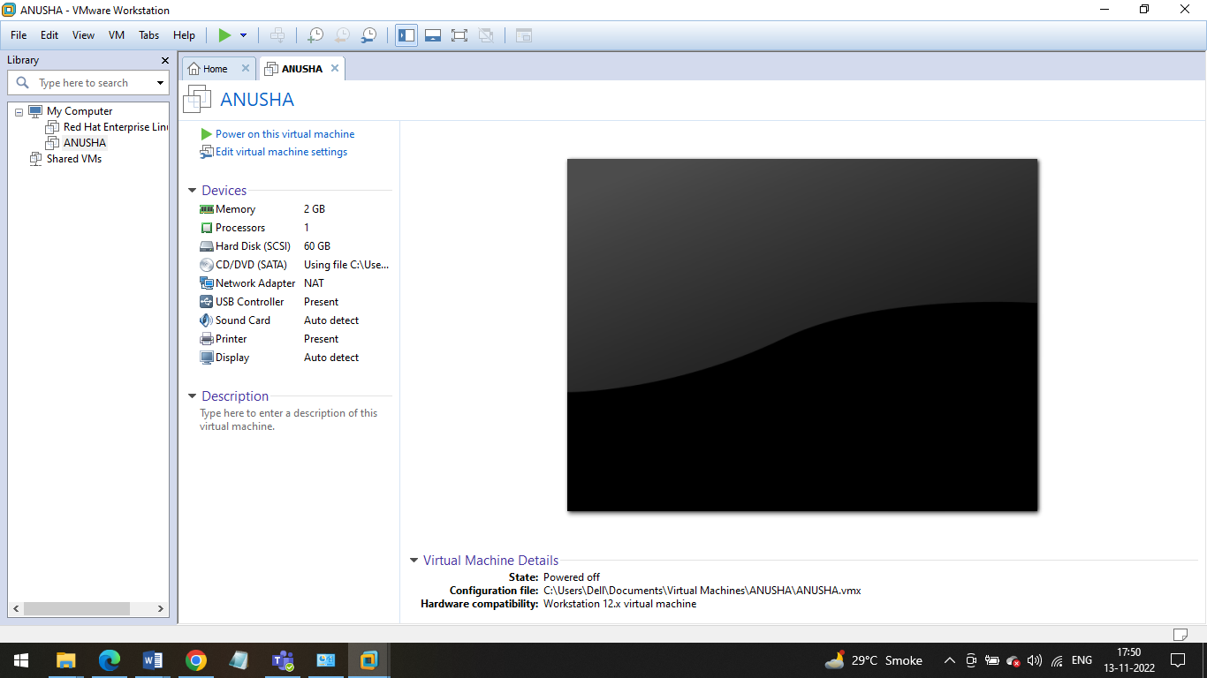

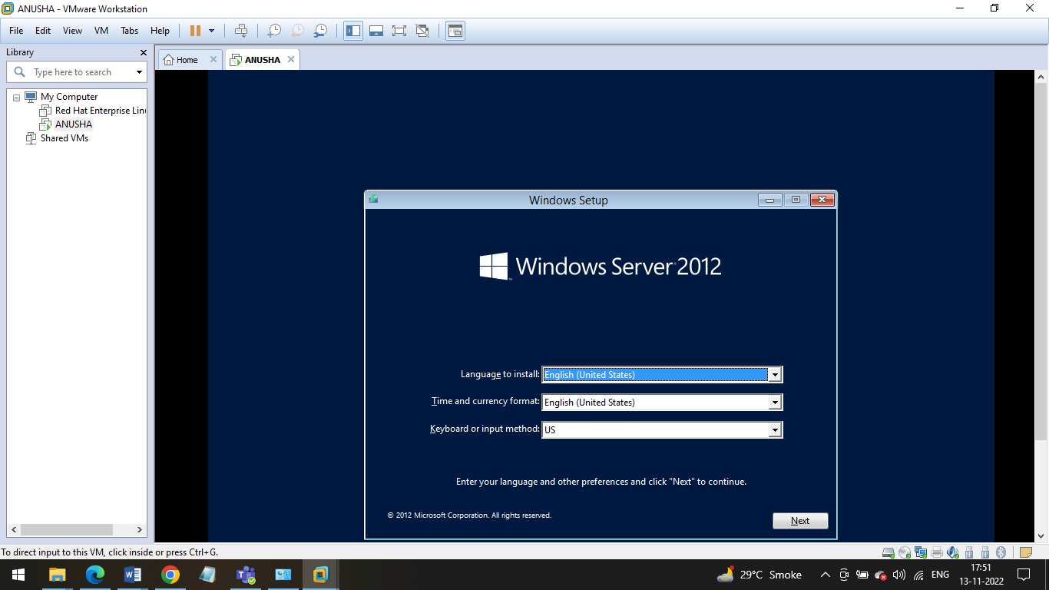

8.Enter the product key and click next. Select Windows Server 2012 Datacenter(Server with a GUI). And click next.

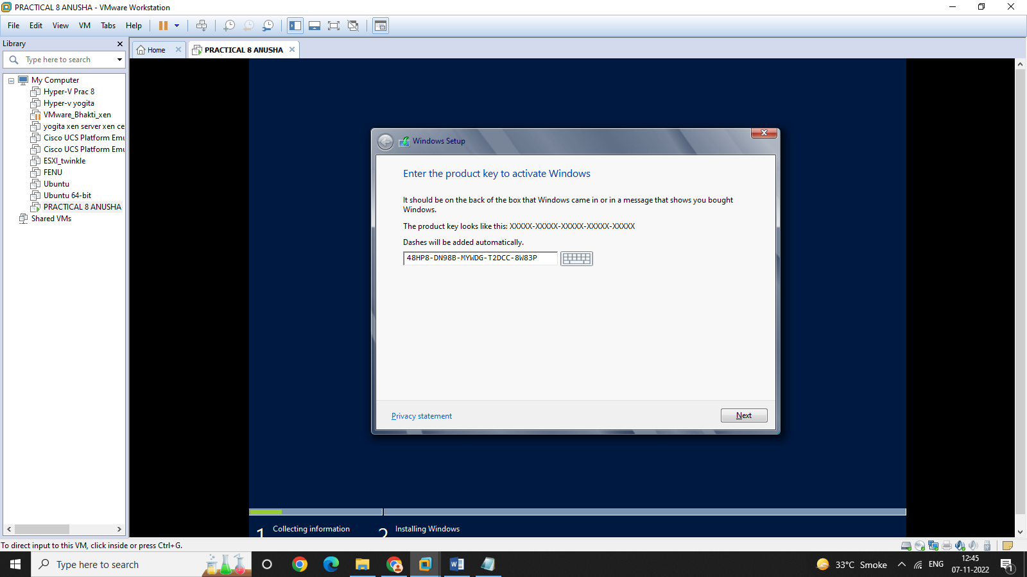

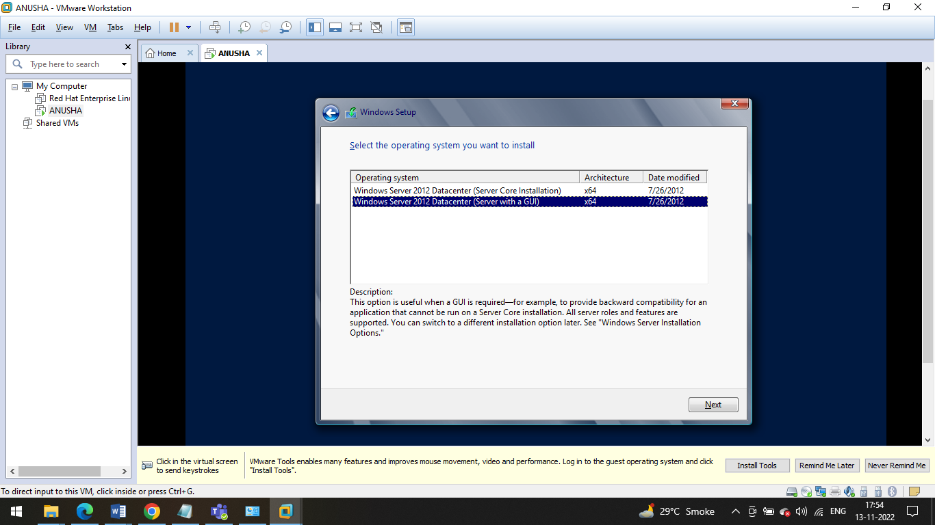

9.Accept the license terms and click next. The installation of windows will start.

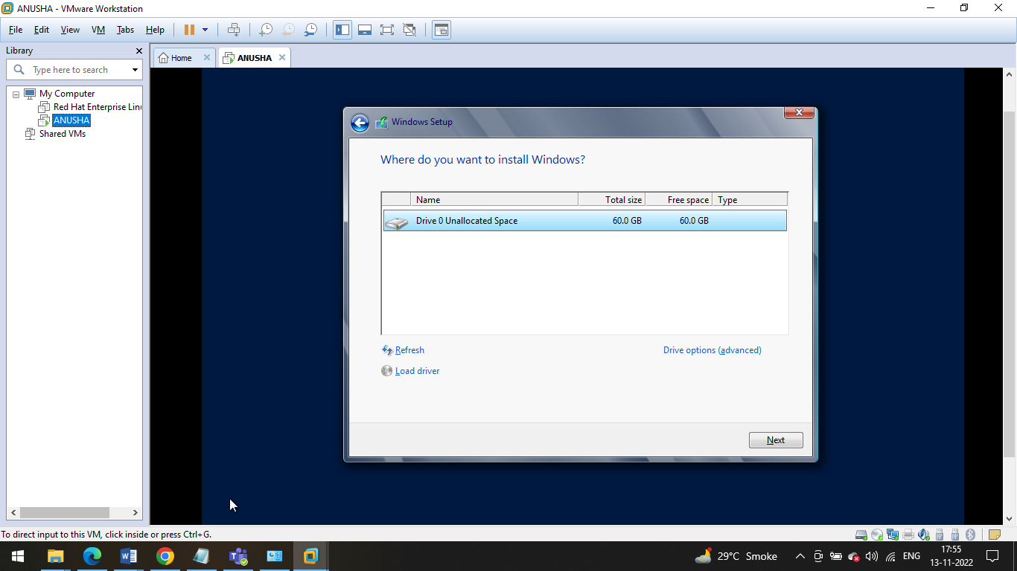

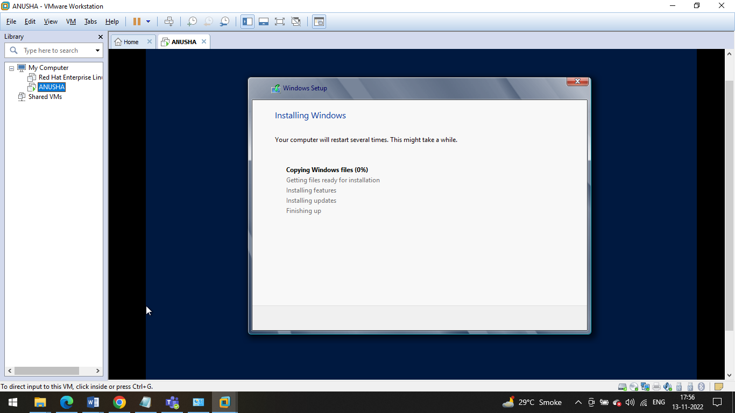

10.Set a password then restart the virtual machine. Put the password and login.

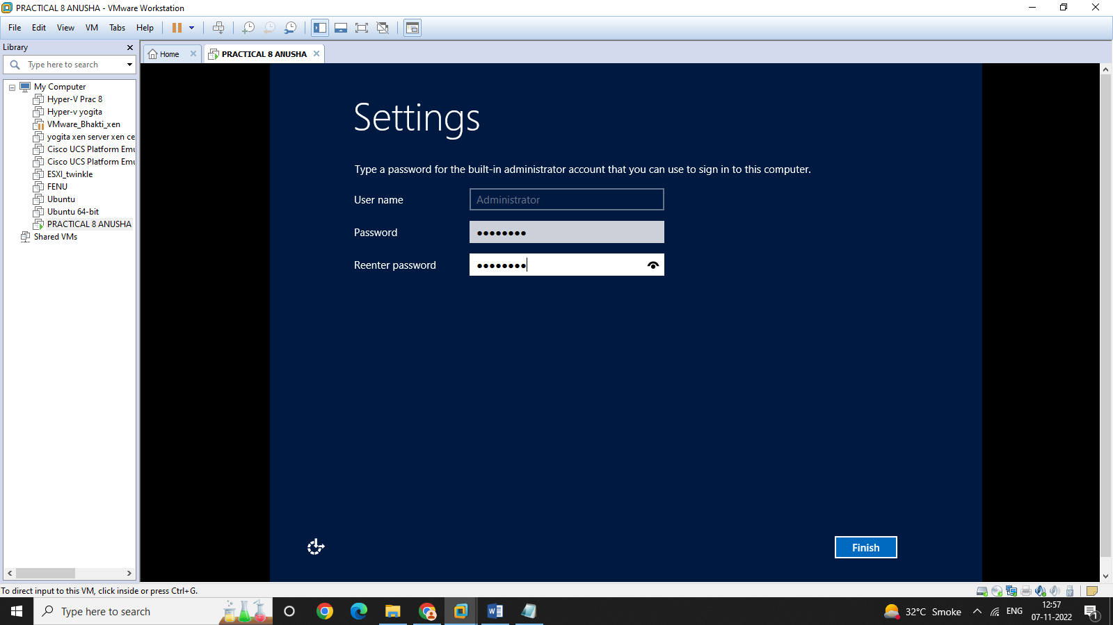

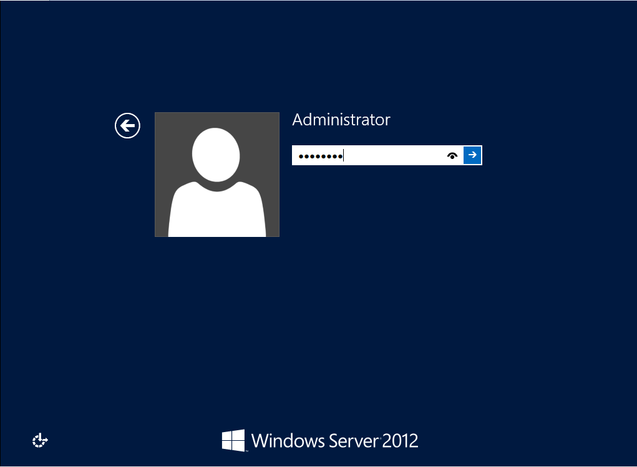

11.Click on Manage and select Add Roles and Features.

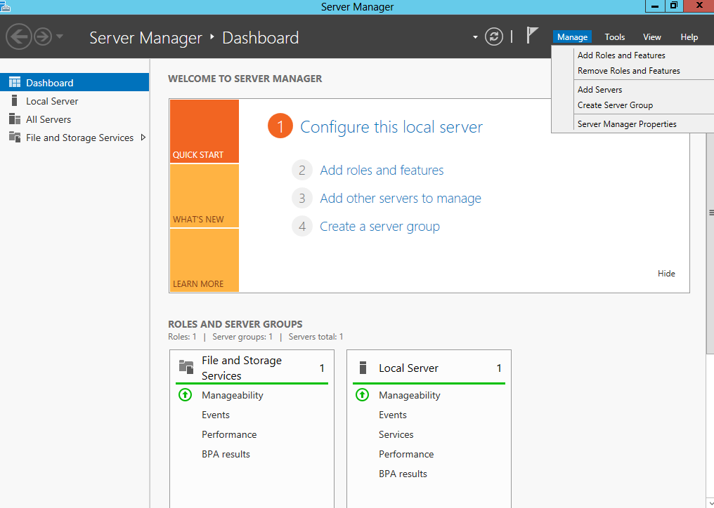

12.Select Hyper-V and then select Failover Clustering and Group policy management. Select the Ethernet0 box and click next.

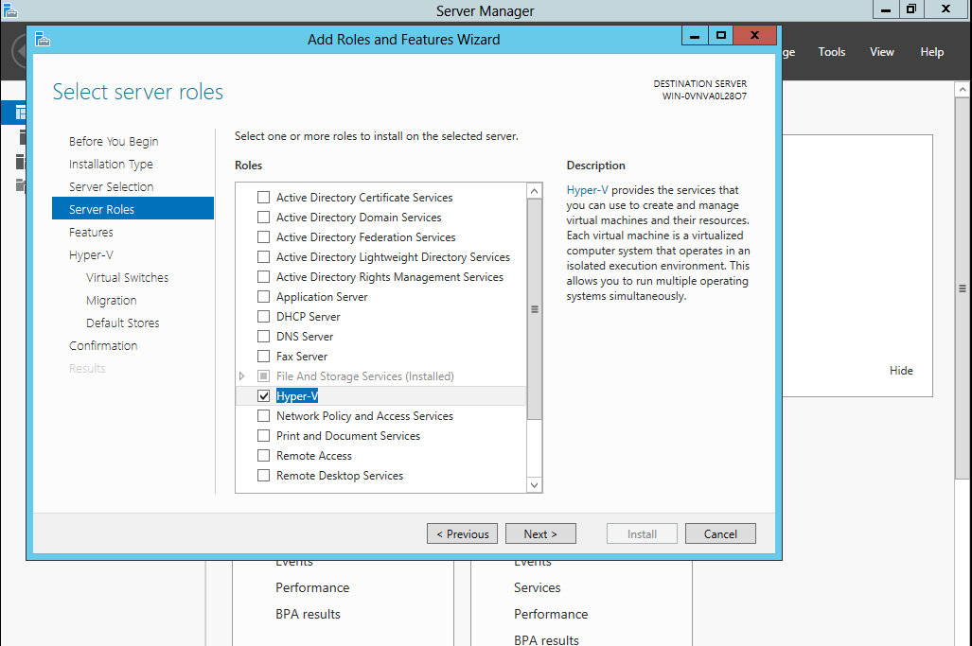

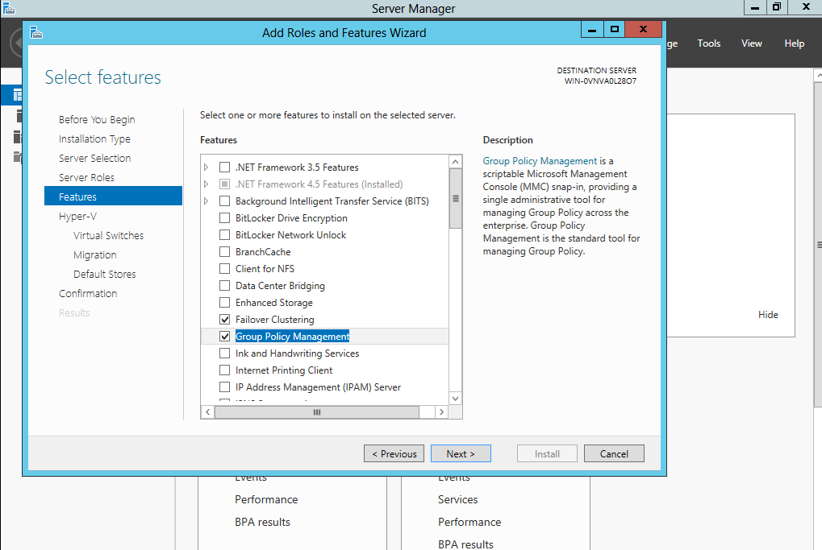

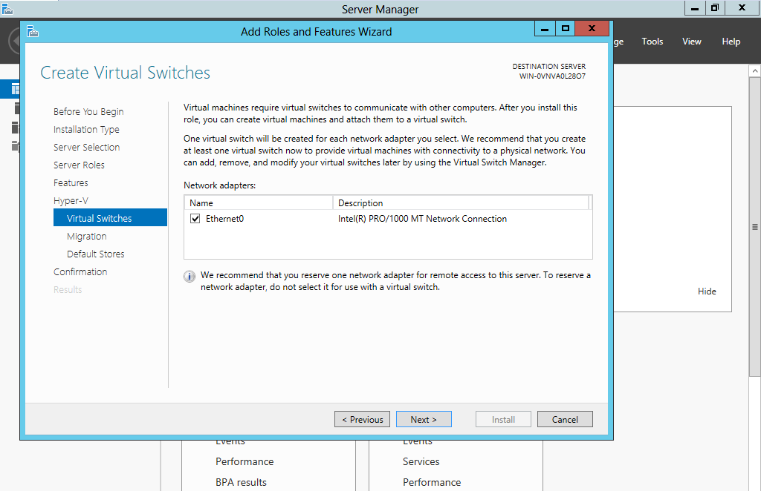

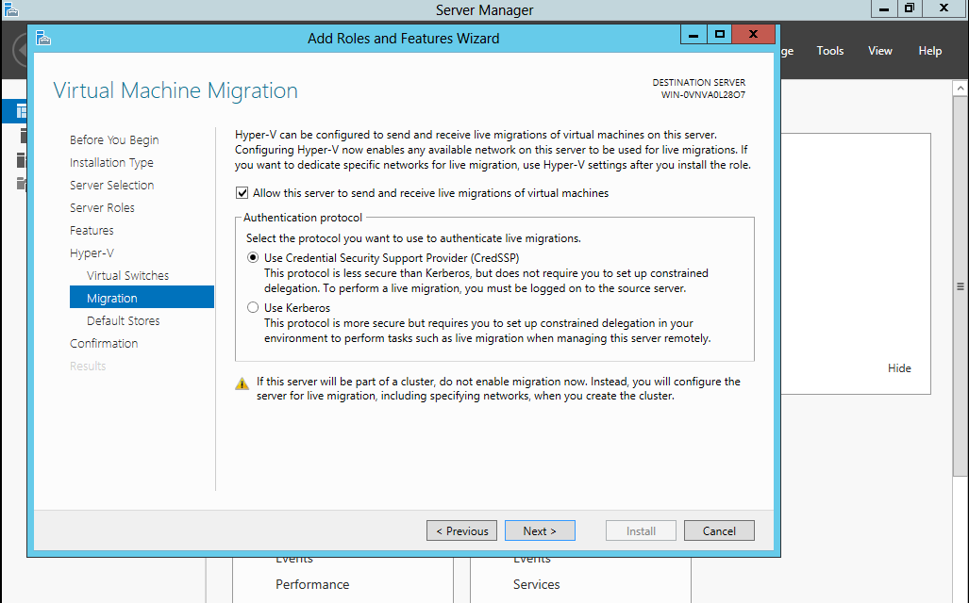

13.Right Click on WIN-0VNADL2807 and create a new virtual machine in Hyper-V and click next.

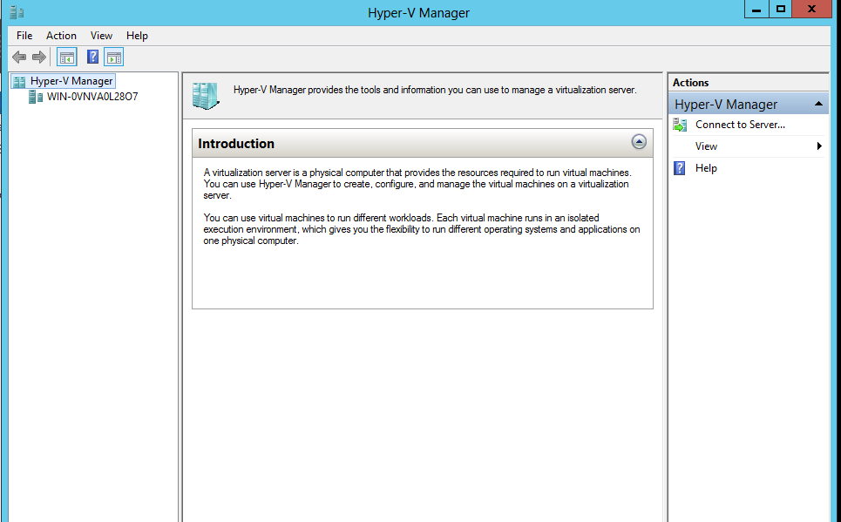

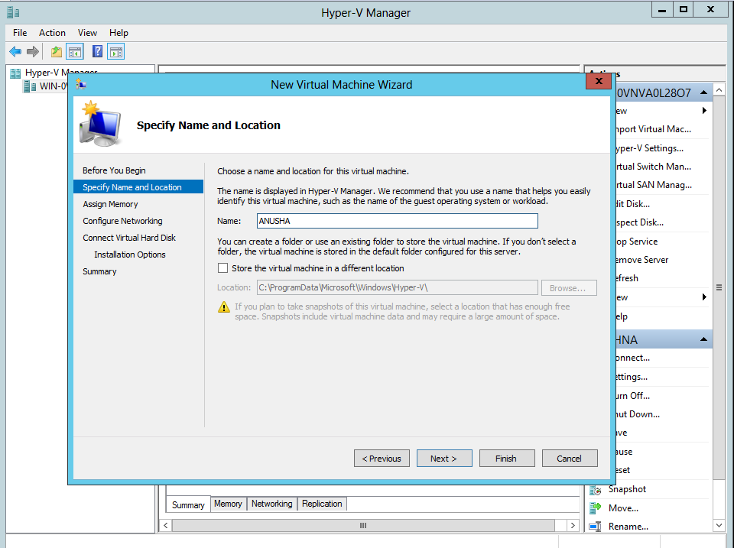

14.Right click on the virtual machine created and click on connect.

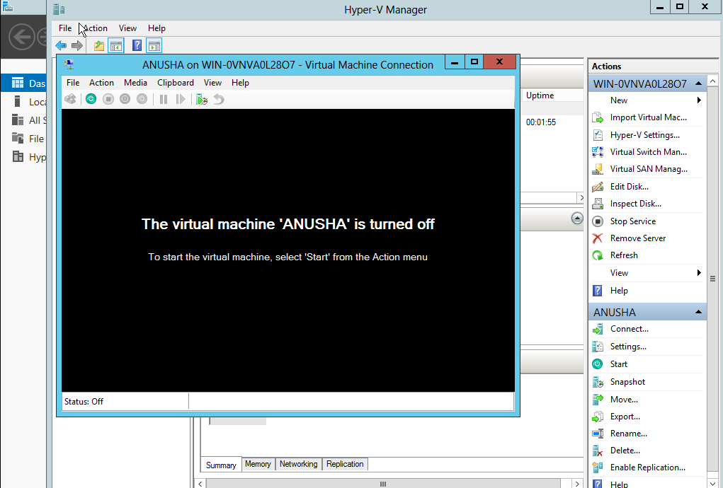

15.Click on media and select Capture D:

Select the ISO image file and click ok

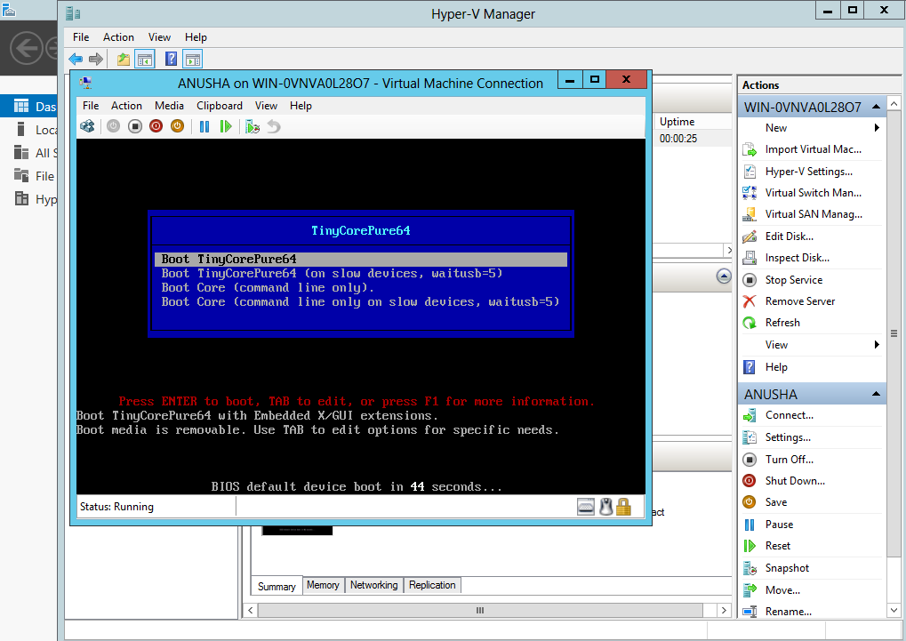

16. Virtual Machine is displayed

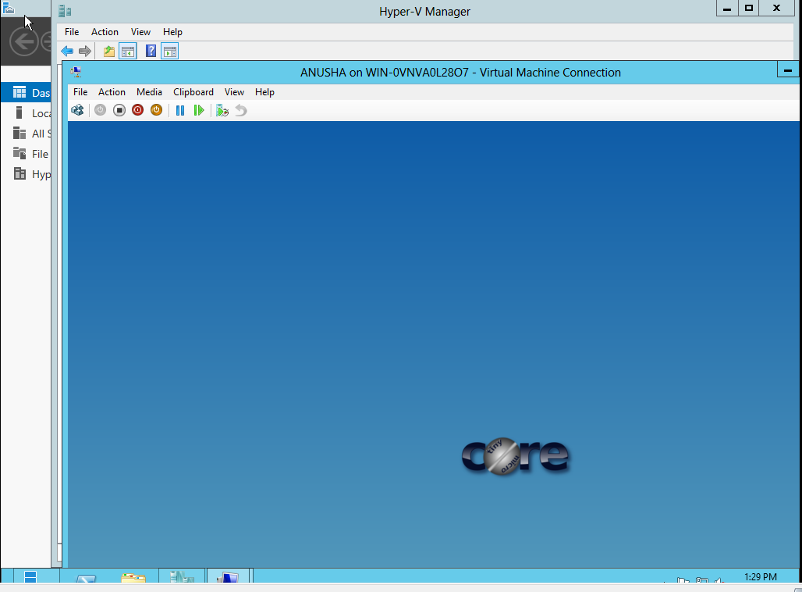

**Practical 9**

**Aim: Develop application for Microsoft Azure**

Step 1: Open visual studio 2019

->Install ASP.NET web development and Azure development

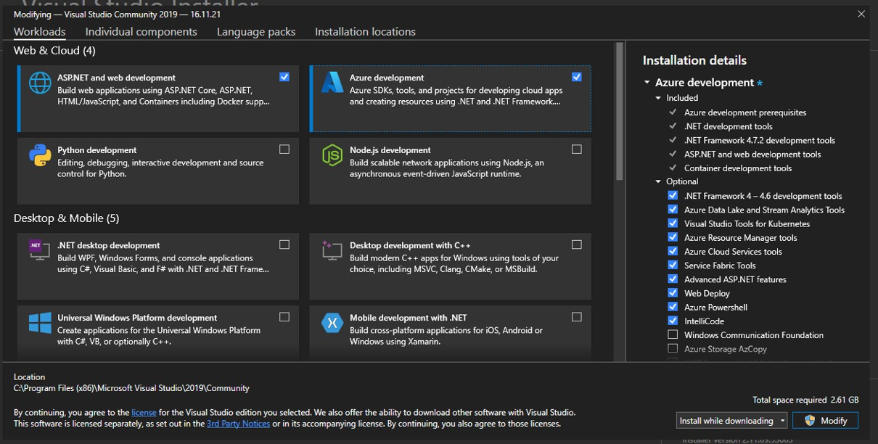

Step 2: Create a new project and select Azure Cloud Service(classic)

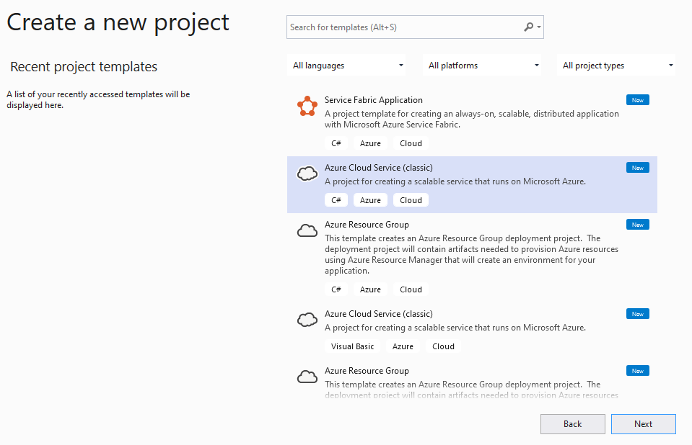

Step 3: In the Pop-up window select “ASP.NET Web Role” and add to the solution

->Clickon “OK”

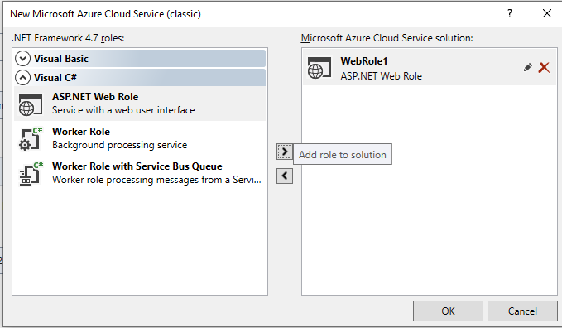

Step 4: In Pop-up Window Select “Empty” and Click on “Create”

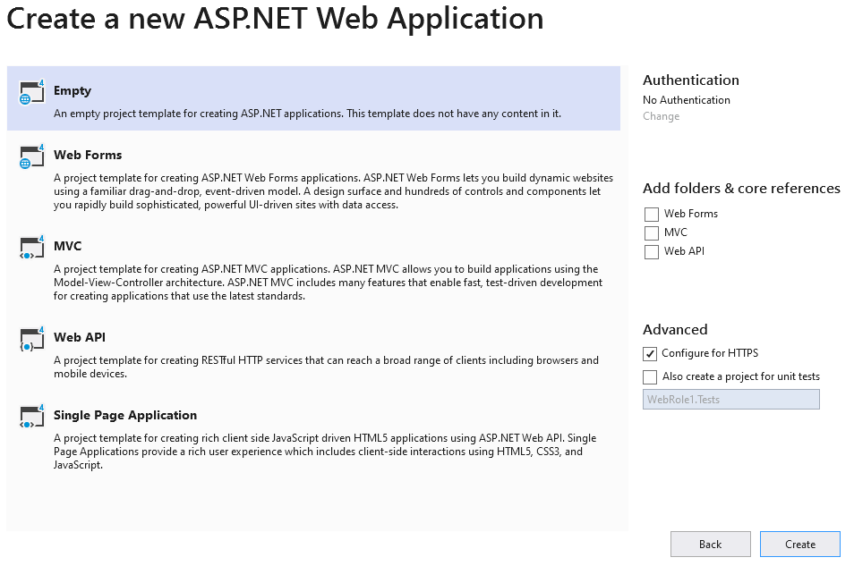

Step 5: Inside solution Explorer Right click on the project file and select “Properties”.underwebsection check the “Use Full Emulator” Checkbox

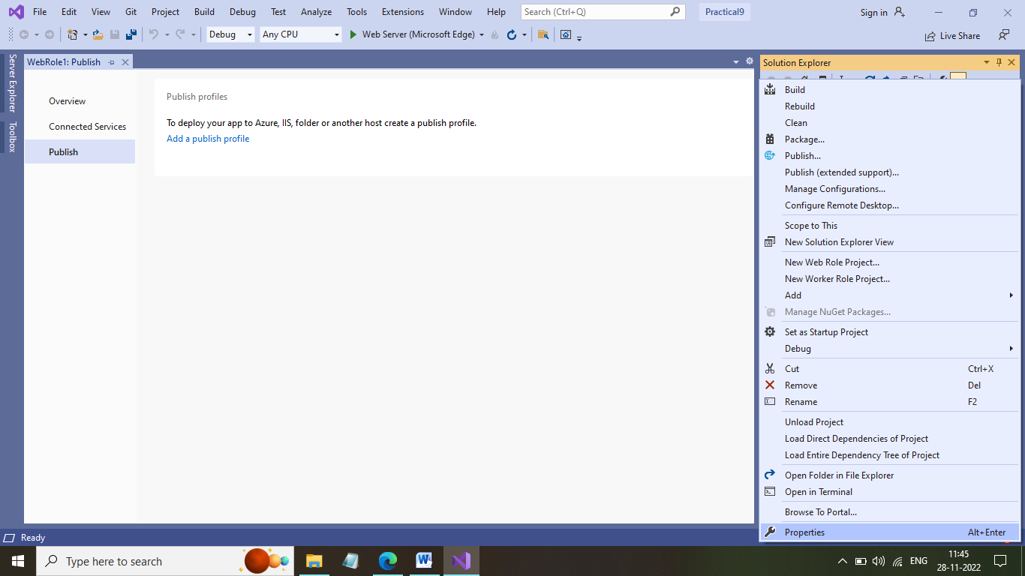

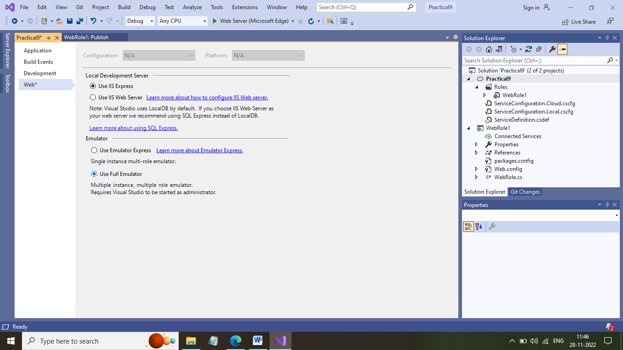

Step 6: inside “ServiceConfiguration.Cloud.cscfg” & “ServiceConfiguration.Local.cscfg”files Change “count” attribute to 3 under “<instances >” tag

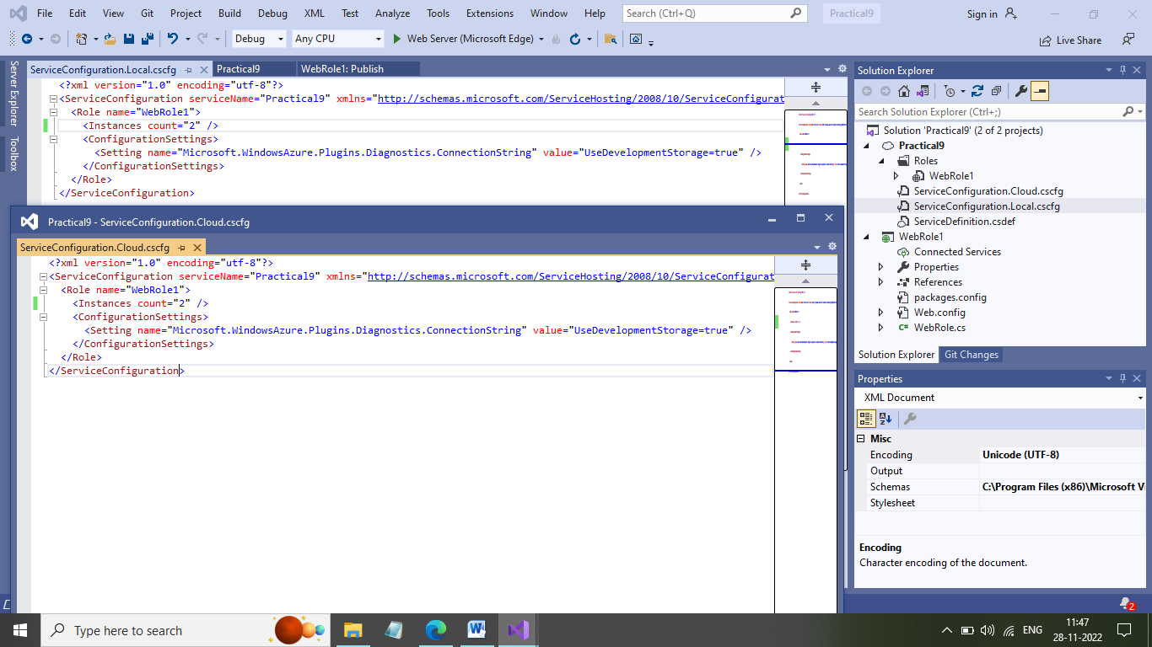

Step 7: Inside solution Explorer under “Web Role” Section Add New Web Formas “webform1.aspx” to print a simple hello message and Deploy the project.

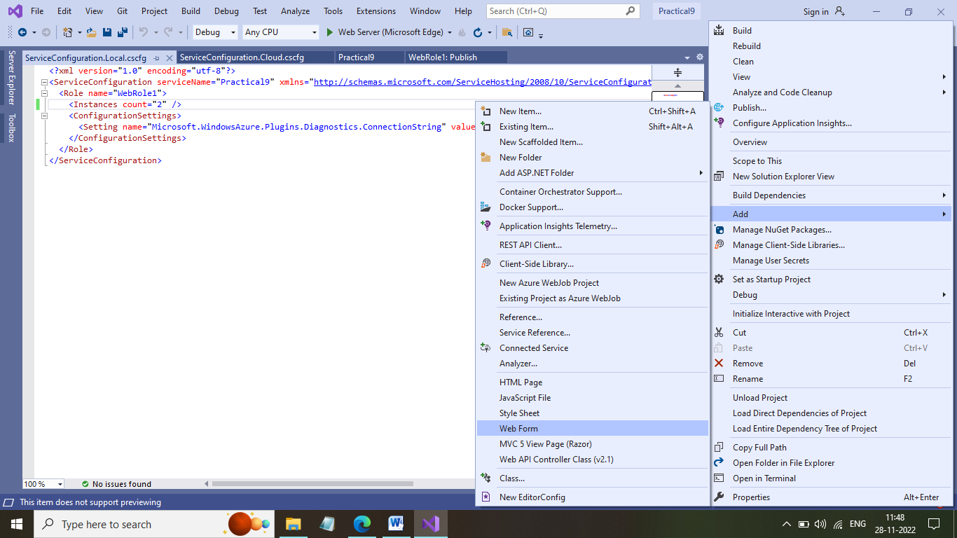

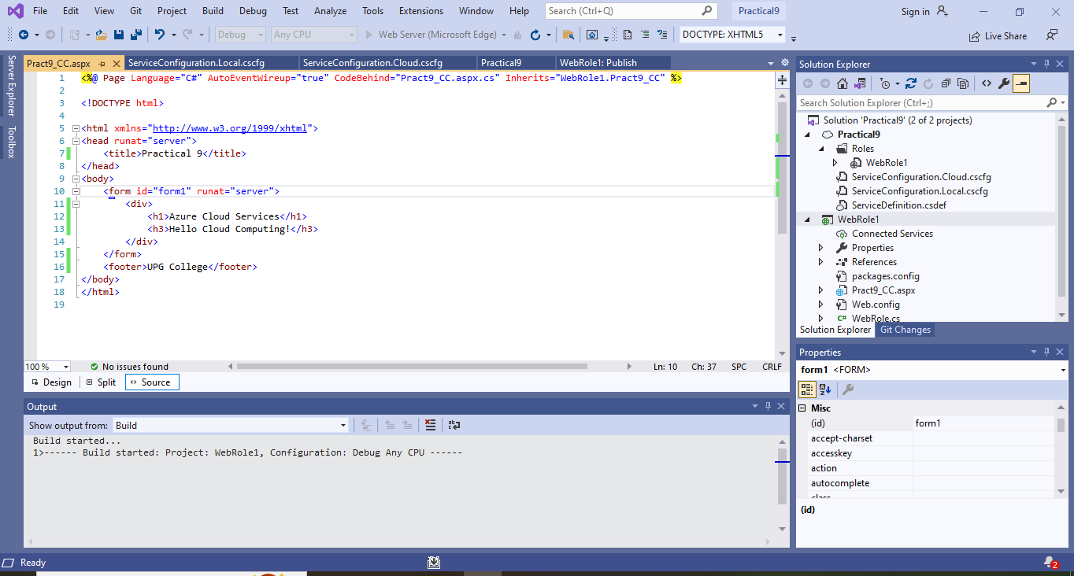

Step 8: To run right click on “webform1.aspx” and select “view browser mode” option.

Next it will show you to run it on Microsoft visual studio at administrator mode

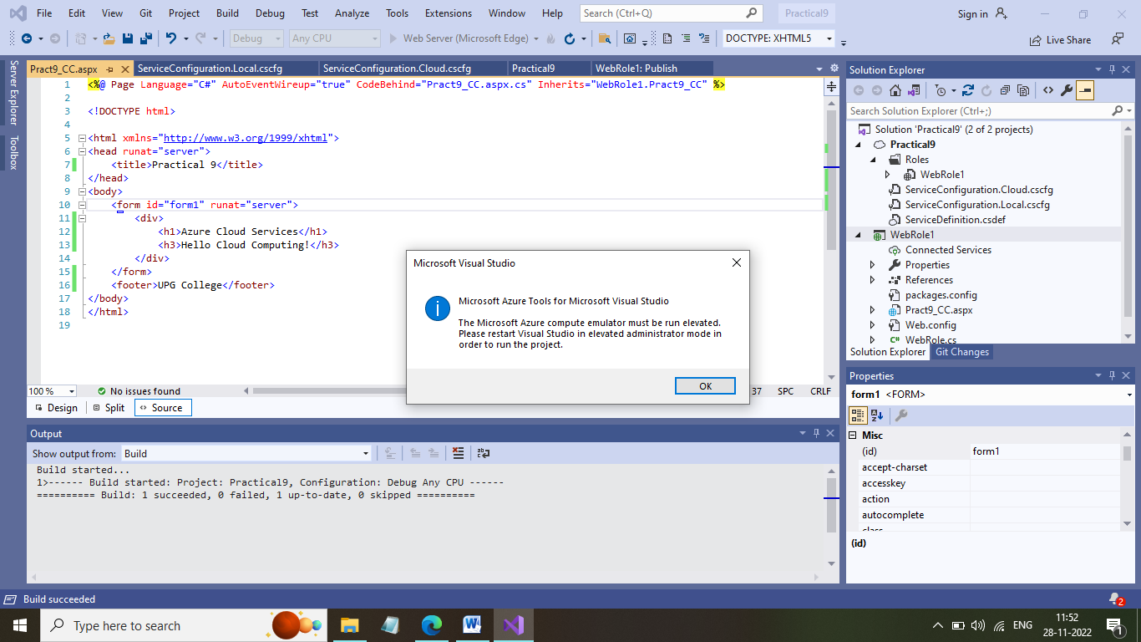

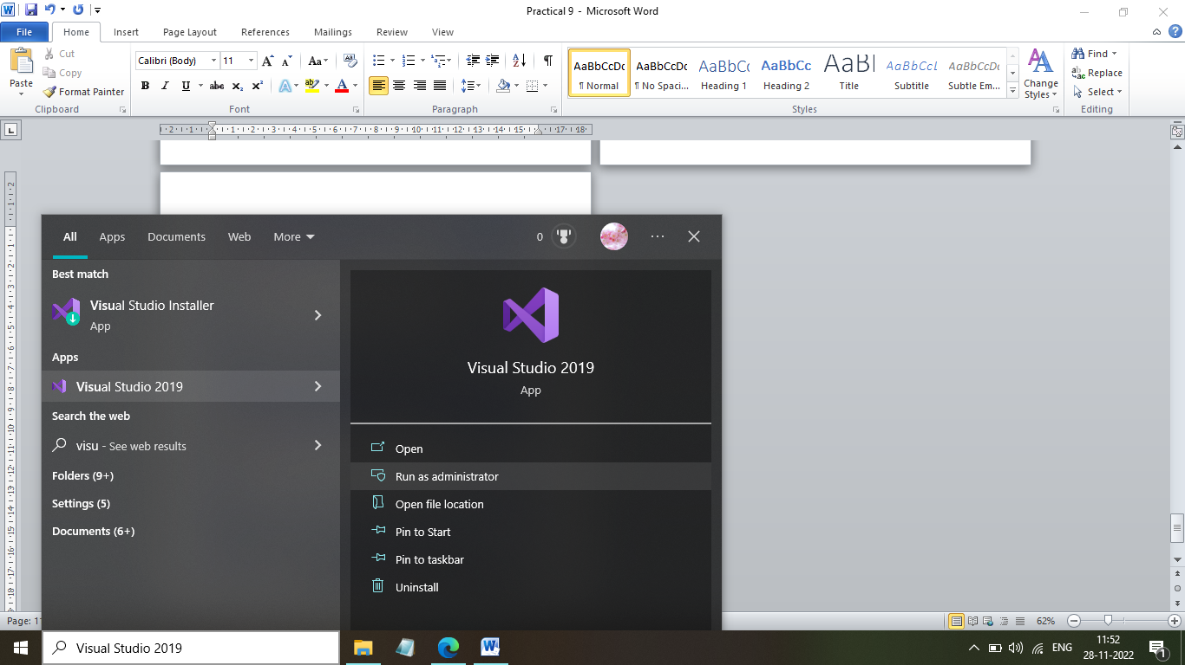

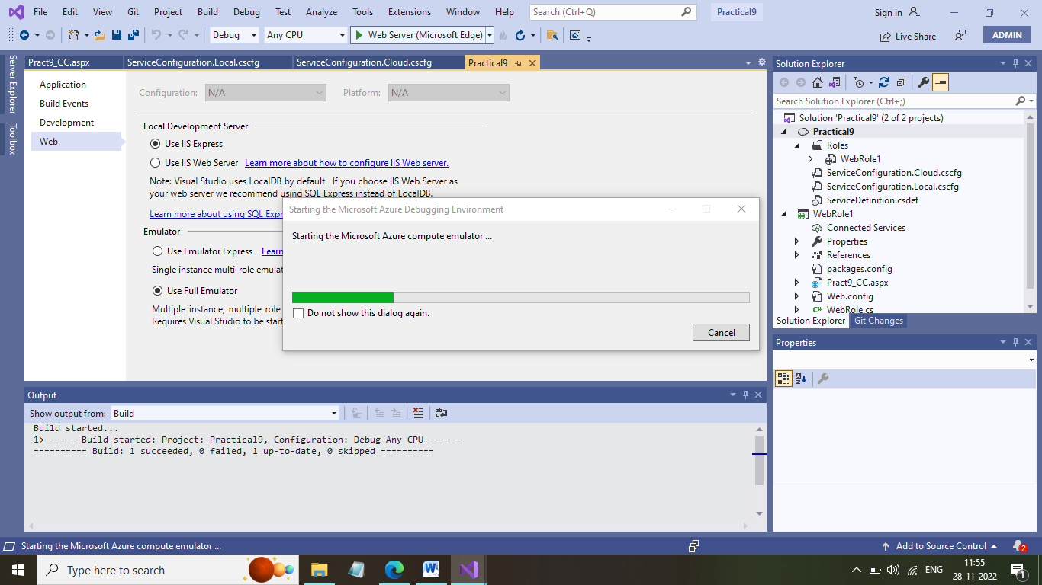

Step 9: Click on windows icon from hidden icons and select “Show Compute Emulator UI” option

